

**Foundation IGCSE (9 – 1) Revision Pack**

**Graphs (Foundation)**

**Name --------------------------------**

**Questions**

**Q1.**

(a)  Complete the table of values for     *y* = *x*2 − 4*x* + 2

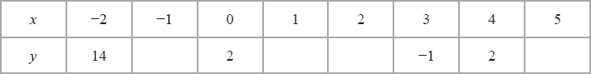

**(2)**

(b)  On the grid, draw the graph of *y* = *x*2 − 4*x* + 2 for values of *x* from −2 to 5

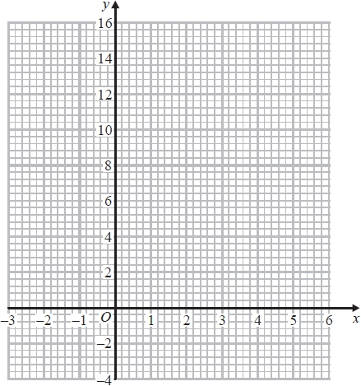

**(2)**

The point *P* (*k*, 4) where *k* > 0 lies on the graph of *y* = *x*2 − 4*x* + 2

(c)  Use your graph to find an estimate for the value of *k*.

...........................................................

**(1)**

**(Total for question = 5 marks)**

**Q2.**

This graph can be used to find the cost, in US dollars ($), of cleaning a carpet with an  
 area of up to 50 m2.

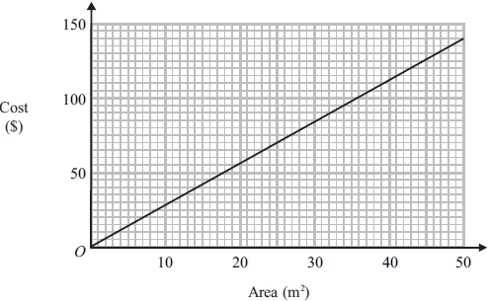

A carpet has an area of 41m2

(a) Use the graph to find the cost of cleaning this carpet.

$...........................................................

**(1)**

The cost of cleaning another carpet is $65

(b) Use the graph to find the area of this carpet.

...........................................................m2

**(1)**

A rectangular carpet has a length of 6.8 m and a width of 5 m.

(c) Find the cost of cleaning this carpet.

$...........................................................

**(3)**

**(Total for question = 5 marks)**

**Q3.**

Jalina left her home at 10 00 to cycle to a park.   
On her way to the park, she stopped at a friend's house and then continued her journey to the park.   
Here is the distance-time graph for her journey to the park.

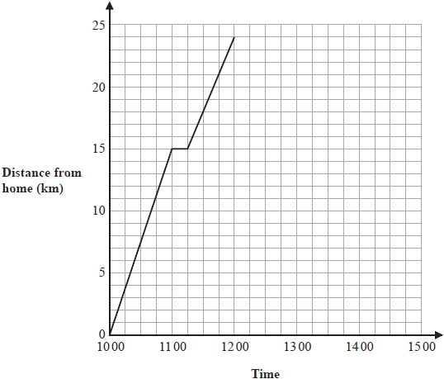

(a)  On her journey to the park, did Jalina cycle at a faster speed before or after she stopped at her friend's house?

Give a reason for your answer.

.............................................................................................................................................

.............................................................................................................................................

.............................................................................................................................................

**(1)**

Jalina stayed at the park for 45 minutes.   
She then cycled, without stopping, at a constant speed of 16 km/h from the park back to her home.

(b)  Show all this information on the distance-time graph.

**(2)**

(c)  Work out Jalina's average cycling speed, in kilometres per hour, for the complete journey to the park and back.

Do **not** include the times when she was not cycling in your calculation.

Give your answer correct to 1 decimal place.

........................................................... km/h

**(3)**

**(Total for question = 6 marks)**

**Q4.**

(a)   Complete the table of values for *y* = *x*2 + 2*x* − 3

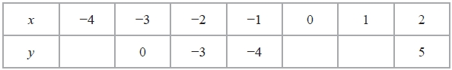

**(2)**

(b)   On the grid, draw the graph of *y* = *x*2 + 2*x* − 3 for values of *x* from −4 to 2

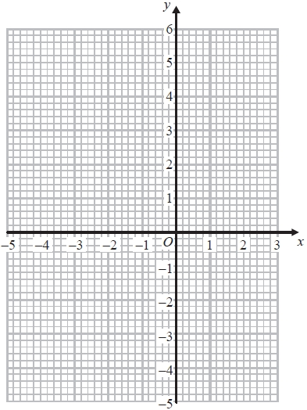

**(2)**

**(Total for Question is 4 marks)**

**Q5.**

Lia left home at 1100 to drive to a shopping centre.   
On her way, she stopped at a friend's house.   
Here is the distance-time graph for her journey to the shopping centre.

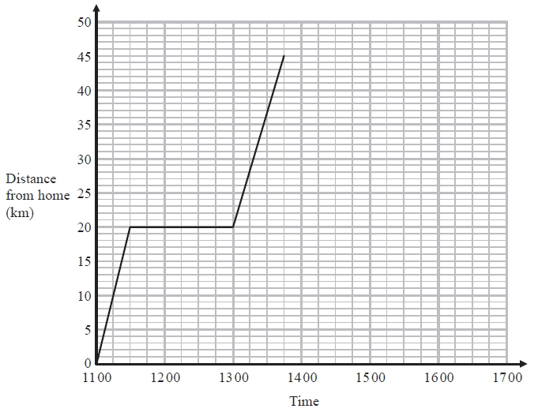

(a)  (i) For how many minutes did Lia stay at her friend's house?

........................................................... minutes

(ii)  How far is it from her friend's house to the shopping centre?

........................................................... km

**(2)**



Lia stayed at the shopping centre for hours.

She then drove back home.   
She arrived home at 16 30

(b)  Show all this information on the distance-time graph.

**(2)**

**(Total for question = 4 marks)**

**Q6.**

Kevin left his home at 1000 to cycle to a lake.   
On the way, he stopped at a friend's house and then continued his journey to the lake.   
Here is the distance-time graph for his journey to the lake.

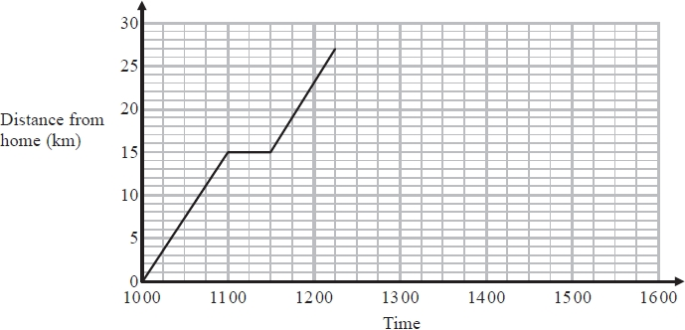

(a)  For how many minutes did Kevin stop at his friend's house?

........................................................... minutes

**(1)**

(b)  How far is the lake from Kevin's home?

........................................................... km

**(1)**

Kevin stayed at the lake until 1315.   
He then cycled, without stopping, at a constant speed from the lake back to his home.

It took Kevin hours to cycle home.



(c)  (i)  Show all this information on the graph.

(ii) Work out Kevin's speed as he cycled from the lake back to his home.

........................................................... km/h

**(4)**  
 **(Total for question = 6 marks)**

**Q7.**

Abri walks along a path from her home to a local village.   
Here is the distance-time graph for her journey from her home to the village.

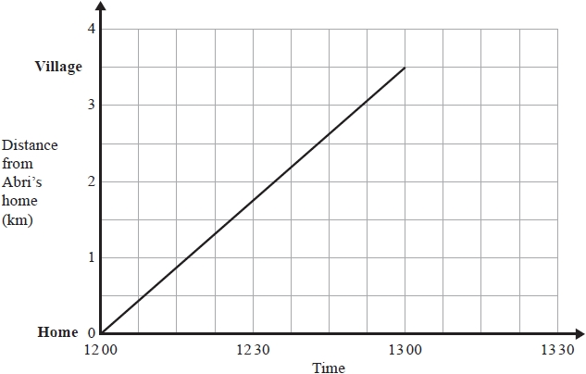

Benito leaves the village at 12 30 and walks at a constant speed along the same path to Abri's home.   
He arrives at Abri's home at 13 15

(a)  Show the information about Benito's journey on the grid.

**(2)**

(b)  How far from the village were Abri and Benito when they passed each other?

........................................................... km

**(1)**

**(Total for question = 3 marks)**

**Q8.**

Usain runs in a race.   
The graph shows his speed, in metres per second (m/s), during the first 10 seconds of the race.

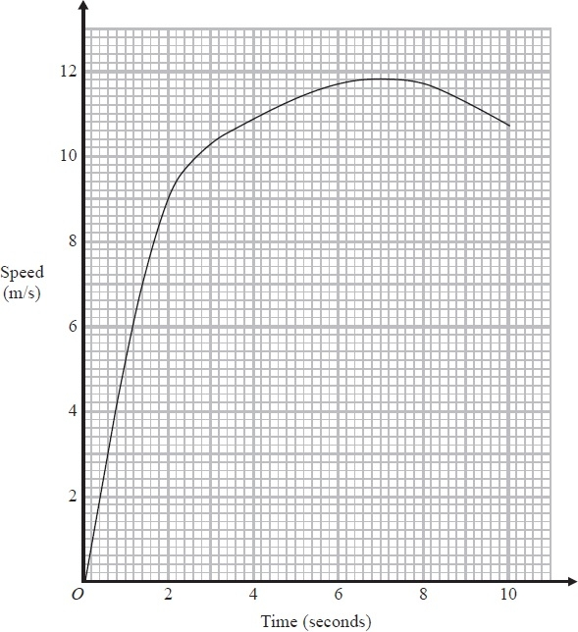

(a)  Write down Usain's speed at 2 seconds.

........................................................... m/s

**(1)**

(b)  Write down Usain's greatest speed.

........................................................... m/s

**(1)**

(c)  Write down the time at which Usain's speed was 7 m/s.

........................................................... seconds

**(1)**

**(Total for Question is 3 marks)**

**Q9.**

(a)   Complete the table of values for *y* = *x*2 – 5*x* + 4

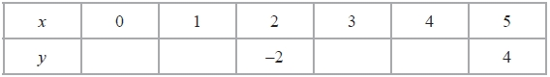

**(2)**

(b)   On the grid, draw the graph of *y* = *x*2 – 5*x* + 4 for all values of *x* from *x* = 0 to *x* = 5

**(2)**

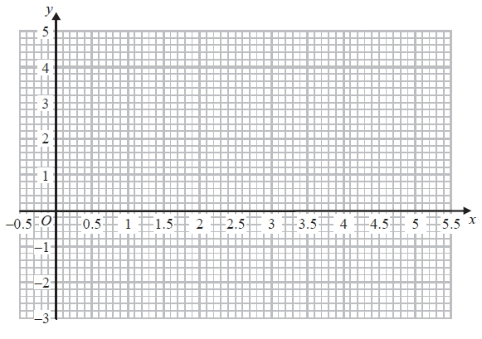

**(Total for Question is 4 marks)**

**Q10.**

(a)  Complete the table of values for *y* = *x*2 − 3*x* − 1

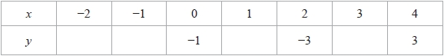

**(2)**

(b)  On the grid, draw the graph of *y* = *x*2 − 3*x* − 1 for all values of *x* from −2 to 4

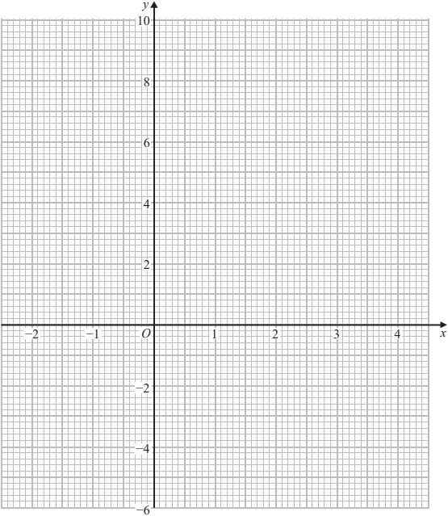

**(2)**

**(Total for question = 4 marks)**

**Q11.**

You can use this graph to convert between miles and kilometres.

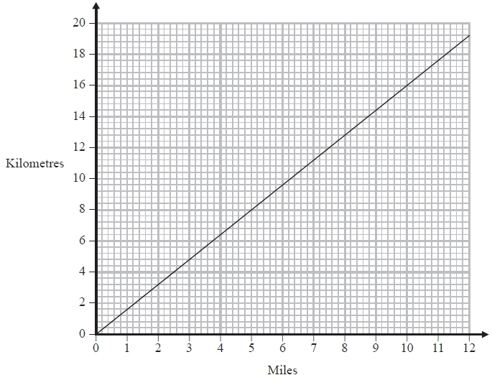

(a)   Use the graph to convert

(i)   10 miles to kilometres

........................................................... kilometres

(ii)   12 kilometres to miles

........................................................... miles

**(2)**

(b)   Convert 80 kilometres to miles

........................................................... miles

**(2)**

**(Total for Question is 4 marks)**

**Q12.**

You can use this graph to convert between US gallons and Canadian gallons.

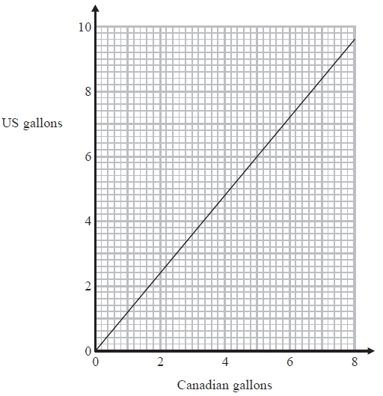

(a)   Convert 4 Canadian gallons to US gallons.

........................................................... US gallons

**(1)**

The fuel tank of Jim's truck holds 27 US gallons of fuel when full.

(b)   Convert 27 US gallons to Canadian gallons.

........................................................... Canadian gallons

**(2)**

**(Total for Question is 3 marks)**

**Q13.**

You can use this graph to convert between euros (€) and Singapore Dollars (SGD).

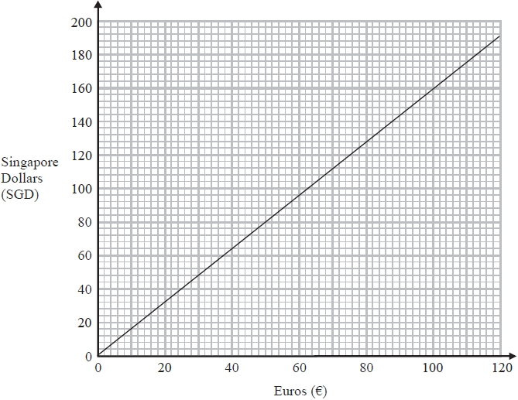

(a)  Convert 50 euros to Singapore Dollars.

........................................................... SGD

**(1)**

(b)  Convert 90 Singapore Dollars to euros.

........................................................... euros

**(1)**

(c)  Convert 550 euros to Singapore Dollars.   
Show your working clearly.

........................................................... SGD

**(2)**

**(Total for question = 4 marks)**

**Q14.**

Pierre wants to convert some money between two currencies.  
 This graph can be used to convert between Euros (€) and Canadian dollars (C$).

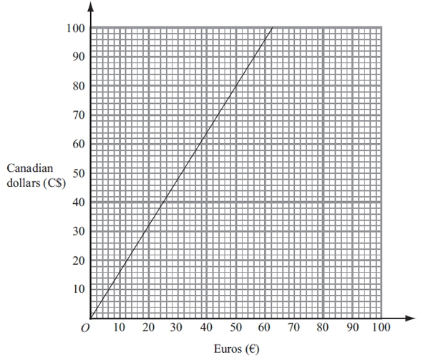

(a) Use the graph to convert

(i) 50 Euros (€) to Canadian dollars (C$),

C$...........................................................

(ii) 60 Canadian dollars (C$) to Euros (€).

€...........................................................

**(2)**

Pierre now decides to use this rule to convert Euros to Canadian dollars.



(b) Use this rule to convert 175 Euros to Canadian dollars.

C$...........................................................

**(2)**

**(Total for question = 4 marks)**

**Q15.**

Mansi left her home at 09 00 to walk to the shops.

She stopped at the newspaper shop and then carried on to the fish shop.

Here is the distance-time graph for Mansi's journey from her home to the fish shop.

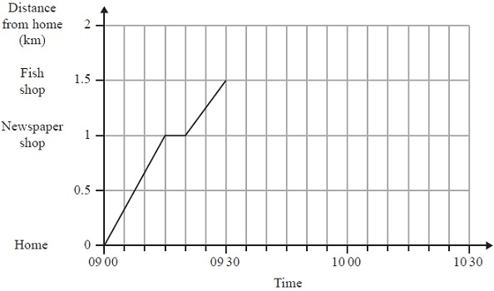

(a)  How many minutes did it take Mansi to walk from the newspaper shop to the fish shop?

........................................................... minutes

**(1)**

(b)  Work out the average speed, in kilometres per hour, for Mansi's journey from her home to the newspaper shop.

........................................................... km/h

**(2)**

Mansi stopped for 10 minutes in the fish shop.   
She then walked home at a constant speed of 3 km/h.

(c)  Show this information on the graph.

**(2)**

**(Total for Question is 5 marks)**

**Q16.**

Bhavik left his home at 12 00 to cycle to Sam's house.  
 On the way Bhavik stopped for a rest, and then continued his journey.  
 The distance-time graph shows his journey.

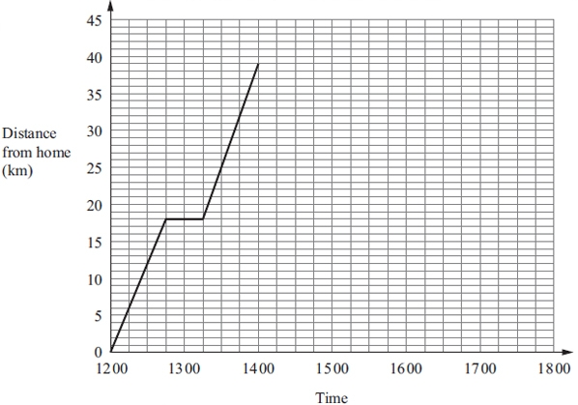

(a) (i) For how many minutes did Bhavik stop for a rest?

........................................................... minutes

(ii) After his rest, how many more kilometres did Bhavik cycle to Sam's house?

........................................................... km

**(2)**

(b) Bhavik stayed at Sam's house for 2 hours.   
He then cycled back to his home.  
He arrived home at 17 15.

Show all this information on the graph.

**(2)**

(c) Write down the times at which Bhavik was 24 kilometres from his home.

...........................................................

...........................................................

**(2)**

(d) Work out the average speed, in kilometres per hour, of Bhavik's journey from Sam's   
house back to his home.

Give your answer correct to 1 decimal place.

........................................................... km/h

**(3)**

**(Total for question = 9 marks)**

**Q17.**

You can use this graph to change between UK pounds (£) and US dollars ($).

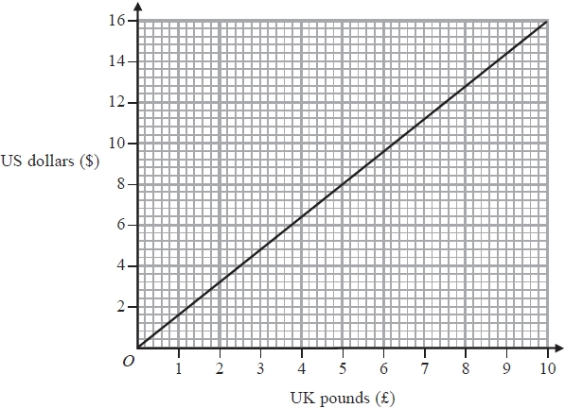

(a)  Use the graph to change £5 to US dollars.

$...........................................................

**(1)**

(b)  Use the graph to change $14 to UK pounds.

£...........................................................

**(1)**

(c)  Change £37.50 to US dollars.

$...........................................................

**(2)**

**(Total for question = 4 marks)**

**Mark Scheme**

Q1.

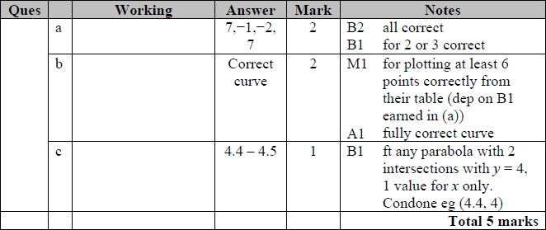

**Q2.**

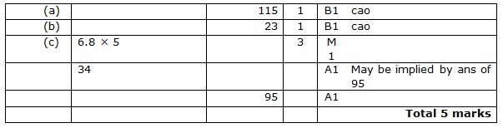

**Q3.**

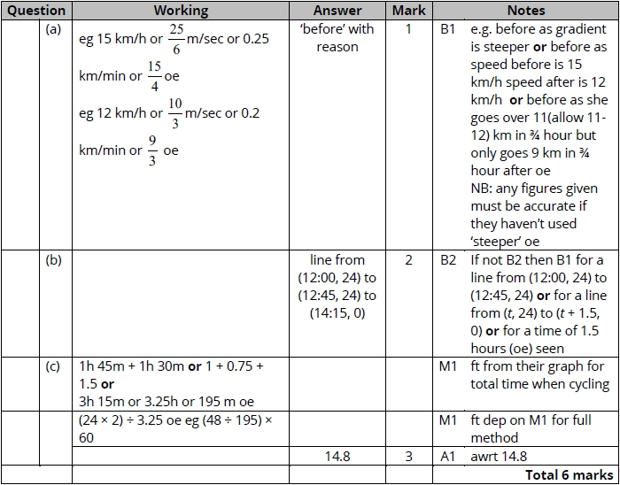

**Q4.**

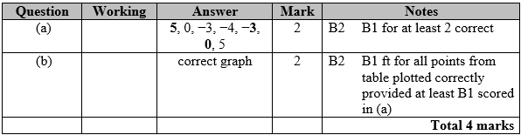

**Q5.**

Apart from question 18c where the mark scheme states otherwise, the correct answer, unless clearly obtained by an incorrect method, should be taken to imply a correct method.

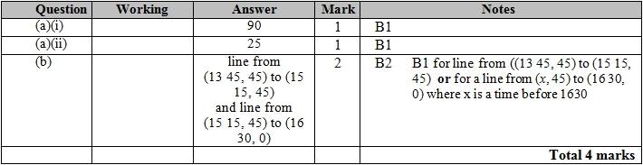

**Q6.**

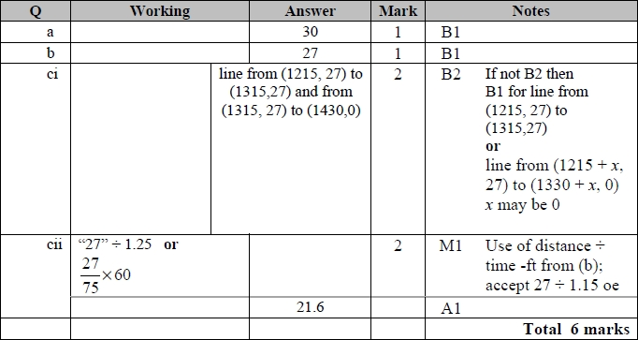

**Q7.**

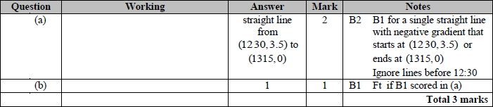

**Q8.**

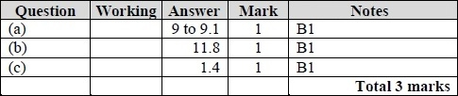

**Q9.**

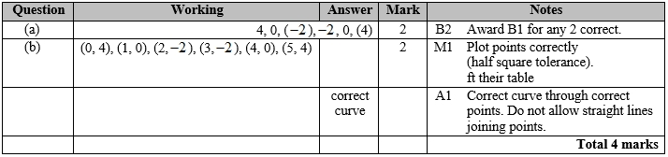

**Q10.**

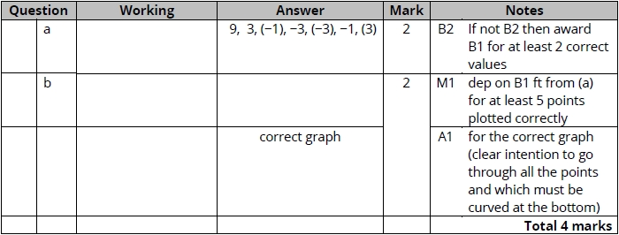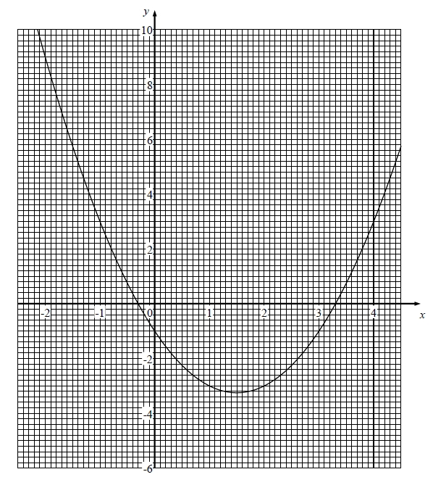

**Q11.**

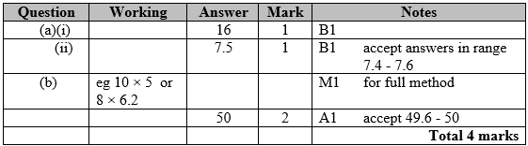

**Q12.**

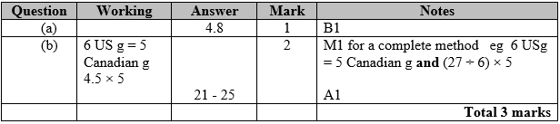

**Q13.**

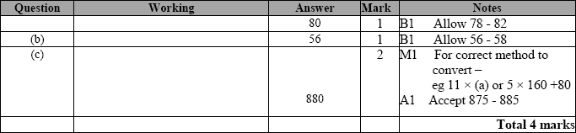

**Q14.**

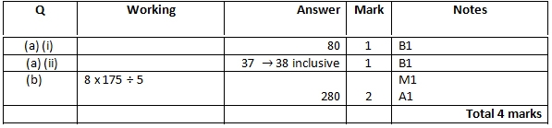

**Q15.**

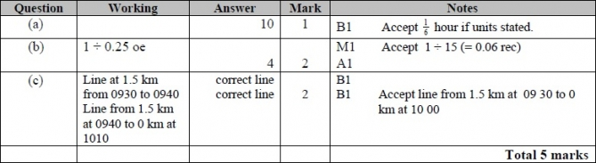

**Q16.**

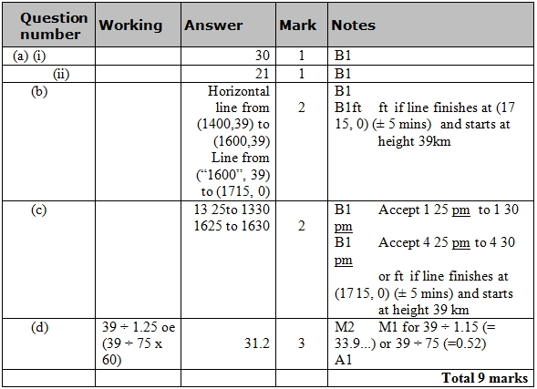

**Q17.**

