[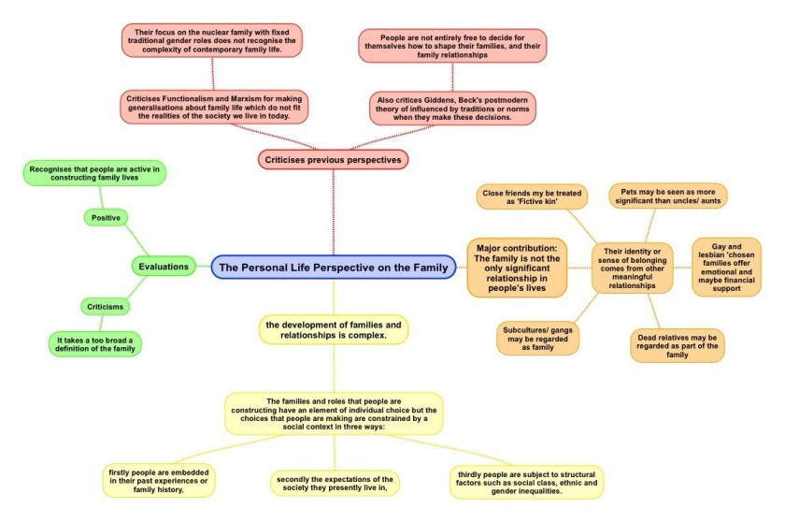](https://sellfy.com/p/3gIV/)

The personal life perspective on the family is essentially an **Interactionist** perspective and makes two basic criticisms of structural perspectives such as Functionalism, Marxism and Feminism’. Carol Smart is the main thinker associated with this perspective.

1. ‘They tend to assume that the traditional nuclear family is the dominant type of family. This ignores the increased diversity of families today. Compared with 50 years ago, many more people now live in other families, such as lone-parent families and so on.
2. They are all structural theories. That is, they assume that families and their members are simply passive puppets manipulated by the structure of society to perform certain functions – for example, to provide the economy with a mobile labour force, or serve the needs of capitalism or of men.

The Sociology of Personal life is strongly influenced by Interactionist ideas and contrasts with structural theories. Sociologists from this perspective believe that in order to understand families, we must start from the point of view of the individuals concerned and the meanings they give to their relationships.’

**Carol Smart** is the main person associated with this perspective. She has become frustrated by the fixation of many commentators with the supposed decline of the possibility of family life. She rejects many of the assumptions about the decline of family life found in theories of individualisation by authors such as Beck and Beck, Gernsheim and Giddens.

Instead, her approach prioritises the bonds between people, the importance of memory and cultural heritage, the significance of emotions (both positive and negative), how family secrets work and change over time, and the underestimated importance of things such as shared possessions or homes in the maintenance and memory of relationships.

By focusing on people’s meanings, Carol Smart’s personal life perspective draws our attention to a range of other personal or intimate relationships that are important to people, even though they may not be conventionally defined as family. These include all kinds of relationships that individuals see as significant and give them a sense of identity, relatedness and belonging, such as:

* Relationships with friends who might be like a sister or a brother to you.
* Fictive kin: close friends who are treated as relatives, for example your mum’s best friend who you call your ‘auntie’
* Gay and lesbian ‘chosen families’ made up of a supportive network of close friends, ex partners and others who are not related by marriage or blood
* Relationships with dead relatives who live on in people’s memories and continue to shape their identities and affect their actions
* Even relationships with pets. For example, Becky Tiper (2011) found in her study of children’s views of family relationships, that children frequently saw their pets as ‘part of the family’

*In short – The Family is not in decline, it is just very different and much more diverse and complex than ever before.*

**Evaluation of the Personal Life Perspective**

* It helps us to understand how people themselves construct and define their relationships as ‘family’ rather than imposing traditional sociological definitions of the family from the outside.
* However, taking the personal life perspective can be accused to taking too broad a view. Critics argue that by including a wide range of personal relationships, we ignore what is special about relationships that are based on blood or marriage.
* The personal life perspective rejects the top down view taken by other perspectives, such as functionalism but it does see intimate relationships as performing the important function of providing us with a sense of belonging and relatedness
* However, unlike functionalism the personal life perspective recognises that relatedness is not always positive