3.4.5 Managing inventory and supply chains

## 

**Ways and value of improving flexibility, speed of response and dependability**

This section will look in detail at how the operational objectives, flexibility, speed of response and dependability can actually be achieved.

**Improving flexibility**

Flexibility is the ability of an organisation to change its operations in some way. The main types of flexibility are

1. **Product flexibility** can be achieved by designing production lines that can be quickly altered to change the end product. With the growth of just-in-time supply of materials, greater automation of production lines and more adaptable machinery, it becomes easier to switch production between different products.
2. **Volume flexibility** can be achieved by maintaining high levels of spare capacity. However, this can be an expensive option because it results in resources being underutilised in the business. For this reason, many businesses choose to **outsource** production so that other businesses manufacture the product or service. In this way, a business can increase volume without having high spare capacity at times when demand is low.
3. **Delivery flexibility** relies in having a flexible workforce, a sophisticated database to manage orders and deliveries in a flexible way and access to delivery vehicles. The latter can be achieved through subcontracting or outsourcing.
4. **Mix flexibility** requires a combination of the factors outlined above. To provide different customers with different variations of the same product requires:

* A production line that can adapt quickly.
* A sophisticated database to match customer needs and requirements with the version of the product being made for a particular customer.
* A flexible workforce with sufficient skills to adapt to making significant variations of the same product.

Growing demand for mix flexibility by customers has led to the growth of mass customisation.

**Mass customisation**

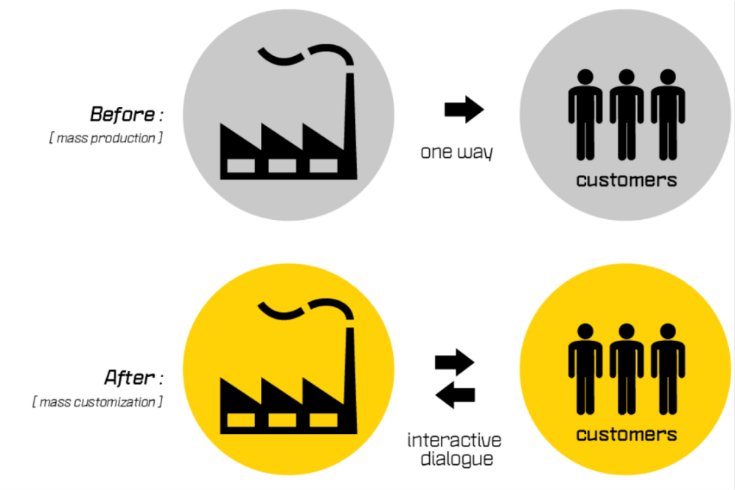In the past, mass production entailed producing a huge amount of **identical** products with no variation whatsoever between product runs. This understandably limited the product choice available to the consumer. However, new technology on the production line has meant that variety can be introduced to products. Mass customisation enables products to be designed according to customer specification. Previously, customisation could only be achieved through labour intensive, craft production methods of production. So, *mass customisation is the term used for producing on a large scale while still enabling individual customer preferences to be met.*

**Factors required for mass customisation**

For mass customisation to take place, certain requirements are necessary. These are:

1. **A market in which customers value variety and individuality:** Some customers are willing to pay a premium price to have their need for variety and individuality met. In this situation, the business has an incentive to invest in new technologies to ensure they are capable of delivering this on the production line. However, mass customisation is possible or desirable for some products. For example, products such as light bulbs will continue to be made using the standard mass production methods.
2. **Quick responsiveness to market changes:** Businesses must be able to respond quickly to market changes in order to retain their competitive advantage. Modern research techniques, customer loyalty cards and customer data bases enable a business to understand and monitor any changes in consumer demand and adapt quickly.
3. **Ability to provide customisation (a wide variety of alternative versions of the same product):** Capital equipment and software now make it possible to program adjustments to individual products on a production line. For example, on a car production line, each car can vary with regard to colour or engine size.
4. **Scope for mass efficiency / economies of scale:** Mass customisation can only be possible where there is a mass market and therefore a high volume of products being produced.

## Advantages and disadvantages of mass customisation

|  |  |
| --- | --- |
| **Advantages** | **Disadvantages** |
| Cost reductions because products are made in volume.  Higher revenue as customers are willing to pay a premium price and competitive advantage as customisation is a selling point.  Greater customer loyalty since individual customer needs are met.  Improved understanding of customers’ wants as the business will need to monitor market changes closely for mass customisation to be successful.  Greater protection from market changes because the business will be flexible enough respond quickly. The business is also not over dependent on supplying a very limited range of products.  Improved workforce motivation since customisation provides a variety of tasks and jobs within the business.  Higher profits since the premium price charged for the product will mean higher profit margins. | Requires sophisticated and expensive management information systems to monitor customer orders throughout the production process. This is extremely expensive initially.  Greater expense in terms of capital equipment and staff training.  A fault in manufacturing of customised products will mean that orders for certain customers will be late.  The entire process is heavily dependent on the flexibility and goodwill of suppliers. The business may also miss out on some purchasing economies of scale since it is far easier to order standard items in bulk from a supplier. |

# Influences on the amount of inventory held

Inventory is another word for stock and can take THREE different forms:

1. Raw materials: components that will be used to create the product.
2. Work in progress: part-finished goods.
3. Finished goods: completed products which are waiting to be sold to a customer.

## Inventory control

It is important the business has sufficient inventory at any one time to match demand. By holding high inventory levels, a business is able to ensure that they have sufficient resources should there be a sudden surge in demand. However, holding too much stock can be expensive. If demand falls suddenly due to a change in tastes and preferences of consumers, then the business will be left with inventory they are unable to sell. Also, inventory must be stored and this will take up space in the business. The business must weigh up the pros and cons of holding inventory in order to decide what is appropriate for them.

## Controlling inventory levels

An inventory control chart is a diagram that is used to register levels of stock / inventory over a period of time. The following are terms associated with the stock control chart that must be understood:

**Maximum inventory levels:** the maximum amount of inventory (stock) the business is willing and able to hold.

**Re-order Levels:** when inventory levels reach this point it will trigger off a new order with the supplier.

**Lead time:** the time it takes from order to delivery of inventory. Sometimes the lead time can be very short but if the inventory is quite complex or technical in nature, the lead time can take much longer. Lead time also depends on proximity to supplier; a local supplier is more likely to deliver in a shorter period time period than is the case with an overseas supplier.

**Re-order quantities:** the amount of inventory the business will order. This amount will depend on factors such as cost and the ability to store the inventory.

**Minimum inventory level:** the absolute minimum amount of inventory the business is happy with holding. Holding stock below this level could mean the business has difficulties meeting customer orders and meeting delivery deadlines. This could damage the reputation of the business.

**Buffer stock:** Buffer or safety inventory is held to ensure that production can continue in an emergency i.e. the supplier fails to deliver. Once the buffer stock has been exhausted, the business is said to be in a situation of ‘stock out’ and production will grind to a halt until fresh inventory is delivered to the production line.

# Just in time (“JIT”)

JIT manufacturing means that a firm only produces what is required, in the correct quantity and at the correct time.

This means that stock levels of raw materials, components, work in progress and finished goods can be kept to a minimum. In a firm which is not using JIT, stock is held in the warehouse as a buffer – in the diagram below this is at 200 units.

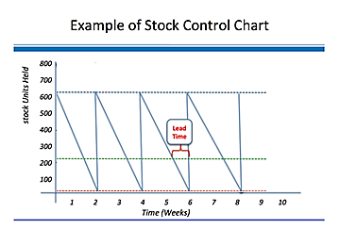

With JIT there is no buffer stock, therefore if stock does not arrive on time the firm will run out of components and production will stop.

This requires a carefully planned scheduling and flow of resources through the production process. Modern manufacturing firms use scheduling software to plan production.

Supplies are delivered right to the production line only when they are needed. For example, a car manufacturing plant might receive exactly the right number and type of tyres for one day’s production, and the supplier would be expected to deliver them to the correct loading bay on the production line within a very narrow time slot.

### The main advantages and disadvantages of JIT can be summarised as follows:

|  |  |
| --- | --- |
| ****Advantages**** | ****Disadvantages**** |
| Lower stock holding means less storage space which saves rent and insurance costs | There is little room for mistakes as minimal stock is kept for re-working faulty product |
| As stock is only obtained when it is needed, less working capital is tied up in stock | Production relies on suppliers, if stock is not delivered on time, the production schedule can be delayed |
| There is less likelihood of stock perishing, becoming obsolete or out of date | There is no spare finished product available to meet unexpected orders, because all product is made to meet actual orders. |
| Avoids the build-up of unsold finished product |  |
| Less time is spent on checking and re-working - the emphasis is on getting it work right first time |  |

# How to manage supply to match demand and the value of doing so

In order to maximise its efficiency, a business will try to achieve full capacity utilisation where possible. This can be done by balancing demand and supply of products. So, where there is spare capacity, the business can try to increase demand etc.

## Managing demand

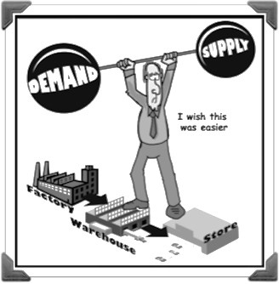A business can improve its marketing mix in an effort to improve demand. For example, a hotel might offer off-peak rates and special deals. However, where there is a capacity shortage (demand is greater than supply) the business can increase the selling price in order to bring demand back down to a manageable level.

## Managing supply

If there is a mismatch between supply and demand, the focus will be on trying to manage supply in order to match demand. The business could invest in new machinery etc. but the downside is that if demand falls again it will result in an increase in spare capacity. To prevent this from happening, the business may:

**Produce to order** means that the business will only begin production once the specific order has been received in advance. This means that there is no need to hold inventory (stock) and it also means that the business is able to plan production schedules ahead of time. However, the downside is that over time, production levels vary and this may place pressure on managers and employees. Also, because no inventory is held, the business will be unable to quickly respond to a sudden surge in demand which could result in lost customers.

**Use of temporary and part time workers** which can be more flexible than employing full time permanent workers. It can be an efficient way of keeping costs down. Part time workers are also able to fit in work alongside other responsibilities outside of work and this may serve to reduce stress. Some employees deliberately seek flexible employment opportunities and offering these contracts can enable the business to retain valued employees. However, such workers may not have commitment to the organisation and may be less loyal than full time permanent employees. It might also lead to a high turnover of staff which can be problematic in a customer facing business.

## Outsourcing

Outsourcing means to transfer activities which were previously carried out inside the business, to a third party outside of the business. For example, a clothing manufacturer in the UK may decide to outsource the manufacture of the clothes to China whilst the Head Office of the company and the design function remains in the UK. A company will outsource activities because it is cost efficient to do so.

On the other hand, **subcontracting** is when a third part takes on a task which the business itself may be unable to do because it does not have the expertise or because it does not have the time. For example, a house builder may subcontract the plastering, electrical and plumbing work to different businesses. Subcontracting may also be suitable if the business is working to full capacity and receives an order it does not want to turn down.

### Advantages of outsourcing

* Businesses are able to react to changes in demand more quickly if they have access to other firms’ production plants.
* Outsourcing providers may be more specialised and therefore more efficient. For example a car manufacturer purchases car tyres from Michelin because it is more efficient than making its own.
* Outsourcing lets a firm focus on activities it is good at.
* A non-standard order can be given to an outsource provider so that the business benefits from the order but suffers no disruption to its normal activities.

### Disadvantages of outsourcing

* The quality of their service is no longer directly under their control. An unreliable outsource provider may ruin the reputation of the company.
* Excessive outsourcing erodes the operations base of the company.
* It can be expensive to outsource because the outsourced business also wants to make a profit.
* Outsourcing may require a firm to give confidential information to the supplier such as details of its methods and patents. This may mean that the firm loses its competitive advantage.

### Factors influencing the decision to outsource

Available capacity – if the business is working below full capacity, there is little incentive to outsource activities.

Expertise – if sufficient skills are lacking in the business for a particular aspect of manufacture, then the business is more likely to outsource.

Quality considerations – if a business sells its product on the basis of high quality, then outsourcing may be a risky strategy. For this reason, some businesses choose **offshoring.** In this situation, the manufacturing of the product is carried out overseas but the business still owns the production facilities. Offshoring allows the company to take advantage of factors such as low labour costs yet still retain control of the production process itself.

Nature of demand – if demand is stable and consistent the business is more likely to complete the tasks in-house rather than outsource. However, if there are surges in demand, the opposite is the case.

Cost – sometimes the business cannot overcome the cost advantage of another business. For this reason, a clothing manufacturer may outsource production overseas to take advantage of low wage rates.

Level of risk – often quality problems can be an issue when a business outsources production and this can have an adverse effect on the reputation of the business.

Impact on profit – companies will expect to make a profit from any work they undertake. Therefore, a decision to outsource or subcontract may result in lower profits because the other business has to make profits too.

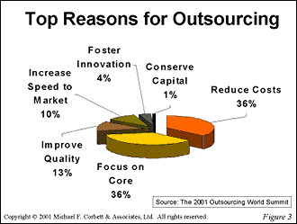

Influences on the choice of suppliers

For a manufacturer, suppliers will mainly provide the raw materials and components needed to produce the finished goods.

For a retailer, suppliers will invariably provide the finished goods that the retailer sells.

## Choosing effective suppliers:

There are several factors to consider when a business chooses their supplier. These are:

**Prices:** If the prices of raw materials etc. are low, the business can either enjoy a good profit margin or pass the savings on to the customer by way of a reduction in the selling price of their product or service. The latter can be useful in a price competitive market. However, the business must ensure that lower prices for raw materials do not undermine the quality of the finished product since lower prices can be charged because the raw materials are of an inferior quality.

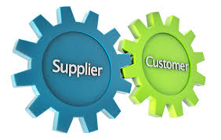**Payment terms:** Many suppliers offer credit to their customers.This means that the supplier will deliver the raw materials to the business but will not expect payment until an agreed period of time has passed. The usual credit period is 28 to 30 days. The credit period offered to a large business from suppliers (such as a supermarket) can be much longer because they order large quantities, using trade credit means that there is a delay in the money leaving the business and this can certainly help in managing cash flow.

**Quality:** Customers expect a certain standard of quality from the product or service they are purchasing from a business and it is up to the business to provide this level of quality consistently to the customer. Clearly, substandard inventory could place the reputation of the business at risk if customer expectations of quality are not met.

**Capacity:** Capacity is the maximum possible output of an organisation. A business needs to ensure that the supplier has sufficient capacity available to deliver the level of inventory required. This can be extremely important if the business requires the supplier to be *flexible* and be in a position to accept and complete orders at short notice.

**Reliability:** This is a vital factor when placing orders with suppliers. An unreliable supplier who fails to deliver on time or who delivers faulty products can result in a damaged reputation for the business. The business should always examine the supplier’s track record for reliability before agreeing to a contact.

# How to manage the supply chain effectively and efficiently and the value of this:

Effective management of the supply chain enables customers to receive greater satisfaction and businesses to achieve their corporate aims and objectives. The **supply chain** is a network of sellers of raw materials, manufacturers who transform those materials into finished products, and wholesalers and retailers who get those products to the final consumer.

**Supply chain management** is the organisation of these activities to create value for the customer and profit for the businesses involved in supplying the products.

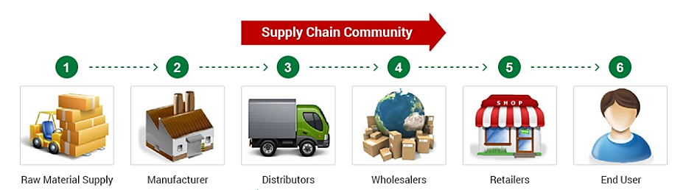

Managing the supply chain effectively entails considering the factors already discussed:

* What the business should produce itself and what it should subcontract or outsource.
* Which suppliers to use and setting out the terms and conditions of contracts placed with suppliers.
* Gaining assurance from suppliers about quality. It is also useful to know how closely suppliers are involved in their own production process. Do they also subcontract work? Do they monitor the conditions under which this work is carried out?
* How closely should the business work with suppliers? Should they check to see that they are abiding by their own code of conduct?

## Effective management of the supply chain will ensure that:

* The right supplies arrive on time.
* A fair price is paid for the items.
* The products are produced in a way which is acceptable to the business and its customers.

Many modern businesses prefer to work with suppliers and in doing so, create a good working relationship. This is especially necessary because many businesses now require flexibility from their suppliers. It is certainly true that businesses may now place a high quantity of *smaller* orders instead of the traditional small quantity of *high volume* orders.

When the supply chain fails the consequences can be on a large scale such as with the horsemeat scandal.

