**The Odyssey - Book 10**

**Read lines 1-27**

List all the ways Aeolus’ existence appears homely and insular:



Add to this diagram and label it:



**Read lines 28-79**

Collect quotes to sum up the portrayal of Odysseus and his crew:

|  |  |
| --- | --- |
| The Crew | Odysseus |
|  |  |
|  |  |
|  |  |

Why does Aeolus refuse *xenia* a second time?

**Read lines 80-133**

How is Telepylus described? Why do you think Homer describes it as thus?

How is Odysseus portrayed in this passage?

**Read lines 134-202**

Create a spider diagram of Circe to show aspects of fantasy in her character. Continue to add to this throughout the story.

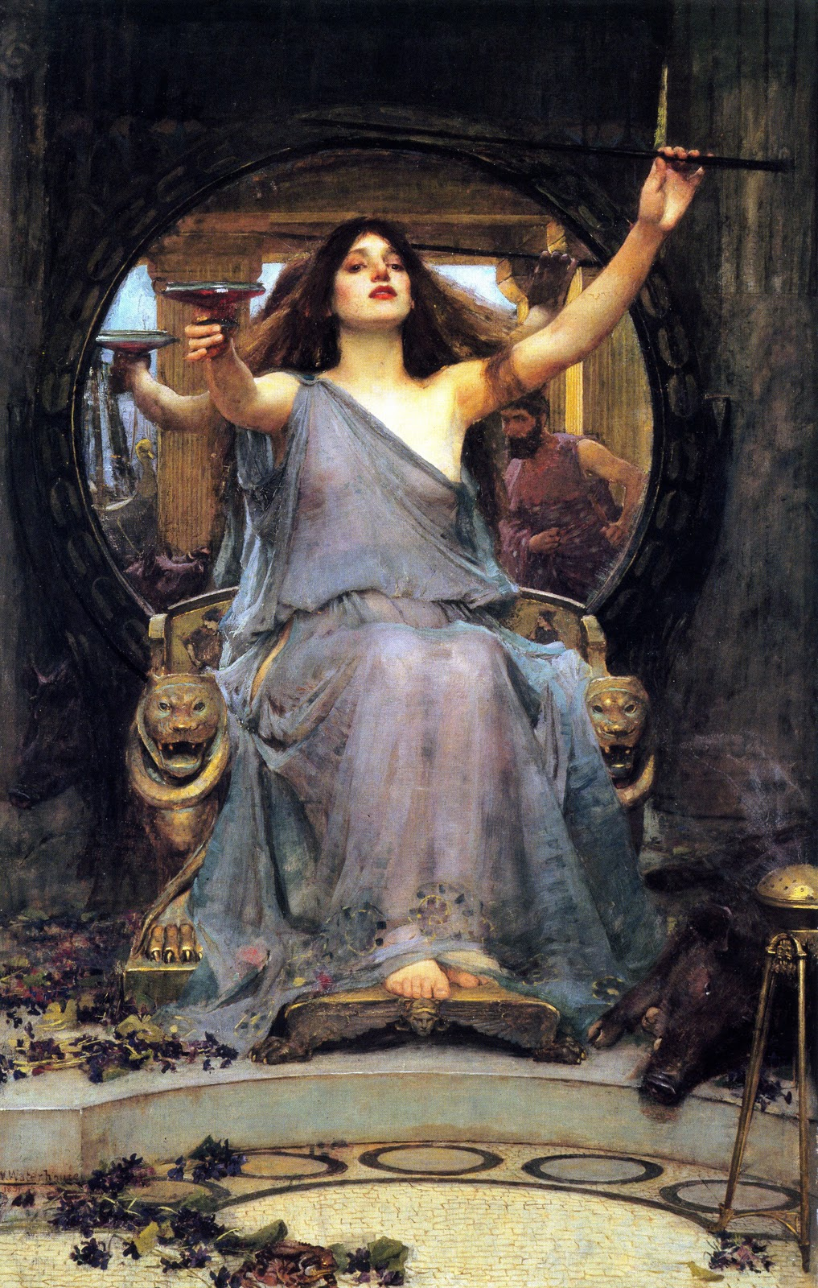

What do we learn about Circe’s house?



How does Odysseus suggest divine help? Why is it only suggested?

**Read lines 203-243**

List all the magical elements we see when first the crew arrive at Circe’s dwelling.

How does Circe turn from an initial gesture of *xenia* to a wicked opponent?

What is the parallel between this episode and that of the Lotus-eaters?

**Read lines 244-306**

How does Homer suggest Eurylochus is an emotional wreck?

Why do you think Odysseus is particularly eager to show his bravery at this point in time?

What is unusual about Odysseus meeting Hermes in this way? Can you think of any explanation for this?

List all the problems with the awkward passage where Hermes instructs Odysseus:

What might this suggest about the origins of this part of the story?

**Read lines 307-375**

How is Circe portrayed as treacherous when she encounters Odysseus?

How does Circe react to Odysseus’ immunity to her potion?

Why do you think the oath taking is seen as a guarantee?

How is homely *xenia* shown in this passage?



What does this *xenia* help downplay about Circe?

**Read lines 376-448**

What further magical elements does Circe demonstrate?

Draw speech and thought bubbles around Odysseus and the crew to show how they feel about one another in this passage:

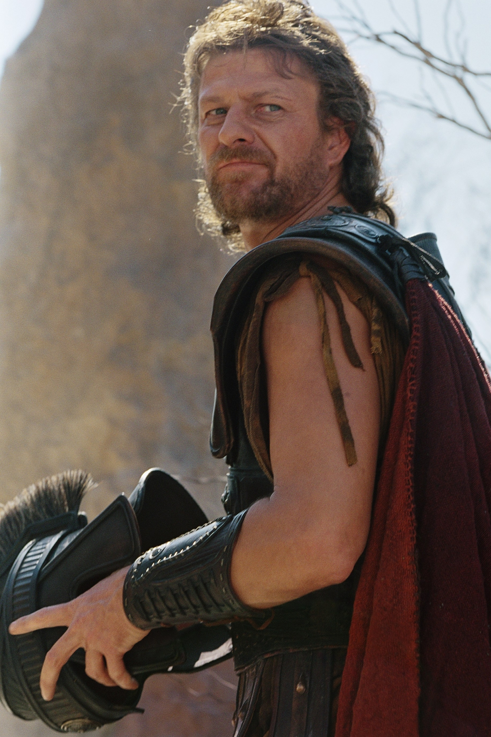

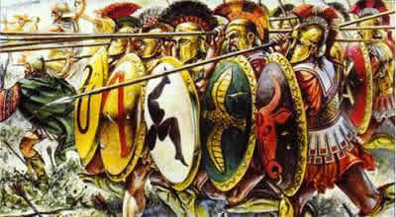

**Read lines 449-573**

What do the crew appeal to that persuades Odysseus to leave Circe?

Complete the flow diagram with details of Circe’s instructions:

What happens to Elpenor before they leave? What small detail about his life seems to suit his death (in Greek thinking)?

It is hard to see any reason for the secrecy of Circe’s last act. What does this tell us about the Odyssey?

**Appendix – Circe and Calypso**

At the start of Book 9, Odysseus draws a direct comparison between these two female characters (9.29-33). It is important to recognise both the differences and similarities between these two (‘how typical…?’ is a common exam style question, which requires comparison).

**Similarities**

Go through Book 10 and compile details about Circe that are similar to Calypso, giving line references:

|  |  |
| --- | --- |
| Calypso | Circe |
| Lives alone in a wooded island. |  |
| Weaves and sings (5.61-63) |  |
| Has strange powers – summons a breeze (5.268) |  |
| Swears an oath to do Odysseus no harm (5.183-190) |  |
| Daughter of Atlas (1.52-53) |  |
| Shows *xenia* throughout. |  |
| Mistrusting sexual relationship (5.151-158) |  |

**Differences**

CALYPSO

CIRCE