

**IGCSE (9 – 1) Revision Pack**

**Interior and Exterior Angles**

**Name --------------------------------**

**Questions**

**Q1.**

Work out the size of each exterior angle of a regular polygon with 15 sides.

........................................................... °

**(Total for Question is 2 marks)**

**Q2.**

Here is a regular 10-sided polygon.

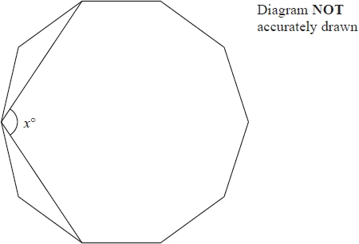

Work out the value of *x*.   
Show your working clearly.

*x* = ...........................................................

**(Total for question = 4 marks)**

**Q3.**

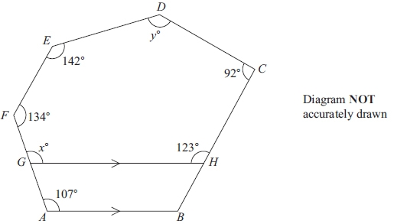

*ABCDEF* is a hexagon.  
*G* is a point on *AF*.  
*H* is a point on *BC*.  
*GH* is parallel to *AB*.

(a) Give a reason why *x* = 107

      ..............................................................................................................................................

**(1)**

(b) Work out the value of *y*.

*y* = ...........................................................

**(4)**

**(Total for question = 6 marks)**

**Q4.**

Each interior angle of a regular polygon is 156°

Work out the number of sides of the polygon.

...........................................................

**(Total for question = 3 marks)**

**Q5.**

Work out the size of an exterior angle of a regular polygon with 8 sides.

...........................................................°

**(Total for question = 2 marks)**

**Q6.**

Find the sum of the interior angles of a polygon with 7 sides.

...........................................................°

**(Total for question = 2 marks)**

**Q7.**

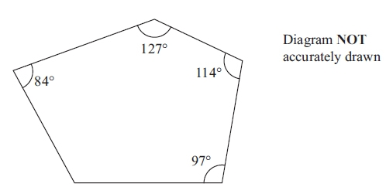

Four of the angles of a pentagon are 97°, 114°, 127° and 84°.

Work out the size of the fifth angle.

............................................................°

**(Total for question = 4 marks)**

**Q8.**

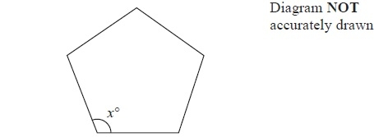

The diagram shows a regular 5-sided polygon.

(a)  Work out the value of *x*.

*x* = ...........................................................

**(2)**

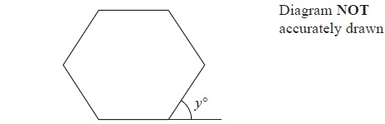

The diagram shows a regular 6-sided polygon.

(b)  Work out the value of *y*.

*y* = ...........................................................

**(2)**

**(Total for Question is 4 marks)**

**Q9.**

The diagram shows two triangles, *CDB* and *BDA*.

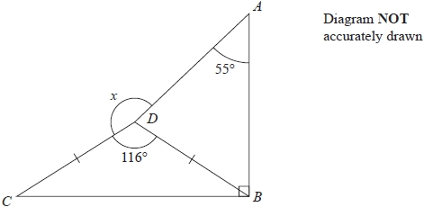

*DC* = *DB*  
Angle *ABC* = 90°   
Angle *CDB* = 116°   
Angle *DAB* = 55°

Work out the size of the angle marked *x*.   
Give a reason for each stage of your working.

........................................................... °

**(Total for question = 5 marks)**

**Q10.**

A regular polygon has *n* sides.   
The size of each interior angle of the regular polygon is 140°

Work out the value of *n*.

*n* = ...........................................................

**(Total for question = 3 marks)**

**Q11.**

Each exterior angle of a regular polygon is 24°

Work out the number of sides of the polygon.

...........................................................

**(Total for question = 2 marks)**

**Q12.**

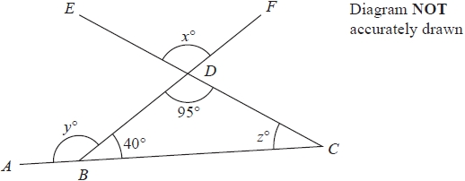

*ABC*, *CDE* and *BDF* are straight lines.

(a)  Write down the value of *x*.

*x* = ...........................................................

**(1)**

(b)  (i)  Find the value of *y*.

*y* = ...........................................................

(ii)  Give a reason for your answer.

.............................................................................................................................................

.............................................................................................................................................

**(2)**

(c)  Find the value of *z*.

*z* = ...........................................................

**(2)**

**(Total for question = 5 marks)**

**Q13.**

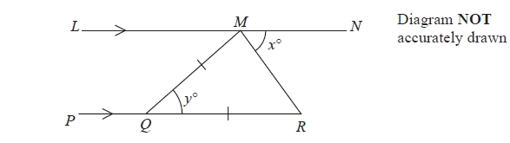

*LMN* is parallel to *PQR*.   
*QM* = *QR*.   
 Angle *RMN* = *x*°   
 Angle *MQR* = *y*°

(a)  Write down an expression for *y* in terms of *x*.

*y* = ...........................................................

**(2)**

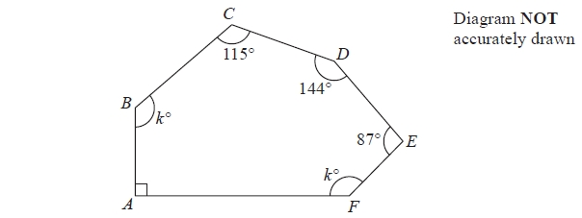

*ABCDEF* is a hexagon.

(b)  Work out the value of *k*.

*k* = ...........................................................

**(4)**

**(Total for question = 6 marks)**

**Q14.**

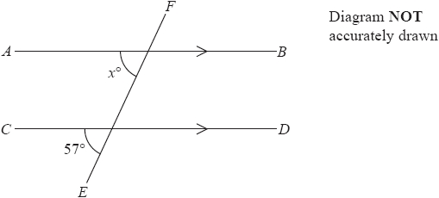

*AB* is parallel to *CD*  
*EF* is a straight line.

(a)  (i)  Find the value of *x*

*x* = ...........................................................

(ii)  Give a reason for your answer.

.............................................................................................................................................

.............................................................................................................................................

**(2)**

Here is a pentagon.

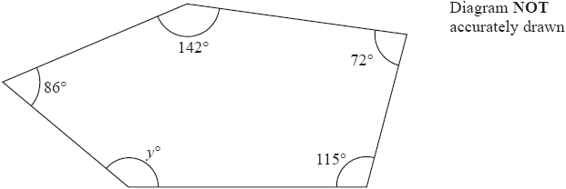

(b)  Work out the value of *y*.

*y* = ...........................................................

**(3)**

**(Total for question = 5 marks)**

**Q15.**

Each interior angle of a regular polygon is 156°

Work out the number of sides of the polygon.

...........................................................

**(Total for question = 3 marks)**

**Q16.**

Work out the size of an exterior angle of a regular polygon with 8 sides.

........................................................... °

**(Total for question = 2 marks)**

**Q17.**

The size of each interior angle of a regular polygon with *n* sides is 140°

Work out the size of each interior angle of a regular polygon with 2*n* sides.

........................................................... °

**(Total for question = 5 marks)**

**Q18.**

(a)  Find the sum of the interior angles of a polygon with 7 sides.

........................................................... °

**(2)**

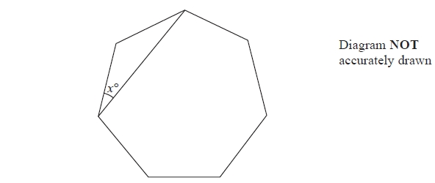

The diagram shows a regular polygon with 7 sides.

(b)  Work out the value of *x*.   
       Give your answer correct to 1 decimal place.

...........................................................

**(2)**

**(Total for question = 4 marks)**

**Q19.**

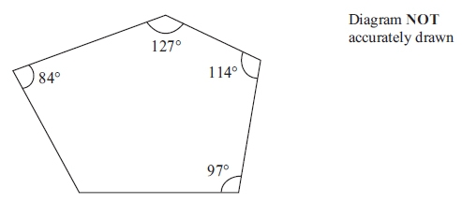

Four of the angles of a pentagon are 97°, 114°, 127° and 84°.

Work out the size of the fifth angle.

...........................................................°

**(2)**

**(Total for question = 4 marks)**

**Q20.**



The diagram shows part of a regular polygon.   
The interior angle and the exterior angle at a vertex are marked.   
The size of the interior angle is 7 times the size of the exterior angle.

Work out the number of sides of the polygon.

...........................................................

**(Total for Question is 3 marks)**

**Q21.**

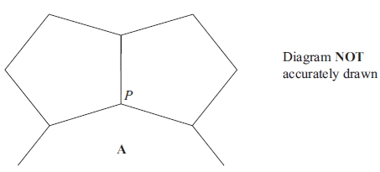

The diagram shows two congruent regular pentagons and part of a regular *n*-sided  
 polygon **A**.  
 Two sides of each of the regular pentagons and two sides of **A** meet at the point *P*.

Calculate the value of *n*.  
 Show your working clearly.

*n* = ...........................................................

**(Total for question = 5 marks)**

**Q22.**

The diagram shows an incomplete regular polygon.

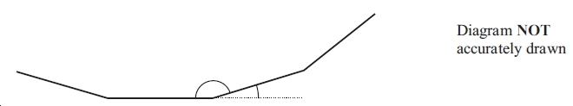

The size of each interior angle is 140 degrees greater than the size of each exterior angle.

Work out the number of sides the regular polygon has.

...............................

**(Total for question = 4 marks)**

**Q23.**

*ABCDE* is a regular pentagon with sides of length 10 cm.

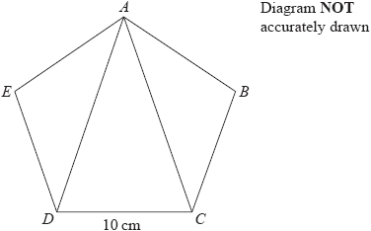

Calculate the area of triangle *ACD*.   
Give your answer correct to 3 significant figures.

........................................................... cm2

**(Total for question = 6 marks)**

**Q24.**

The diagram shows two congruent regular pentagons drawn inside a regular octagon.

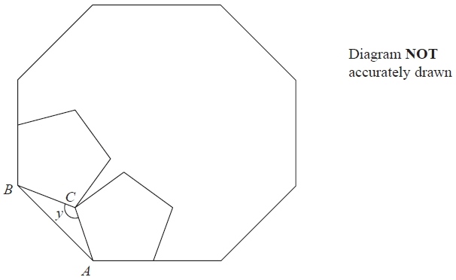

One side of each pentagon lies along a side of the octagon.

*AB* is a side of the octagon.   
*AC* is a side of one of the pentagons.   
*BC* is a side of the other pentagon.

Work out the size of angle *y*.   
Show your working clearly.

........................................................... °

**(Total for question = 5 marks)**

**Q25.**

Each exterior angle of a regular polygon is 15°

(a)  How many sides has the regular polygon?

...........................................................

**(2)**

The diagram shows 3 identical regular pentagons.

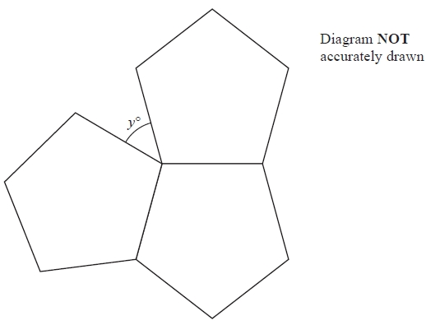

(b)  Work out the value of *y*.

*y* = ...........................................................

**(3)**

**(Total for question = 5 marks)**

**Q26.**

Each exterior angle of a regular polygon is 18°

Work out the number of sides of this regular polygon.

...........................................................

**(Total for question = 2 marks)**

**Q27.**

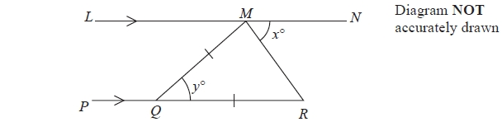

*LMN* is parallel to *PQR*.   
*QM* = *QR*.   
Angle *RMN* = *x*°   
Angle *MQR* = *y*°

(a)  Write down an expression for *y* in terms of *x*.

*y* = ...........................................................

**(2)**

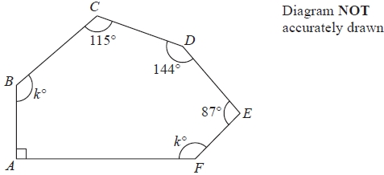

*ABCDEF* is a hexagon.

(b)  Work out the value of *k*.

*k* = ...........................................................

**(4)**

**(Total for question = 6 marks)**

**Mark Scheme**

Q1.

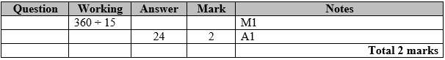

**Q2.**

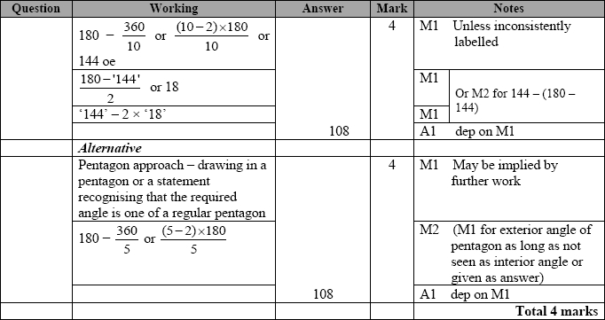

**Q3.**

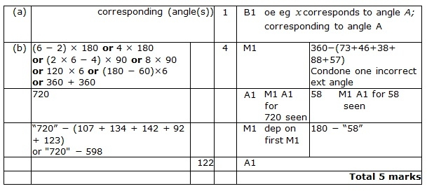

**Q4.**

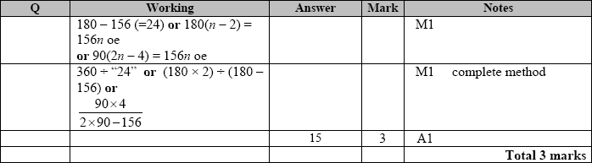

**Q5.**

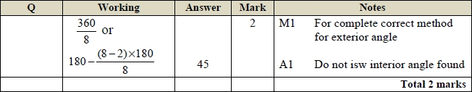

**Q6.**

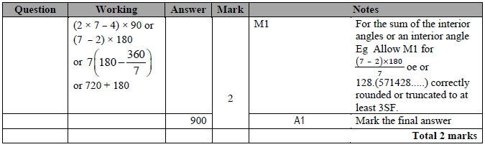

**Q7.**

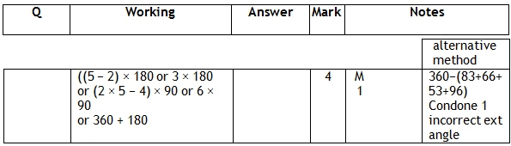

**Q8.**

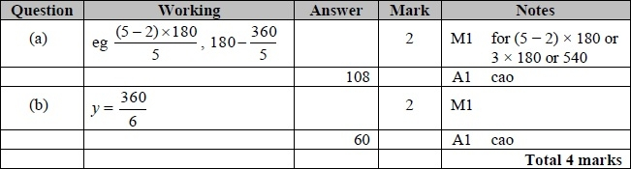

**Q9.**

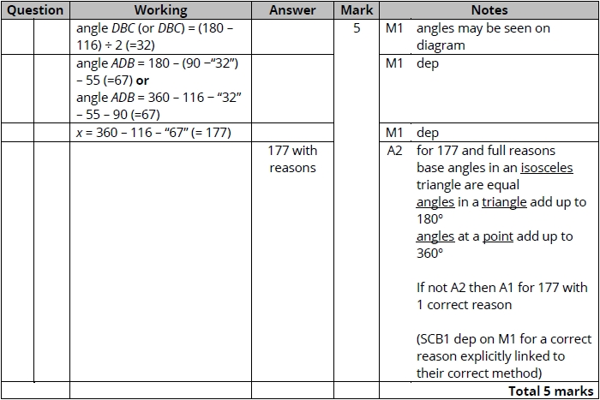

**Q10.**

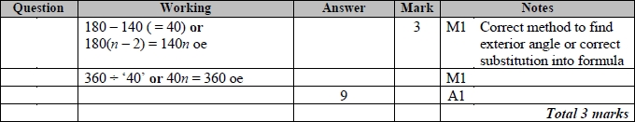

**Q11.**

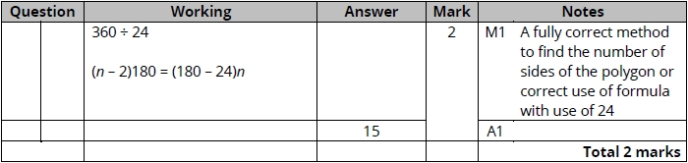

**Q12.**

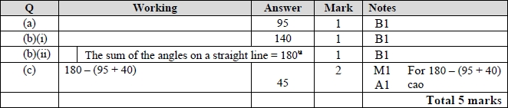

**Q13.**

Apart from question 18c where the mark scheme states otherwise, the correct answer, unless clearly obtained by an incorrect method, should be taken to imply a correct method.

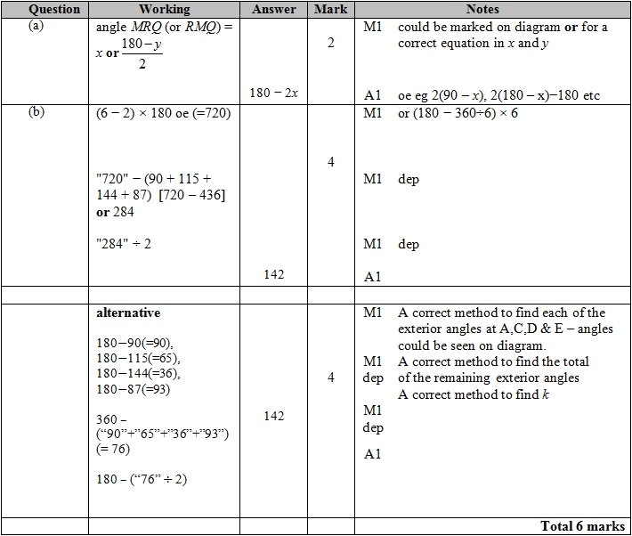

**Q14.**

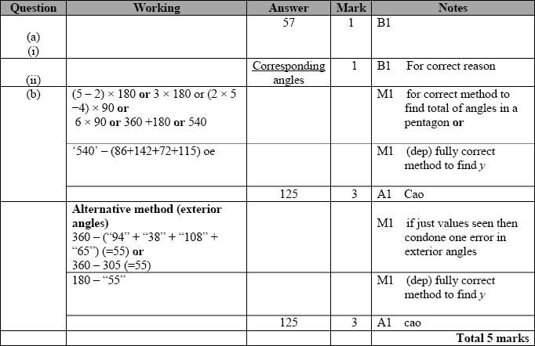

**Q15.**

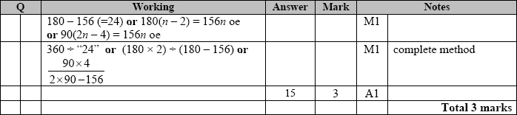

**Q16.**

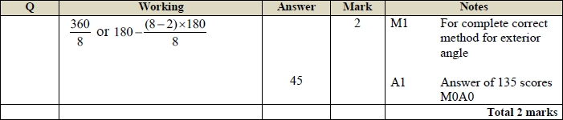

**Q17.**

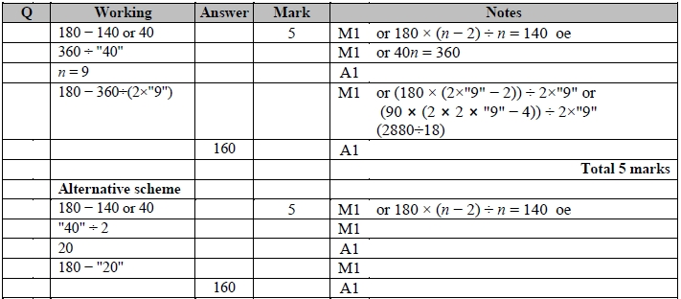

**Q18.**

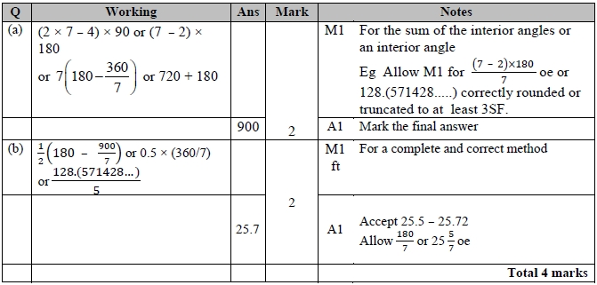

**Q19.**

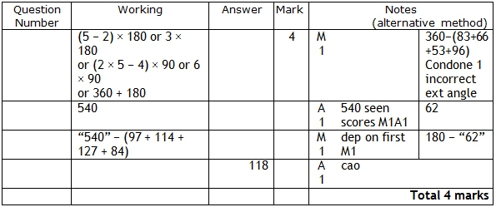

**Q20.**

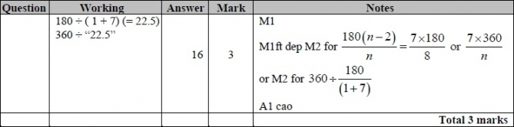

**Q21.**

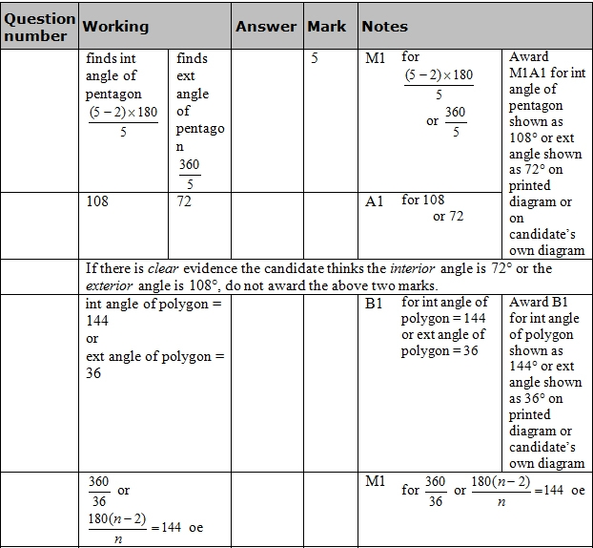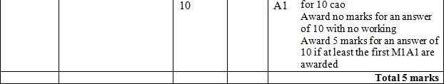

**Q22.**

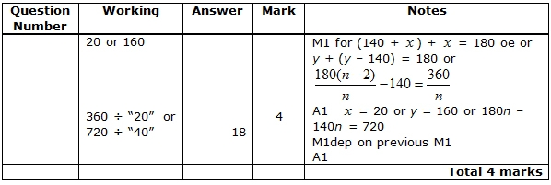

**Q23.**

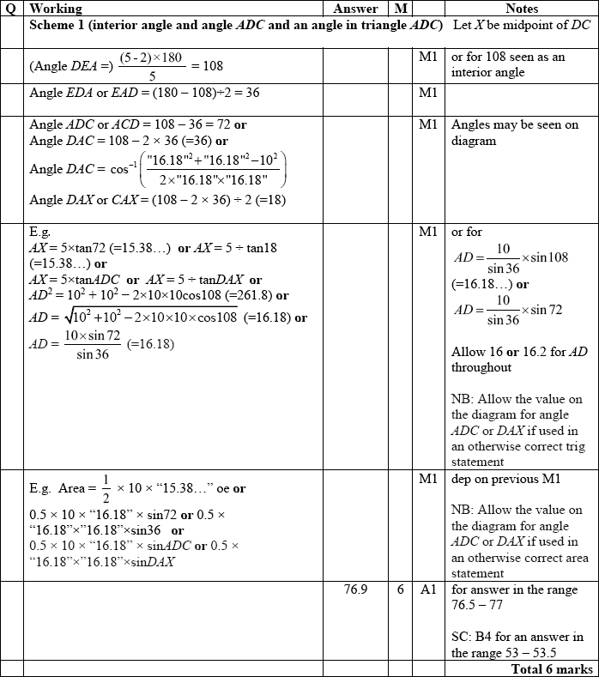

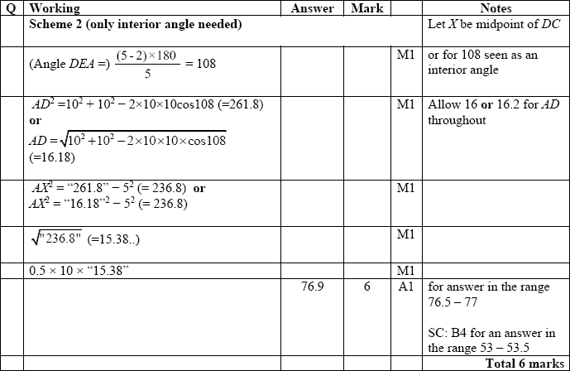

**Q24.**

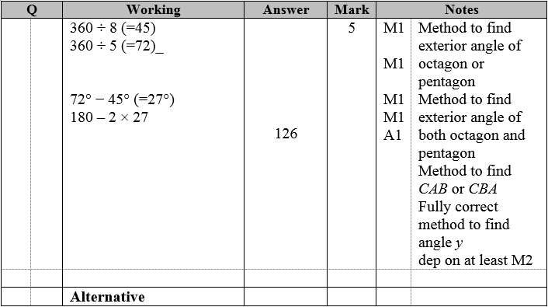

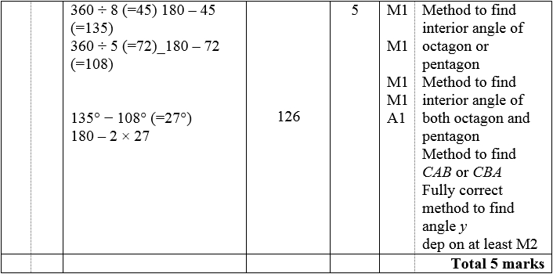

**Q25.**

The correct answer, unless clearly obtained by an incorrect method, should be taken to imply a correct method.

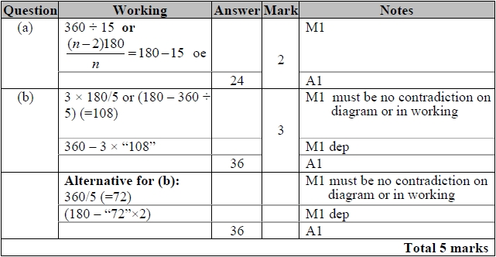

**Q26.**

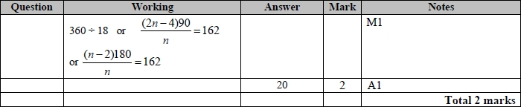

**Q27.**

The correct answer, unless clearly obtained by an incorrect method, should be taken to imply a correct method.

