

**Higher IGCSE (9 – 1) Revision Pack**

**Percentages**

**(60 Questions)**

**Name --------------------------------**

**Questions**

**Q1.**

A bank pays compound interest of 6% per annum on its savings accounts.   
Julia invests $7500 for 3 years.

Calculate the total interest gained after 3 years.

$ ...........................................................

**(Total for question is 3 marks)**

**Q2.**

Liam invests £8000 in a savings account for 4 years.   
The savings account pays compound interest at a rate of

4.5% for the first year   
2.75% for all subsequent years.

(a)  Work out the value of Liam's investment at the end of 4 years.

£...........................................................

**(3)**

Max invests some money in a savings bond.   
The savings bond pays interest at a rate of 2% per year.

At the end of the first year, his savings bond is worth £5763

(b)  How much money did Max invest in the savings bond?

£...........................................................

**(3)**

**(Total for question = 6 marks)**

**Q3.**

Lisa sees a dress in a sale.   
The normal price of the dress is $45   
The price of the dress is reduced by 12% in the sale.

(a)  Work out the price of the dress in the sale.

$ ...........................................................

**(3)**

Lisa's weekly pay increases from $525 to $546

(b)  Calculate her percentage pay increase.

........................................................... %

**(3)**

**(Total for question = 6 marks)**

**Q4.**

Kwo invests HK$40 000 for 3 years at 2% per year compound interest.   
Work out the value of the investment at the end of 3 years.

HK$ ...........................................................

**(Total for question = 3 marks)**

**Q5.**

Amit invests 15000 rupees.

At the end of one year, his investment has increased by

(a)  Work out the value of Amit's investment at the end of one year.

........................................................... rupees

**(2)**

Priya invests a sum of money at an interest rate of 8% per year.   
At the end of one year, the interest she receives is 1800 rupees.

(b)  Work out the value of Priya's investment at the end of one year.

........................................................... rupees

**(3)**

**(Total for question = 5 marks)**

**Q6.**

Jomo invested an amount of money at 4% per annum **compound interest**.  
 At the end of 2 years, the value of his investment was £3380

How much of the £3380 was interest?

£...........................................................

**(Total for question = 4 marks)**

**Q7.**

In 1981, the population of India was 683 million.   
Between 1981 and 1991, the population of India increased by 163 million.

(a)  Express 163 million as a percentage of 683 million.

Give your answer correct to 3 significant figures.

........................................................... %

**(2)**

In 2001, the population of India was 1028 million.   
Between 2001 and 2011, the population of India increased by 17.6%

(b)  Increase 1028 million by 17.6%

Give your answer to the nearest million.

........................................................... million

**(3)**

In 2001, the population of India was 1028 million.   
Between 1971 and 2001, the population of India increased by 87.6%

(c)  Work out the population of India in 1971.

Give your answer correct to the nearest million.

........................................................... million

**(3)**

**(Total for question = 8 marks)**

**Q8.**

In January 2007 the population of Canada was 32 million.   
7 million of these Canadian people spoke French as their first language.

(a) Express 7 million as a percentage of 32 million.   
Give your answer correct to 1 decimal place.

........................................................... %

**(2)**

Between January 2007 and January 2009 the population of Canada increased by 4%.

(b) Increase 32 million by 4%.   
Give your answer correct to the nearest million.

........................................................... million

**(3)**

**(Total for question is 5 marks)**

**Q9.**

The table shows information about the numbers of fish caught by 40 people in one day.

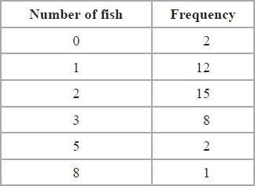

(a)  Work out the mean number of fish caught.

...........................................................

**(3)**

(b)  Work out what percentage of the 40 people caught less than 2 fish.

........................................................... %

**(2)**

**(Total for question = 5 marks)**

**Q10.**

The table gives some information about the average price of a litre of petrol in England.

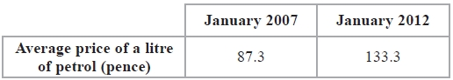

(a)   Work out the percentage increase in the average price of a litre of petrol in England between January 2007 and January 2012.   
Give your answer correct to 3 significant figures.

........................................................... %

**(3)**

The average price of a litre of petrol in England increased by 20% from January 2010 to January 2012.

(b)   Work out the average price of a litre of petrol in England in January 2010.   
Give your answer in pence, correct to 1 decimal place.

........................................................... pence

**(3)**

**(Total for Question is 6 marks)**

**Q11.**

On 9th May, 2009, there were 3440 people in the world with swine flu.  
 Of these people, 1639 were in the USA.

(a) Express 1639 as a percentage of 3440   
Give your answer correct to 1 decimal place.

........................................................... %

**(2)**

The 3440 people who had swine flu on 9th May was an increase of 37.6% on  
 the number of people who had swine flu on 8th May.

(b) Calculate the number of people who had swine flu on 8th May.

...........................................................

**(3)**

**(Total for question = 5 marks)**

**Q12.**

Joseph travels to work each day by train.  
 The weekly cost of his train journey is £45  
 Joseph's weekly pay is £625

(a) Work out 45 as a percentage of 625

...........................................................%

**(2)**

(b) The weekly cost of his train journey increases by 8%.

Increase £45 by 8%.

£...........................................................

**(3)**

(c) Joseph's weekly pay increases to £640

Calculate the percentage increase from 625 to 640

...........................................................%

**(3)**

(d) Joseph decides to cycle to work.   
He cycles 18 km to work.  
His journey to work takes 1 hour 20 minutes.

Calculate his average speed in kilometres per hour.

...........................................................km/h

**(3)**  
**(Total for question = 11 marks)**

**Q13.**

The table shows information about the time, in minutes, spent on homework by each of  
 32 pupils in one night.

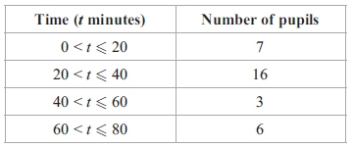

(a) Calculate the percentage of the 32 pupils who spent more than 60 minutes on their   
homework.

...........................................................%

**(2)**

(b) Calculate an estimate for the total time spent on homework by the 32 pupils.

...........................................................minutes

**(3)**

**(Total for question = 5 marks)**

**Q14.**

An airline increases the prices of its flights by 8%.

(a) Before the increase, the price of a flight to Cairo was £475

Work out the price of a flight to Cairo after the increase.

£...........................................................

**(3)**

(b) The increase in price of a flight to Mumbai was £48

Work out the price of a flight to Mumbai after the increase.

£...........................................................

**(3)**

**(Total for question = 6 marks)**

**Q15.**

(a)  Dilip buys a painting for $ 675   
Later, he sells it and makes a percentage profit of 12%.

Work out the price for which Dilip sells the painting.

$ ...........................................................

**(3)**

(b)  Renuka sells her car.   
She makes a loss of $ 2162   
Her percentage loss is 23%.

Work out the price for which Renuka sells her car.

$ ...........................................................

**(3)**

(c)  Lin bought a computer that had a value of $ 1500   
At the end of each year, the value of her computer had depreciated by 40% of its   
value at the start of that year.

Calculate the value of her computer at the end of 3 years.

$ ...........................................................

**(3)**

**(Total for Question is 9 marks)**

**Q16.**

In a sale, all normal prices are reduced by 15%.

(a)   The normal price of a washing machine is 270 dollars.   
Work out the sale price of the washing machine.

........................................................... dollars

**(3)**

(b)   The normal price of a food processor is reduced by 13.50 dollars.   
Work out the normal price of the food processor.

........................................................... dollars

**(3)**

**(Total for Question is 6 marks)**

**Q17.**

On Monday, Nalim made a journey.  
 On Tuesday, she made the same journey.  
 Her average speed on Tuesday was 25% greater than her average speed on Monday.

Calculate the percentage reduction in the time her journey took on Tuesday compared  
 with Monday.

...........................................................%

**(Total for question = 3 marks)**

**Q18.**

In a sale, normal prices are reduced by 15%.  
 The normal price of a television was $640

Work out the sale price of the television.

$...........................................................

**(Total for question = 3 marks)**

**Q19.**

The population of India increased by 20% between 1989 and 1999.  
 The population of India increased by a further 17% between 1999 and 2009.

Calculate the percentage by which the population of India increased between 1989  
 and 2009.

........................................................... %

**(Total for question = 3 marks)**

**Q20.**

Nigel bought 12 boxes of melons.   
He paid $15 for each box.   
There were 12 melons in each box.

Nigel sold of the melons for $1.60 each.

He sold all the other melons at a reduced price.

He made an overall profit of 15%

Work out how much Nigel sold each reduced price melon for.

$ ...........................................................

**(Total for question = 5 marks)**

**Q21.**

Bhavin, Max and Imran share 6000 rupees in the ratios 2 : 3 : 7

Imran then gives of his share of the money to Bhavin.

What percentage of the 6000 rupees does Bhavin now have?   
Give your answer correct to the nearest whole number.

........................................................... %

**(Total for question = 5 marks)**

**Q22.**

Kim bought 12 boxes of drinks.   
He paid $15 for each box.   
There were 12 drinks in each box.

Kim sold 3⁄4 of the drinks for $1.50 each.

He sold all of the other drinks at a reduced price.

He made an overall profit of 15%.

Work out how much Kim sold each reduced price drink for.

$ ...........................................................

**(Total for Question is 5 marks)**

**Q23.**

A clothes shop has a sale.

In the sale, normal prices are reduced by 12%   
The normal price of a shirt is £30

(a)  Work out the sale price of the shirt.

£ ...........................................................

**(3)**

The price of a coat is reduced by £9 in the sale.

(b)  Work out the normal price of the coat.

£ ...........................................................

**(3)**

**(Total for question = 6 marks)**

**Q24.**

In a sale, all normal prices are reduced by 15%   
The normal price of a mixer is reduced by 22.50 dollars.

Work out the normal price of the mixer.

........................................................... dollars

**(Total for question = 3 marks)**

**Q25.**

On 1st May 2012, the cost of 5.7 grams of gold was 15 960 rupees.

(a)  Work out the cost, in rupees, of 4.6 grams of gold on the same day.

........................................................... rupees

**(2)**

The cost of gold decreased by 7.5% from 1st May 2012 to 1st May 2013

(b)  Work out the cost, in rupees, of 5.7 grams of gold on 1st May 2013

........................................................... rupees

**(3)**

**(Total for question = 5 marks)**

**Q26.**

Kwo invests HK$ 40000 for 3 years at 2.5% per year compound interest.   
Work out the value of the investment at the end of 3 years.

HK$...........................................................

**(Total for question = 3 marks)**

**Q27.**

The value of a boat depreciates by 16% each year.   
At the end of 2012, the value of the boat is £65000

Work out the value of the boat at the end of 2015

£ ...........................................................

**(Total for question = 3 marks)**

**Q28.**

In a sale, normal prices are reduced by 8%

(a)  The normal price of a jacket is £28

Work out the price of the jacket in the sale.

£ ...........................................................

**(3)**

(b)  In the sale, the price of a shirt decreases by £3

Work out the normal price of the shirt.

£ ...........................................................

**(3)**

**(Total for question = 6 marks)**

**Q29.**

In a sale, all normal prices are reduced by 20%

(a)  The normal price of a television set is 485 euros.

Work out the sale price of the television set.

........................................................... euros

**(3)**

(b)  In the sale, the normal price of a tablet computer is reduced by 79 euros.

Work out the normal price of the tablet computer.

........................................................... euros

**(3)**

**(Total for question = 6 marks)**

**Q30.**

(a)   Helen's savings increased from £155 to £167.40

Work out the percentage increase in Helen's savings.

........................................................... %

**(3)**

(b)   Joe's savings increased by 4.5%.   
His savings are now £125.40

What were his savings before the increase?

£ = ...........................................................

**(3)**

**(Total for Question is 6 marks)**

**Q31.**

Eloy's height was 125 cm when his age was 7 years.   
His height was 153 cm when his age was 12 years.

(a)  Work out the percentage increase in Eloy’s height between the ages of 7 and 12 years.

...........................................................%

**(3)**

Eloy's height at the age of 12 years was 85% of his height at the age of 20 years.

(b)  Work out Eloy's height when his age was 20 years.

........................................................... cm

**(3)**

**(Total for question = 6 marks)**

**Q32.**

A shop, *Furniture 4U*, had a sale.

(a) In the sale, normal prices were reduced by 15%.

(i) The normal price of a table was $280

Work out the sale price of the table.

$...........................................................

(ii) The normal price of a chair was reduced in the sale by $24

Work out the normal price of the chair.

$...........................................................

**(6)**

(b) Ruth, Suha and Yasmin went to the sale.   
The amounts of money spent by Ruth, Suha and Yasmin were in the ratios 2 : 3 : 7  
Ruth and Suha spent a total of $320 in the sale.

Work out the amount of money Yasmin spent in the sale.

$...........................................................

**(3)**  
**(Total for question = 9 marks)**

**Q33.**

Ying eats some yoghurt. 

The yoghurt contains 192 mg of calcium.   
This is 16% of the total amount of calcium that Ying should have each day.

Work out the total amount of calcium that Ying should have each day.

........................................................... mg

**(Total for question = 3 marks)**

**Q34.**

There were 2.1 million people living in Dubai in 2013   
1.75 million of these people were not born in Dubai.

(a)  Work out 1.75 as a percentage of 2.1

Give your answer correct to 1 decimal place.

........................................................... %

**(2)**

The unit of currency in Dubai is the dirham.   
The exchange rate is £1 = 5.52 dirham.

The cost of a pair of running shoes in Dubai is 343 dirham.   
The cost of an identical pair of running shoes in the UK is £54.99

The pair of running shoes is more expensive in Dubai than in the UK.

(b)  How much more expensive?

Give your answer to the nearest dirham.

........................................................... dirham

**(3)**

A plane flies a distance of 5522 km from London to Abu Dhabi in 7 hours 24 minutes.

(c)  Work out the average speed of the plane.

Give your answer in kilometres per hour, correct to 3 significant figures.

........................................................... kilometres per hour

**(3)**

**(Total for question = 8 marks)**

**Q35.**

* The diagram shows the floor plan of Mary's conservatory.

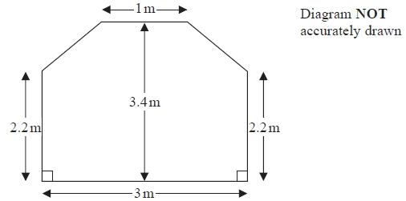

Mary is going to cover the floor with tiles.

The tiles are sold in packs.   
One pack of tiles will cover 2m2  
A pack of tiles normally costs £24.80   
Mary gets a discount of 25% off the cost of the tiles.

Mary has £100

Does Mary have enough money to buy all the tiles she needs?   
You must show all your working.

**(Total for question = 5 marks)**

**Q36.**

Lydia is buying a ring.  
The ring costs £60   
She pays a deposit of 40%.  
Work out how much she pays as the deposit.

£. . . . . . . . . . . . . . . . . . . . . .

**(Total for Question is 2 marks)**

**Q37.**

Bill's weight decreases from 64.8 kg to 59.3 kg.

Calculate the percentage decrease in Bill's weight.  
 Give your answer correct to 3 significant figures.

       ..............................................................................................................................................

**(Total for Question is 3 marks)**

**Q38.**

A ticket to a theme park costs £35 plus 20% VAT.

Work out the total cost of the ticket.

       ..............................................................................................................................................

**(Total for Question is 3 marks)**

**Q39.**

Kristen buys a laptop.

She gets a discount of 20% off the normal price.   
Kristen pays £480 for the laptop.

Work out the discount. Give your answer in pounds.

£ ...........................................................

**(Total for question = 3 marks)**

**Q40.**

*  During a 10 year period, the number of people living in Sherbury increased by 5% to 20 265

In the same period, the number of people living in Yaston increased by 7.5% to 13 502

Compare the increase in the number of people living in Sherbury with the increase in the number of people living in Yaston during this 10 year period.

**(Total for question = 3 marks)**

**Q41.**

The population of a city increased by 5.2% for the year 2014

At the beginning of 2015 the population of the city was 1560 000

Lin assumes that the population will continue to increase at a constant rate of 5.2% each year.

(a)  Use Lin's assumption to estimate the population of the city at the beginning of 2017   
      Give your answer correct to 3 significant figures.

...........................................................

**(3)**

(b)  (i)  Use Lin's assumption to work out the year in which the population of the city will   
            reach 2 000 000

...........................................................

(ii)  If Lin's assumption about the rate of increase of the population is too low,   
      how might this affect your answer to (b)(i)?

.............................................................................................................................................

.............................................................................................................................................

.............................................................................................................................................

**(3)**

**(Total for question = 6 marks)**

**Q42.**

Sally has £520   
Katie has £360

Sally and Katie are each going to give 15% of their money to charity.

Work out the total amount of money they give to charity.

£ ...........................................................

**(Total for question = 3 marks)**

**Q43.**

Claire is making a loaf of bread.   
A loaf of bread loses 12% of its weight when it is baked.

Claire wants the baked loaf of bread to weigh 1.1 kg.

Work out the weight of the loaf of bread before it is baked.

........................................................... kg

**(Total for question = 3 marks)**

**Q44.**

Sasha takes a music exam.

The table shows the result that Sasha can get for different percentages in her music exam.

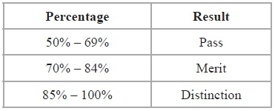

Sasha gets 62 out of 80 in her music exam.

What result does Sasha get?

You must show your working.

...........................................................  
**(Total for Question is 3 marks)**

**Q45.**

In a sale normal prices are reduced by 20%.

A washing machine has a sale price of £464

By how much money is the normal price of the washing machine reduced?

£ ...........................................................   
**(Total for Question is 3 marks)**

**Q46.**

Ibrar bought a house for £145 000

The value of the house depreciated by 4% in the first year.   
The value of the house depreciated by 2.5% in the second year.

Ibrar says,

"4 + 2.5 = 6.5 so in two years the value of my house depreciated by 6.5%"

(a)  Is Ibrar right?   
      You must give a reason for your answer.

.............................................................................................................................................

.............................................................................................................................................

**(2)**

The value of Ibrar's house increases by *x*% in the third year.   
At the end of the third year the value of Ibrar's house is £140 000

(b)  Work out the value of *x*.   
       Give your answer correct to 3 significant figures.

...........................................................

**(3)**

**(Total for question = 5 marks)**

**Q47.**

In a shop, all normal prices are reduced by 20% to give the sale price.

The sale price of a TV set is then reduced by 30%.

Mary says,

"30 + 20 = 50, so this means that the normal price of the TV set has been reduced by 50%."

Is Mary right?   
You must give a reason for your answer.

.............................................................................................................................................

.............................................................................................................................................

.............................................................................................................................................

**(Total for question = 2 marks)**

**Q48.**

Bella invests £5000 in an account for two years.   
The account pays 3% compound interest per annum.

Bella has to pay 20% tax on the interest earned each year.   
This tax is taken from the account at the end of each year.

How much money will Bella have in her account at the end of the two years?

**(Total for question = 4 marks)**

**Q49.**

Katie invests £200 in a savings account for 2 years.

The account pays compound interest at an annual rate of

3.3% for the first year

1.5% for the second year

(a) Work out the total amount of money in Katie's account at the end of 2 years.

£...........................................................

**(3)**

Katie travels to work by train.   
The cost of her weekly train ticket increases by 12.5% to £225

Katie's weekly pay increases by 5% to £535.50

*(b) Compare the increase in the amount of money Katie has to pay for her weekly train ticket with the increase in her weekly pay.

**(3)**

**(Total for Question is 6 marks)**

**Q50.**

*  The Kumar family are going to go to New York.

They will go with Highway Airlines or Jetstream Airlines.

The tables show how much it costs for each adult and each child to go with these airlines.

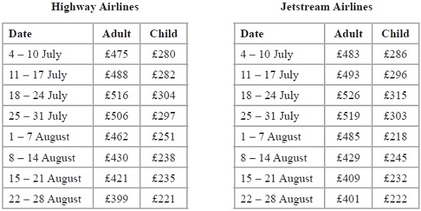

Highway Airlines give a discount of 5% of the total cost for booking online.

Jetstream Airlines give a discount of £25 per person for booking online.

The Kumar family are going to New York on 3 August.

They will buy 2 adult tickets and 1 child ticket.

They will book online.

The Kumar family want to pay the lower total cost.

Which airline should they choose?

**(Total for Question is 5 marks)**

**Q51.**

Danny bought a car for £10 000

The value of the car depreciated by 20% in the first year.  
Then the value of the car depreciated by 10% in the second year.

Work out the value of Danny's car at the end of two years.

£ . . . . . . . . . . . . . . . . . .

**(Total for Question is 3 marks)**

**Q52.**

Here is a diagram showing a rectangle, *ABCD*, and a circle.

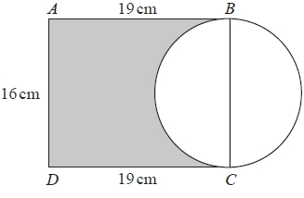

*BC* is a diameter of the circle.

Calculate the percentage of the area of the rectangle that is shaded.   
Give your answer correct to 1 decimal place.

........................................................... %

**(Total for question is 4 marks)**

**Q53.**

*  Peter has £20 000 to invest in a savings account for 2 years.

He finds information about two savings accounts.

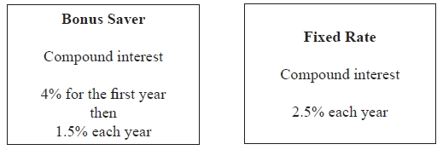

Peter wants to have as much money as possible in his savings account at the end of 2 years.

Which of these savings accounts should he choose?

**(Total for question = 4 marks)**

**Q54.**

Danielle invested £2800 for *n* years in a savings account.

She was paid 2.5% per annum compound interest.   
The interest is paid into the account at the end of each year.

At the end of *n* years, the amount of money in the savings account is greater than £3000 for the first time.

Work out the value of *n*.

...........................................................

**(Total for question = 2 marks)**

**Q55.**

* Ella wants to invest £6000 in a savings account for 2 years.

   She finds information about savings accounts at two different banks.

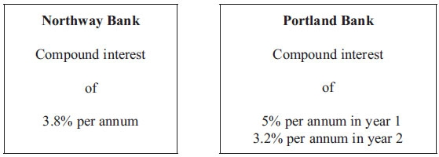

Ella wants to choose the bank that pays the greater total amount of interest for the 2 years.

Which bank should she choose?  
 You must show all your working.

**(Total for Question is 4 marks)**

**Q56.**

The value of a van depreciates at the rate of 20% per year.   
Gary buys a new van for £27 500   
After *n* years the value of the van is £11 264

Find the value of *n*.

..........................

**(Total for Question is 2 marks)**

**Q57.**

*  This notice was in a car magazine.

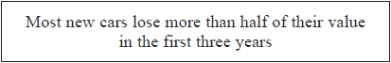

Paul bought a new car. The value of the car was £15 000

In the first year, the value of the car depreciated by 23%.   
After the first year, the value of the car depreciated by 18% each year.

Work out if Paul's car lost more than half of its value by the end of three years.

**(Total for question = 4 marks)**

**Q58.**

Martin bought a computer for £1200  
 At the end of each year the value of the computer is depreciated by 20%.

After how many years will the value of the computer be £491.52?  
 You must show your working.

       ..............................................................................................................................................

**(Total for Question is 3 marks)**

**Q59.**

The value of a car depreciates by 25% each year.

At the end of 2013 the value of the car was £4800

Work out the value of the car at the end of 2015

£...........................................................

**(Total for Question is 3 marks)**

**Q60.**

Tony buys and sells cars.   
He has to reach a target of at least 40% profit on each car he sells.

On Monday, Tony buys a car for £1500   
On Tuesday, Tony sells the car for £2150

Show that Tony reaches his target for this car.

**(Total for question = 3 marks)**

**End of questions**