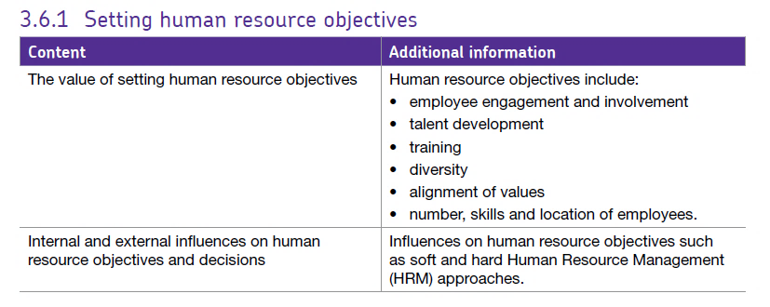3.6.1 Setting human resource objectives

# **What is HRM?**

HRM refers to how the employees are managed and treated within an organisation. Effective human resource management has become more important in recent times. Here are some reasons why:

* Most businesses now provide services rather than produce goods – people are the critical resource in the quality and customer service level of any service business
* Competitiveness requires a business to be efficient and productive – this is difficult unless the workforce is well motivated, has the right skills and is effectively organised
* The move towards fewer layers of management hierarchy (flatter organisational structures) has placed greater emphasis on delegation and communication

As a result, if a business is to be successful and achieve its objectives, then it needs to manage its human resources effectively.

<https://www.cipd.co.uk/knowledge/work/trends/uk-working-lives>

The key is to remember that **HRM is a strategic approach**. HRM uses a variety of **techniques** to help meet the strategic needs of the business in an integrated way. The key tools are:

* Workforce planning
* Recruitment & selection
* Training & development
* Rewarding and motivating staff
* Communication
* Roles and responsibilities (organisational structures)

# **HR objectives**.

Whilst the precise HR objectives will vary from business to business and industry to industry. Also, the way in which HR is managed depends on the type of firm.

Some firms adopt a **soft HR style** where they see workers as a valuable asset to be nurtured and looked after, these managers have a higher concern for people and so may be Team leader or Country Club leader on the Blake Mouton grid. Other firms may see workers as a resource to be exploited and a source of competitive advantage, these firms as using a **hard HR style,** this firm might be produce / perish or impoverished leader on the Blake Mouton Grid.

The following are commonly seen as important HR objectives:

## Ensure human resources are employed cost-effectively

Pay rates for staff need to be competitive but within the budget of the firm, staff should be working for the hours they are in employment and not have ‘spare’ time when they are not being productive. Most firms also have to consider **staff turnover** – what % of staff leave and are replaced each year as higher turnover can cost money in recruitment and lost productivity but may also suggest a wider problem.

## Diversity

Diversity means recognising the differences between individual employees and also the differences that might exist between different groups of employees. Employee diversity could be based on gender, race and ethnicity, disability, religion, sexuality, class and age.

Policies relating to equality are intended to create a fairer society whereby all employees can contribute and fulfil their potential.

There is employment legislation to ensure that businesses take this matter seriously. For example, in 2010 the UK government passed the Equalities Act which offered protection to employees against:

* Direct and indirect discrimination
* Harassment
* Victimisation

A more diverse workforce has many benefits for the organisation since it will:

* Attract a range of candidates when recruiting.
* Help the business to more fully understand the needs of customers who themselves are diverse.

## Alignment of values

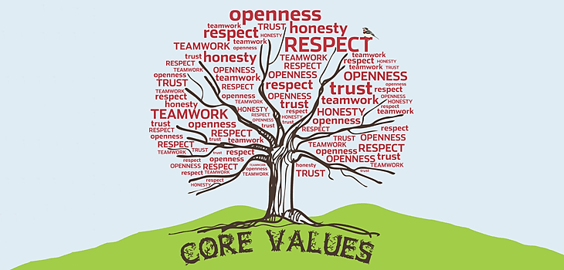All functions of the business, including the HR function, should be working towards a common goal; fulfilling the corporate objectives. In order for staff across the organisation to share this vision, the following is required:

The values of the organisation must be clearly set out and communicated to all staff.

It is important that all staff, at whatever level they work at in the organisation, believe that their actions can directly influence the business.

## Talent development / training

Very few jobs remain static, often employees need to be retrained for new systems and some staff can be trained to take more senior positions in the firm. This will mean that the business can potentially exploit strengths of staff to improve their product portfolio or management and therefore their ability to compete.

## Number, skills and location of employees

It is normal for the labour needs of the business to change over time. A business might grow, move overseas, replace employees with technology or introduce new products. Each of these changes means that the business will require a slightly different workforce. The business must ensure that it has sufficient employees to meet the needs of customers.

Having a workforce of the correct size and in the right place with the right skills also assists the business in providing high quality customer service.

Ensuring the business has the correct number of employees throughout the year can be challenging when the business faces seasonal demand.

E.g. Royal Mail require additional employees over the Christmas period because of the increase in demand for postal services. One way this can be achieved is to ensure that employees are employed on **flexible contracts** such as temporary, part-time and zero hours’ contracts.

Developments in technology have impacted on HR objectives in terms of location. Some businesses have opted to have a proportion of their employees engaged in **teleworking**. This allows employees to conduct work for the business at an approved alternative worksite.

## Make effective use of workforce potential

If people are under or over worked they will not achieve their potential, it is therefore important to ensure that jobs have suitable, achievable workloads so that productivity is high and the firm is utilising all the skills of its employees.

## Match the workforce to the business needs

Workforce planning to ensure business has the right number of staff in the right locations with the right skills, this will require effective recruitment to match workforce needs, training programmes to cover skills gaps or respond to changes in technology, processes & market and having the right number and mix of staff at each location where the business operates in multiple sites and countries. Some firms may also consider outsourcing activities that can be done better and more cost-effectively by external suppliers.

## Maintain good employer / employee relations / employee engagement.

Relations between employers and employees can often cause disputes and disagreements, this can often be caused by a lack of communication or poor communication such that employees feel confused and insecure about their positions. This can lead to unnecessary and costly industrial disputes. Good areas for the business to focus on include:

* Sensitive handling or potential problems with employees (e.g. dismissal, redundancy, major changes in the business)
* Complying with all relevant employment legislation
* 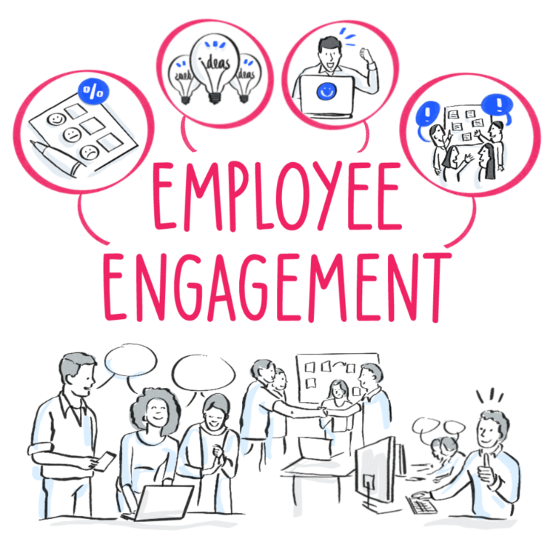Good understanding of and commitment to achieving the businesses mission, goals and objectives.
* Enabling employees to contribute to the continuous improvement of the business and is sometimes referred to as the ‘employee voice’

# Benefits of setting HR objectives

* Setting objectives will help to ensure that all staff are working towards the same goal. SMART objectives will ensure that goals are clear.
* Objectives provide a yardstick by which to judge success or failure.
* Measureable and timed objectives will allow managers and individuals to establish the reasons for success and failure. Practices that have worked effectively in one part of the organisation can be adopted in other parts of the organisation through the use of **benchmarking**.

# Problems of setting HR objectives

* Objectives are only as good as the information they are based on. The external environment could change rapidly and as a result the business may not meet its anticipated growth; this will render the predicted staffing needs incorrect.
* Some HR objectives may conflict with others. For example, an objective of training might undermine an objective relating to increased labour productivity, particularly in the short term.
* The HR department may not have sufficient resources or a large enough HR budget to meet all their objectives.
* If objectives are ‘imposed’ rather than agreed, employees may not feel that they have ‘ownership’ and may not be committed to achieving the objectives.
* HR objectives might be too ambitious or unrealistic.

# Influences on HRM Objectives

The main internal and external influences which are likely to affect the human resources function are summarised below:

## Internal influences on HRM objectives

### Corporate objectives

E.g. an objective of cost reduction is likely to require HR to implement redundancies, job reallocations etc. <https://www.rotherhamadvertiser.co.uk/news/view,fashion-giant-boohoocom-to-create-1200-jobs-at-new-tinsley-base_26791.htm>

### Operational strategies

E.g. introduction of new IT or other systems and processes may require new staff training, fewer staff <http://www.cityam.com/284697/argos-adds-150-new-tech-roles-london-and-milton-keynes>

### Marketing strategies

E.g. new product development or opportunities to enter a new market may require changes to organisational structure and recruitment of a new sales team - **read the part about Anoushka** <https://internetretailing.net/industry/industry/updated-coronavirus-round-up-annoushka-is-using-digital-to-give-an-in-store-experience-adidas-china-sales-sharply-down-plus-amazon-deliveroo-wh-smith-intu-21100>

### Financial strategies

E.g. a decision to reduce costs by outsourcing training would result in changes to training programmes or the internal pressure to reduce fixed costs could mean that firms have to make people redundant. <https://www.thenorthernecho.co.uk/news/18152423.job-losses-teesside-new-look-closes-stores/>

## External influences on HRM objectives

### Market changes

E.g. a loss of market share to a competitor may require a change in divisional management or job losses to improve competitiveness (see social changes article)

### Economic changes

E.g. the recession of 2008-10 placed great pressure on HR departments to reduce staff costs and improve productivity

<https://www.theguardian.com/business/2018/apr/20/nissan-to-cut-hundreds-of-jobs-at-sunderland-plant>

<https://uk.kantar.com/consumer/shoppers/2019/fastest-growth-since-november-puts-grocery-market-in-better-health/>

### Technological changes

E.g. the rapid growth of social networking may require changes to the way the business communicates with employees and customers <https://www.chroniclelive.co.uk/business/business-news/scores-jobs-lost-worldpay-gateshead-14572329>

### Social changes

E.g. the growing number of single-person households is increasing demand from employees for flexible working options

<https://www.theguardian.com/business/2019/mar/05/long-read-aldi-discount-supermarket-changed-britain-shopping>

### Political & legal changes

E.g. EU legislation on areas such as maximum working time and other employment rights impacts directly on workforce planning and remuneration <http://www.bbc.co.uk/news/business-43668187>

<https://www.bbc.co.uk/news/business-51702864>

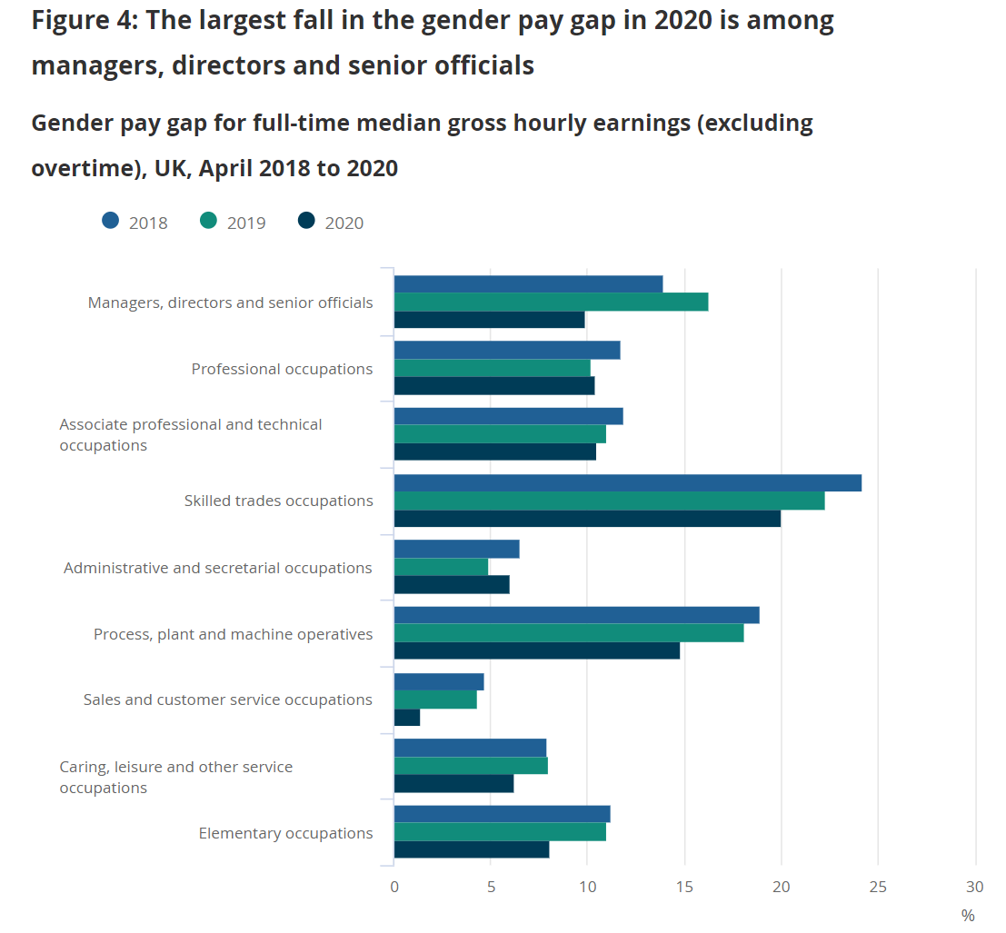

There is a searchable table towards the bottom of this page where you can look at pay gaps.

[UK gender pay gap data](https://www.ons.gov.uk/employmentandlabourmarket/peopleinwork/earningsandworkinghours/bulletins/genderpaygapintheuk/2020%23:~:text=The%20gender%20pay%20gap%20among,10%25%20for%20older%20age%20groups.)