

**Marking Scheme**

**Recurring Decimals**

**Q1.**

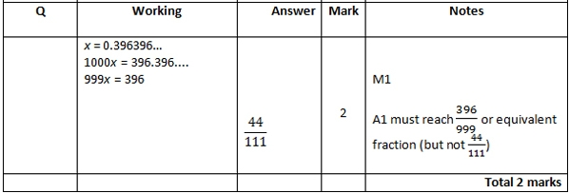

**Q2.**

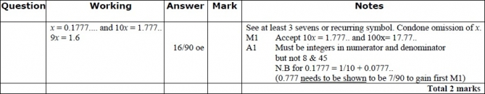

**Q3.**

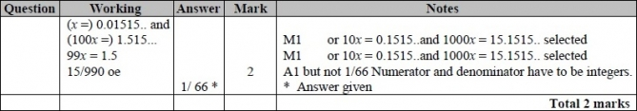

**Q4.**

The correct answer, unless clearly obtained by an incorrect method, should be taken to imply a correct method.

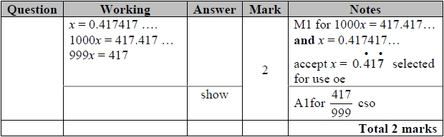

**Q5.**

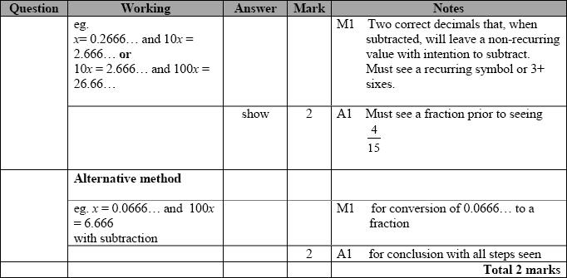

**Q6.**

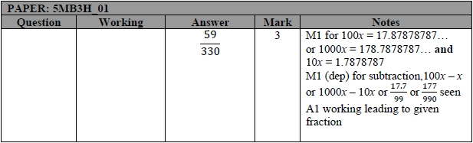

**Q7.**

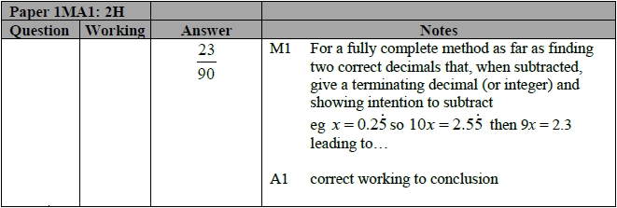

**Q8.**

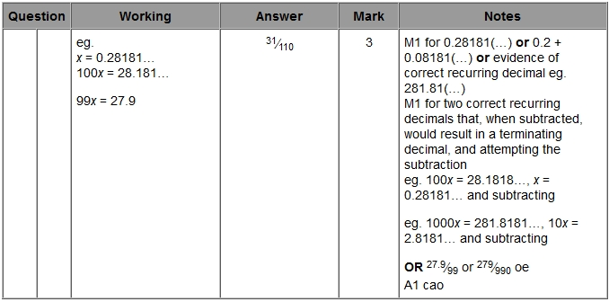

**Q9.**

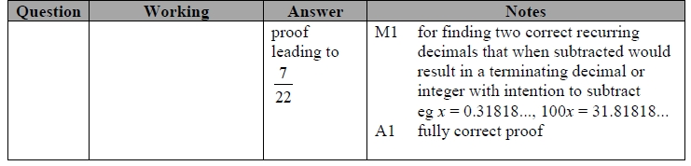

**Q10.**

