

**Higher IGCSE (9 – 1) Revision Pack**

**Sequences and Series (Part 1)**

**Name --------------------------------**

**Questions**

**Q1.**

Here is a sequence of patterns made from centimetre squares.

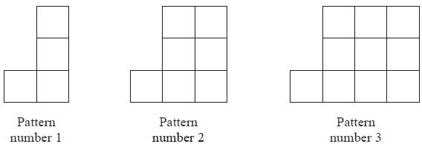

(a)   Find an expression, in terms of *n*, for the total number of centimetre squares in Pattern number *n*.

...........................................................

**(2)**

A pattern in this sequence has 88 centimetre squares.

(b)   Work out the Pattern number of this pattern.

...........................................................

**(2)**

**(Total for Question is 4 marks)**

**Q2.**

Here are some rows of a number pattern.

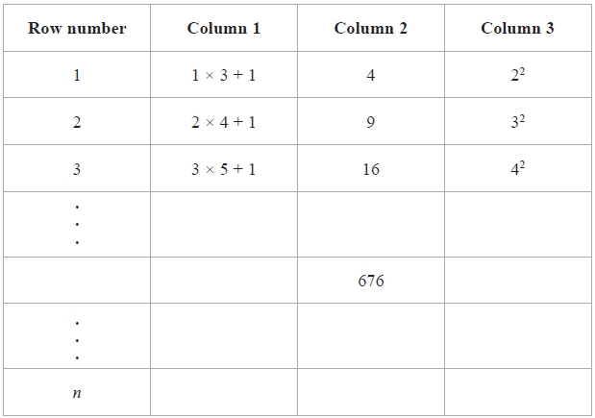

(a)  Write down the Row number of the row that has 676 in Column 2

...........................................................

**(1)**

(b)  For Row number *n*,

(i)  write down an expression, in terms of *n*, that should go in Column 1

...........................................................

(ii)  write down an expression, in terms of *n*, that should go in Column 3

...........................................................

**(2)**

**(Total for question = 3 marks)**

**Q3.**

Here are the first five terms of an arithmetic sequence.

7           10           13           16           19

Find an expression for the *n*th term of the sequence.

...........................................................

**(Total for question = 2 marks)**

**Q4.**

The 4th term of an arithmetic series is 17   
The 10th term of the same arithmetic series is 35

Find the sum of the first 50 terms of this arithmetic series.

**(Total for question = 5 marks)**

**Q5.**

The *n*th term of an arithmetic sequence is 3*n* + 2 where *n* is a positive integer.

(a)  Determine whether 93 is a term in this arithmetic sequence.

**(2)**

(b)  Find an expression for the sum of the *n*th term and the (*n* + 1)th term of this sequence.   
Give your answer in its simplest form.

**(2)**

The sum of two consecutive terms in this sequence is 91

(c)  Find the smaller of these two terms.

**(2)**

**(Total for question = 6 marks)**

**Q6.**

Here are the first five terms of an arithmetic sequence.

4     9     14     19     24

(a) Find, in terms of *n*, an expression for the *n*th term of this sequence.

...........................................................

**(2)**

Here are the first five terms of a different sequence.

2     2     0     −4     −10

An expression for the *n*th term of this sequence is 3*n* − *n*2

(b) Write down, in terms of *n*, an expression for the *n*th term of a sequence whose first five terms are

4     4     0     −8     −20

...........................................................

**(1)**

**(Total for Question is 3 marks)**

**Q7.**

The diagrams show a sequence of patterns made from grey tiles and white tiles.

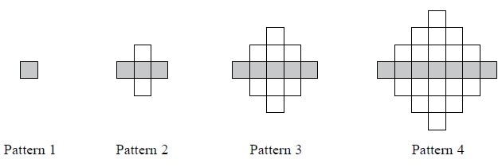

The number of grey tiles in each pattern forms an arithmetic sequence.

(a)  Find an expression, in terms of *n*, for the number of grey tiles in Pattern *n*.

**(2)**

The **total** number of grey tiles and white tiles in each pattern is always the sum of the squares of two consecutive whole numbers.

(b)  Find an expression, in terms of *n*, for the **total** number of grey tiles and white tiles in Pattern *n*.   
Give your answer in its simplest form.

**(3)**

(c)  Is there a pattern for which the total number of grey tiles and white tiles is 231?   
Give a reason for your answer.

**(2)**

The total number of grey tiles and white tiles in any pattern of this sequence is always an odd number.

(d)  Explain why.

**(2)**

**(Total for question = 9 marks)**

**Q8.**

Here are the first four terms of an arithmetic sequence.



(a)  Find, in terms of *n*, an expression for the *n*th term of this arithmetic sequence.

...........................................................

**(2)**

(b)  Is 121 a term of this arithmetic sequence?   
       You must explain your answer.

.............................................................................................................................................

.............................................................................................................................................

.............................................................................................................................................

**(2)**

**(Total for question = 4 marks)**

**Q9.**

Here is an equilateral triangle.

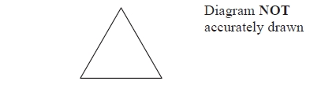

The equilateral triangle has a perimeter of 24 cm.

Some of these equilateral triangles are used to make this sequence of quadrilaterals.

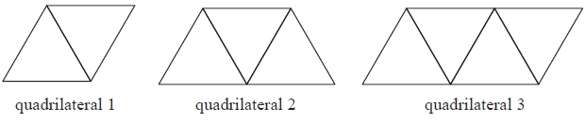

Find an expression for the perimeter, in centimetres, of quadrilateral *n*.

...........................................................

**(Total for question = 3 marks)**

**Q10.**

Here are the first 5 terms of an arithmetic sequence.

|  |  |  |  |  |
| --- | --- | --- | --- | --- |
| 3 | 9 | 15 | 21 | 27 |

(a) Find an expression, in terms of *n*, for the *n*th term of this sequence.

      ..............................................................................................................................................

**(2)**

Ben says that 150 is in the sequence.

(b) Is Ben right?  
       You must explain your answer.

      ..............................................................................................................................................

      ..............................................................................................................................................

      ..............................................................................................................................................

**(1)**

**(Total for Question is 3 marks)**

**Q11.**

Here are the first four terms of an arithmetic sequence.

6         10         14         18

(a)  Write an expression, in terms of *n*, for the *n*th term of this sequence.

...........................................................

**(2)**

The *n*th term of a different arithmetic sequence is 3*n* + 5

(b)  Is 108 a term of this sequence?   
Show how you get your answer.

**(2)**

**(Total for question = 4 marks)**

**Q12.**

The *n*th term of a number sequence is 2*n* + 1

Write down the first 3 terms of the number sequence.

...........................................................

**(Total for question = 2 marks)**

**Q13.**

Here are the first 5 terms of an arithmetic sequence.

|  |  |  |  |  |  |
| --- | --- | --- | --- | --- | --- |
|  | 6 | 10 | 14 | 18 | 22 |

(a) Write down an expression, in terms of *n*, for the *n*th term of this sequence.

      ..............................................................................................................................................

**(2)**

The *n*th term of a different sequence is 2*n*2 – 4

(b) Find the 3rd term of this sequence.

      ..............................................................................................................................................

**(2)**

**(Total for Question is 4 marks)**

**Q14.**

Here are the first 5 terms of an arithmetic sequence.

3          10          17          24          31

(a)  Find an expression, in terms of *n*, for the *n*th term of this sequence.

...........................................................

**(2)**

The *n*th term of a different sequence is 3*n*2 + 5

(b)  Find the 4th term of this sequence.

...........................................................

**(2)**

**(Total for question = 4 marks)**

**Q15.**

Here are the first five terms of an arithmetic sequence.

7            13            19            25            31

Prove that the difference between the squares of any two terms of the sequence is always a multiple of 24

**(Total for question is 6 marks)**

**Q16.**

Here are the first five terms of an arithmetic sequence.



(a) Write down an expression, in terms of *n*, for the *n*th term of this sequence.

      ..............................................................................................................................................

**(2)**

The *n*th term of a different number sequence is 3*n*2 + 7

(b) Find the 10th term of this sequence.

      ..............................................................................................................................................

**(2)**

**(Total for Question is 4 marks)**

**Q17.**

* The *n*th term of sequence A is 3*n* − 2   
The *n*th term of sequence B is 10 − 2*n*

Sally says there is only one number that is in both sequence A and sequence B.

Is Sally right?   
You must explain your answer.

**(Total for question = 2 marks)**

**Q18.**

Here are some patterns made from white centimetre squares and grey centimetre squares.

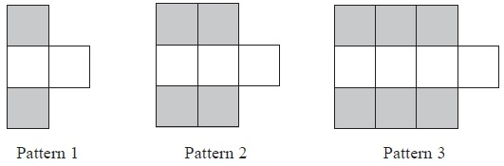

A Pattern has 20 grey squares.

(a)  Work out how many white squares there are in this Pattern.

...........................................................

**(2)**

(b)  Find an expression, in terms of *n*, for the total number of centimetre squares in Pattern *n*.

...........................................................

**(2)**

**(Total for Question is 4 marks)**

**Q19.**

The first five terms of an arithmetic sequence are

|  |  |  |  |  |
| --- | --- | --- | --- | --- |
| 2 | 6 | 10 | 14 | 18 |

(a) Write down an expression, in terms of *n*, for the *n*th term of this sequence.

      ..............................................................................................................................................

**(2)**

An expression for the *n*th term of a different sequence is 20 – 5*n*

(b) work out the 10th term of this sequence.

      ..............................................................................................................................................

**(2)**

**(Total for Question is 4 marks)**

**Q20.**

Here are the first four terms of an arithmetic sequence.

          10      16      22      28

(a) Find the 10th term of this sequence.

. . . . . . . . . . . . . . . . . . . . . .

**(1)**

(b) Find an expression, in terms of *n*, for the *n*th term of the sequence.

. . . . . . . . . . . . . . . . . . . . . .

**(2)**

**(Total for Question is 3 marks)**

**Q21.**

Here are the first five terms of an arithmetic sequence.

|  |  |  |  |  |
| --- | --- | --- | --- | --- |
| 2 | 7 | 12 | 17 | 22 |

(a) Explain why the number 271 cannot be a term in this sequence.

      ..............................................................................................................................................

      ..............................................................................................................................................

**(1)**

(b) Write down an expression, in terms of *n*, for the *n*th term of the sequence.

      ..............................................................................................................................................

**(2)**

**(Total for Question is 3 marks)**

**End of questions**