

**Higher IGCSE (9 – 1) Revision Pack**

**Solving Quadratic Equations**

**Name --------------------------------**

**Questions**

**Q1.**

Here is a trapezium.

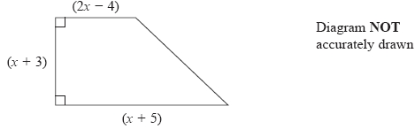

All measurements are in centimetres.

The area of the trapezium is 60 cm2

Show that   3*x*2 + 10*x* − 117 = 0

**(3)**

(b)  Work out the value of *x*

Show your working clearly.   
Give your answer correct to 3 significant figures.

...........................................................

**(3)**

**(Total for question = 6 marks)**

**Q2.**

The diagram shows a circular pond, of radius *r* metres, surrounded by a circular path.   
The circular path has a constant width of 1.5 metres.

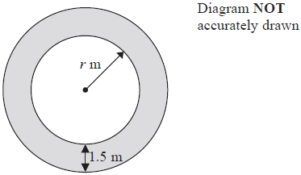

  
The area of the path is the area of the pond.

(a)  Show that 2*r*2 − 60*r* − 45 = 0

**(3)**

(b)  Calculate the area of the pond.   
Show your working clearly.   
Give your answer correct to 3 significant figures.

........................................................... m2

**(5)**

**(Total for question = 8 marks)**

**Q3.**

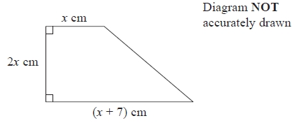

The diagram shows a trapezium.   
The trapezium has an area of 17 cm2

(a)  Show that 2*x*2 + 7*x* − 17 = 0

**(3)**

(b)  Work out the value of *x*.   
Give your answer correct to 3 significant figures.   
Show your working clearly.

*x* = ...........................................................

**(3)**

**(Total for question = 6 marks)**

**Q4.**

Here is a hexagon.

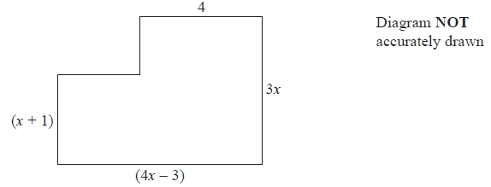

In the diagram, all the measurements are in centimetres.   
All the corners are right angles.

The area of the hexagon is 40 cm2

(a)   Show that 4*x*2 + 9*x* − 47 = 0

**(3)**

(b)   Solve 4*x*2 + 9*x* − 47 = 0

Show your working clearly.   
Give your solutions correct to 3 significant figures.

...........................................................

**(3)**

(c)   Find the length of the longest side of the hexagon.   
Give your answer correct to 3 significant figures.

........................................................... cm

**(2)**

**(Total for Question is 8 marks)**

**Q5.**

A rectangular piece of card has length (3*x* – 13) cm and width (*x* – 2) cm.   
A square, with sides of length 25 cm, is removed from each corner of the card.

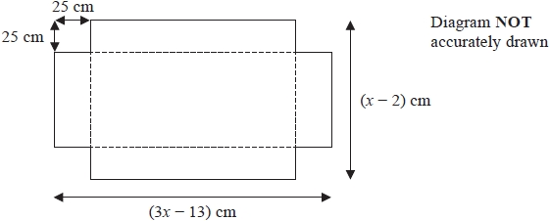

The card is then folded along the dashed lines to make an open box with height 25 cm as shown below.

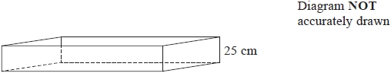

(a)  Show that the length of the open box is (3*x* – 63) cm.

**(1)**

The volume of the open box is 81 900 cm3

(b)  Find the value of *x*.

Show clear algebraic working.

*x* = ...........................................................

**(5)**

**(Total for question = 6 marks)**

**Q6.**

(a)  Factorise 4*x*2 − 1

...........................................................

**(2)**

  
(b)  Solve

Show clear algebraic working.

...........................................................

**(4)**

**(Total for question = 6 marks)**

**Q7.**

The diagram shows a rectangular playground of width *x* metres and length 3*x* metres.

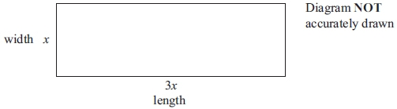

The playground is extended, by adding 10 metres to its width and 20 metres to its  
length, to form a larger rectangular playground.

The area of the larger rectangular playground is double the area of the original  
playground.

(a) Show that 3*x*2 − 50*x* − 200 = 0

**(3)**

(b) Calculate the area of the original playground.

...........................................................m2

**(5)**

**(Total for question = 8 marks)**

**Q8.**

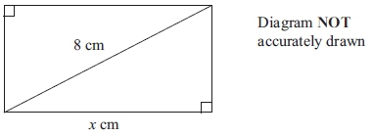

The diagram shows a rectangle.  
The length of the rectangle is *x* cm.  
The length of a diagonal of the rectangle is 8 cm.  
The perimeter of the rectangle is 20 cm.

(a) Show that *x*2 − 10*x* + 18 = 0

**(4)**

(b) Solve *x*2 − 10*x* + 18 = 0   
Give your solutions correct to 3 significant figures.  
Show your working clearly.

...........................................................

**(3)**

**(Total for question = 7 marks)**

**Q9.**

Clare buys some shares for $50*x*.  
Later, she sells the shares for $(600 + 5*x*).  
She makes a profit of x%

(a) Show that     *x*2 + 90*x* − 1200 = 0

**(3)**

(b) Solve *x*2 + 90*x* − 1200 = 0   
Find the value of *x* correct to 3 significant figures.

*x* = ...........................................................

**(3)**

**(Total for question = 6 marks)**

**Q10.**



Solve

Show clear algebraic working.

..............................................................

**(Total for question = 5 marks)**

**Q11.**

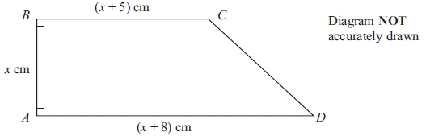

The diagram shows a trapezium *ABCD* with *AD* parallel to *BC*.   
*AB* = *x* cm, *BC* = (*x* + 5) cm and *AD* = (*x* + 8) cm.   
The area of the trapezium is 42 cm2.

(a) Show that 2*x*2 + 13*x* − 84 = 0

**(2)**

(b) Calculate the perimeter of the trapezium.

........................................................... cm

**(5)**

**(Total for question = 7 marks)**

**Q12.**



(a) Simplify

...........................................................

**(2)**

(b) Factorise     a2 − 144

...........................................................

**(2)**



(c) Make *q* the subject of the formula

*q* = ...........................................................

**(2)**



(d) Solve

*y* = ...........................................................

**(3)**

**(Total for question = 2 marks)**

**Q13.**

Solve the simultaneous equations

*y* = 2*x*2  
  
*y* = 20 − 3*x*

Show clear algebraic working.

...........................................................

**(Total for question = 5 marks)**

**Q14.**

Solve the simultaneous equations

y = 3*x* + 2

*x*2 + *y*2 = 20

Show clear algebraic working.

...........................................................

**(Total for question = 6 marks)**

**Q15.**

Solve the simultaneous equations



Show clear algebraic working.

...........................................................

**(Total for question = 6 marks)**

**Q16.**

Solve the equation 5*x*2 + 8*x* – 23 = 0   
Show your working clearly.   
Give uyou solutions correct to 3 significant figures.

...........................................................

**(Total for question = 3 marks)**

**Q17.**



Solve

Show clear algebraic working.

*x* = ...........................................................

**(Total for question = 4 marks)**

**Q18.**

Solve the equation

Show clear algebraic working.

...........................................................

**(Total for question = 5 marks)**

**Q19.**

Solve = 2

Show clear algebraic working.

...........................................................

**(Total for question = 5 marks)**

**Q20.**

Solve the equation 

Show clear algebraic working.

...........................................................

**(Total for Question is 5 marks)**

**Q21.**

Solve   

Show clear algebraic working.

...........................................................

**(Total for question = 4 marks)**

**Q22.**

Solve 

*x* = ...........................................................

**(2)**

**(Total for question = 4 marks)**

**Q23.**

(a)  Solve  

Show clear algebraic working.

*x* = ...........................................................

**(3)**

(b)  Make *p* the subject of the formula

...........................................................

**(4)**

**(Total for question = 7 marks)**

**Q24.**

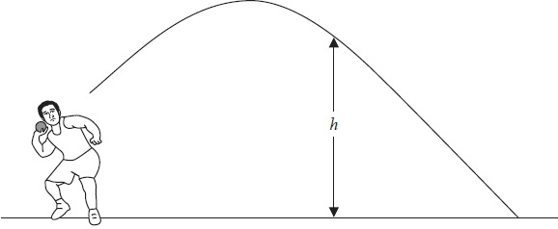

Ivan is a shot putter.   
The formula *h* = 2 + 6*t* − 5*t*2 gives the height, *h* metres, of the shot above the ground *t* seconds after he has released the shot.

(i)  Solve 2 + 6*t* − 5*t*2 = 0   
Give your solutions correct to 3 significant figures.   
Show your working clearly.

...........................................................

The shot hits the ground after *T* seconds.

(ii)  Write down the value of *T*.   
Give your answer correct to 3 significant figures.

*T* = ...........................................................

**(Total for Question is 4 marks)**

**Q25.**

Solve 5*x*2 + 2*x* − 4 = 0  
 Give your solutions correct to 3 significant figures.  
 Show your working clearly.

...........................................................

**(Total for question = 3 marks)**

**Q26.**

Solve 2*x*2 – 6*x* + 3 - 0

Give your solutions correct to 3 significant figures.   
Show your working clearly.

...........................................................

**(Total for question = 3 marks)**

**Q27.**

Solve   11*x*2 − 3*x* − 5 = 0   
Show your working clearly.   
Give your solutions correct to 2 decimal places.

...........................................................

**(Total for question = 3 marks)**

**Q28.**

A stone is thrown vertically upwards from a point *O*.

The height above *O* of the stone *t* seconds after it was thrown from *O* is *h* metres, where *h* = 17*t* – 5*t*2

Work out the values of *t* when the height of the stone above *O* is 12 metres.

Show your working clearly.

...........................................................

**(Total for question = 3 marks)**

**Q29.**

Solve     3*x*2 + 2*x* − 7 = 0   
Give your solutions correct to 3 significant figures.   
Show your working clearly.

...........................................................

**(Total for question = 3 marks)**

**Q30.**

(a)  Solve    *x*2 − 4*x* − 1 = 0

Show your working clearly.   
Give your solutions correct to 3 significant figures.

...........................................................

**(3)**

Hence, or otherwise,

(b)  solve    (*x* + 3)2 − 4(*x* + 3) − 1 = 0

giving your solutions correct to 3 significant figures.

...........................................................

**(1)**

**(Total for question = 4 marks)**

**Q31.**

Solve the simultaneous equations

*y*2 + 4*x* = 12   
2*x* + 3*y* = 10

Show clear algebraic working.

...........................................................

**(Total for question = 6 marks)**

**Q32.**

Solve the simultaneous equations

*y* = 2*x* − 3

*x*2 + *y*2 = 2

...........................................................

**(Total for question = 6 marks)**

**Q33.**

Solve the simultaneous equations

*x*2 + *y*2 = 52

2*x* + *y* = 8

Show clear algebraic working.

...........................................................

**(Total for question = 6 marks)**

**Q34.**

The diagram shows a trapezium.

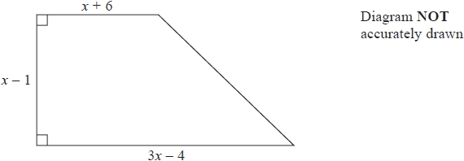

All measurements on the diagram are in centimetres.

The area of the trapezium is 119 cm2

(i)  Show that     2*x*2 − *x* − 120 = 0

(ii)  Find the value of *x*.   
Show your working clearly.

*x* = ...........................................................

**(Total for question = 6 marks)**

**Q35.**

The diagram shows a rectangle.

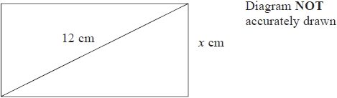

The width of the rectangle is *x* cm.   
The length of a diagonal of the rectangle is 12 cm.

The perimeter of the rectangle is 28 cm.

Find the possible values of *x*.   
Give your values correct to 3 significant figures.   
Show your working clearly.

...........................................................

**(Total for question = 7 marks)**

**Q36.**

A rectangular lawn has a length of 3*x* metres and a width of 2*x* metres.   
The lawn has a path of width 1 metre on three of its sides.

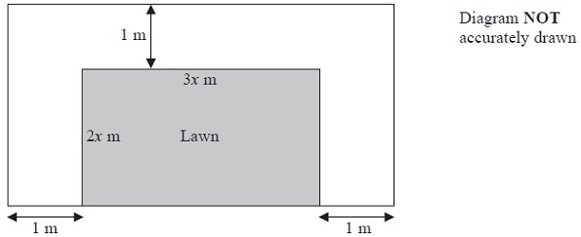

The total area of the lawn and the path is 100 m2

(a)  Show that    6*x*2 + 7*x* − 98 = 0

**(2)**

(b)  Calculate the area of the lawn.   
Show clear algebraic working.

........................................................... m2

**(5)**

**(Total for Question is 7 marks)**

**End of questions**