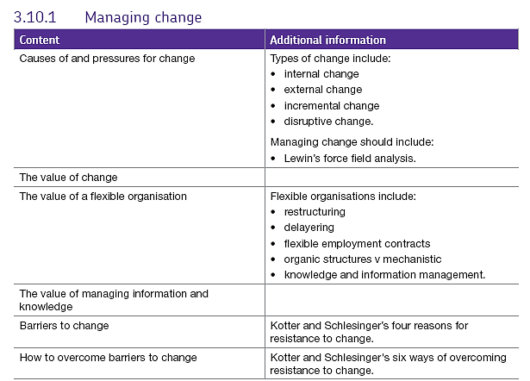3.10.1 Managing change

# Strategic change.

There are many types of change and many causes of it.

Pressure for change within businesses can come from many areas, it can be **internal** (caused by factors within the business e.g. new leadership, relocation) or **external** (caused by factors outside the business in its external environment e.g. new competitors entering the market or a new technology being developed).

Change can **evolve incrementally** or it can be **dramatic. Incremental change** happens in stages over a period of time while **dramatic (or global) change** can happen all at once or within a very short period of time.

Sometimes if there is change in the market (e.g. if consumer tastes change) but the management are not sure what to do or cannot make a clear decision on how to proceed, then the firm may go through a **state of flux.**  Firms go through a periods of flux where they try unsuccessfully to make changes or they make changes which come too late - strategy is erratic and not thought through properly. Eventually this can lead to global change or, it may lead to the end of the business – good examples here are Kodak or Blockbuster.

Firms plan ahead for incremental change but also need to have contingency plans so they can cope if dramatic changes take place – this would include **business-process re-engineering** – completely redesigning the way the firm does business.

The other type of change is **disruptive change** which is usually caused by new players coming into an established market and causing change to how it operates. For example Airbnb in the tourism market and Uber in the taxi market.

The main stages of change process are:

Other things which could be included in this process:

* Communicating changes
  + Trying to bring in initial changes which bring positive results quickly so that people can see the benefit of them
* Training for staff
* Managing staff – different approaches – soft HRM and hard HRM
* Give staff some support – check if they are managing the change well.

# Managing change

Much of the pressure for change in a business is external and a business has to be prepared to face the demands of a changing external environment

## **How is change organised and promoted?**

This is usually done through the corporate plan which sets out the firm’s central objectives and how it intends to achieve them. The firm’s corporate plan will include

* the overall objectives of the business for a specific timeframe e.g. profit targets,

sales growth, market share growth

* the strategies to be used – often based around Ansoff’s matrix
* functional objectives

## **What are the benefits of corporate planning?**

* Clear focus and purpose which can be communicated
* There is a framework for controlling and reviewing
* Gives an overview of the whole firm in conjunction with a SWOT analysis and

marketing audit.

## **What are the limitations to corporate planning?**

* The plan cannot cover every possible circumstance – there may be unforeseen

events which require contingency planning.

* There will always be disagreement about the plan and to move forward everyone

needs to be working together

* The plan has to reflect legal and political constraints
* Plans will be affected by internal and external constraints.

Even with a really solid corporate plan, sometimes change is hard to achieve. One of the main drawbacks of corporate planning is that it can be inflexible; once a plan is in place some people may find it hard to move from the plan or it may take a long time to recognise that the plan isn’t working.

Firms have to be realistic and identify a point where they can say that a plan isn’t working and needs to be adapted or given up. By the say token, if a plan is super successful e.g. the launch of a new product, the firm may have to adapt its capacity quickly to satisfy demand and should have a plan for that.

# **Lewin’s force field analysis.**

Many factors drive change in a business.  **Lewin** identified four forces:   
  
In Lewin’s model there are forces **driving change** and forces **restraining it**. Where there is equilibrium between the two sets of forces there will be no change. In order for change to occur the **driving force must exceed the restraining force**

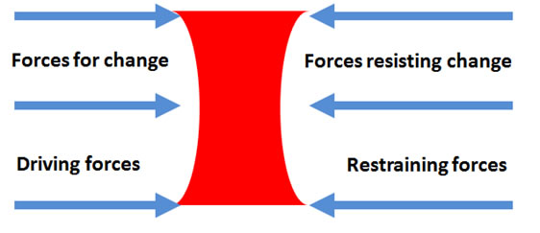

Lewin’s analysis can be used to:

* Investigate the balance of power involved in an issue which will be different in every case and firm.
* Identify the key stakeholders on the issue
* Identify opponents and allies – people who are likely to be against you and people who are likely to offer support.
* Identify how to influence the target groups – find out what your opponents object to and decide how you will counteract their arguments.

# Flexible organisations and change.

A flexible organisation refers to the fact that a firm can respond quickly to changes in its environment The organisation structure must be suitable to encourage the effective / efficient flow of communication and be adaptable e.g. through use of different types of employment contracts and flexible working options, to meet the needs of employees and the business. Flexible organisations often feature or require:

* **Restructuring**

For the organisation to be flexible it may need to have core or key workers who are supported by peripheral, temporary or part-time staff. Core workers are those who are hard to replace and have specific skills or knowledge for the business. Peripheral workers are those who carry out admin and support functions – they are additional to the main function of the business, these people are easy to replace, they have less job security.

* **Delayering**

Taller structures are unlikely to be very responsive to change as responsibility is concentrated with few people so decisions take time to filter down making flatter organisations better in terms of responsiveness. Delayering removes levels from the hierarchy and is often used as part of a cost reduction strategy.

Both of these strategies involve moving to a more organic structure from a mechanistic structure.

**Organic structures** - aka flat structures are decentralised with wide spans of control. Power to make decisions is devolved, these structures can appear disorganised, chains of command and hierarchy can be blurred so they need monitoring to retain efficiency. The organisation and teams are fluid and relationships are key to good performance.

**Mechanistic structures** – aka tall structures, usually have very formal channels of communication and chains of command. The organisation of the business follows a predictable pattern and employees know the systems. This may be good in some situations e.g. claims handling for an insurance firm.

**Flexible employment contracts**

These include the use of temporary, short contract and agency workers as well as zero hours contracts. This means the firm can access employees when needed or decrease staffing when not needed. This can help minimise costs however it can be difficult if the job requires good relations with customers over the long-term, high levels of customer service, or detailed product knowledge.

**Good knowledge and information management.**

Firms gather information about customers and potential customers; they also hold databases of suppliers and other contacts. It is important that this information is held centrally and access is controlled so that senior staff can all access the information rather than one person privately holding data as, if something happens to that person, the data or knowledge will be lost.

Data about customers can be gathered through sales people or through EPOS, loyalty cards etc. It can then be used to evaluate the effectiveness of strategies e.g. marketing campaigns.

# Barriers to change.

There are many things which might cause problems for an organisation trying to implement change.

* Lack of clear focus and objectives
* Inappropriate or insufficient levels of resources
* Staff with incorrect skills or training

Additionally, the workers can also affect the firm’s ability to implement strategies if communication of the objectives is not clear and workers views are not listened to. The organisation structure may not be appropriate to facilitate change and competitor actions may disrupt plans.

# Resistance to change.

Many of the concepts we have looked at in A level Business require change within firms, in fact, firms are constantly having to change because their internal and external environments circumstances are dynamic - a customer may go out of business and be unable to pay a large debt causing cash flow problems or a supplier fails to meet a deadline which means the firm loses a large order or a new competitor enters a market and the firm must “adapt or die.”

These factors may impact the running of the firm in a small way for a short period of time e.g. if overtime is removed for 3 months, however, they may impact the firm in the much longer term e.g. if some product groups are withdrawn and others are brought online or if production is out-sourced rather than being done in-house and there are subsequent redundancies. These changes can all result in resistance to the new strategies or plans adopted by the firm.

## Causes of resistance - Kotter and Schlesinger.

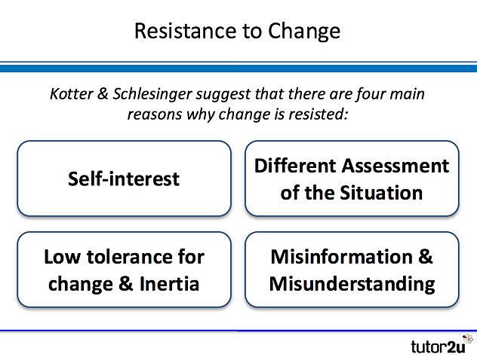

There are many reasons why change is resisted by people working in business. This study note outlines the four main reasons as identified by Kotter & Schlesinger.

1. Self-interest

Self-interest is a powerful motivator; this often arises from a perceived threat to job security, status and financial position. Individuals often place their own interests ahead of those of their organisation, particularly if they don't feel a strong loyalty to it

1. Misinformation & Misunderstanding

People don’t understand why change is needed, perhaps because they are misinformed about the real strategic position of the business. Perception may be widespread that there is no compelling reason for change or perhaps even an element of people fooling themselves that things are better than they really are.

1. Different Assessment of the Situation

Here there is disagreement about the need for change or what that change needs to be. Some people may simply disagree with the change proposed, or they may feel they have a better solution. This is different from “self-interest” – the resistance here is based on disagreement about what is best for the business.

1. Low Tolerance and Inertia

Many people suffer from inertia or reluctance to change, preferring things to stay “the way they are,” many people need security, predictability & stability in their work, if there is low tolerance of change (perhaps arising from past experience) then resistance to change may grow

## How can senior management overcome the inevitable resistance to change when change is required?

## 

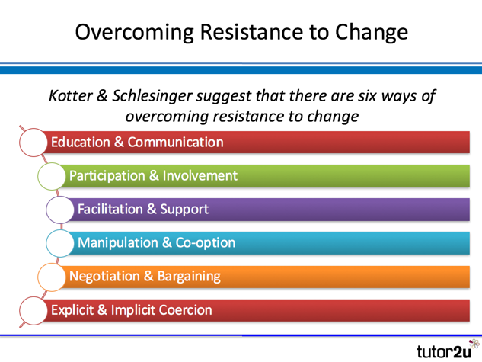Six approaches were suggested by Kotter & Schlesinger.

**Education & Communication**

The starting point for successful change is to communicate effectively the reasons why change is needed!

Honest communication about the issues and the proposed action helps people see the logic of change, effective education helps address misconceptions about the change, including misinformation or inaccuracies. Education and communication are unlikely to achieve very short-term effects. They need to be delivered consistently and over a long-period for maximum impact.

1. **Participation & Involvement**

Involvement in a change programme can be an effective way of bringing “on-board” people who would otherwise resist, participation often leads to commitment, not just compliance. A common issue in any change programme is just how much involvement should be permitted. Delays and obstacles need to be avoided.

1. **Facilitation & Support**

Kotter & Schlesinger identified what they called “adjustment problems” during change programmes. Most people (though not all) will need support to help them cope with change. Key elements of facilitation and support might include additional training, counselling and mentoring as well as simply listening to the concerns of people affected, if fear and anxiety is at the heart of resistance to change, then facilitation and support become particularly important

1. **Co-option & Manipulation**

Co-option involves bringing specific individuals into roles that are part of change management (perhaps managers who are likely to be otherwise resistant to change)

Manipulation involves the selective use of information to encourage people to behave in a particular way, whilst the use of manipulation might be seen as unethical; it might be the only option if other methods of overcoming resistance to change prove ineffective

1. **Negotiation & Bargaining**

The idea here is to give people who resist an incentive to change – or leave

The negotiation and bargaining might involve offering better financial rewards for those who accept the requirements of the change programme, alternatively, enhanced rewards for leaving might also be offered. This approach is commonly used when a business needs to restructure the organisation (e.g. by delayering)

1. **Explicit & Implicit Coercion**

This approach is very much the “last resort” if other methods of overcoming resistance to change fail

Explicit coercion involves people been told exactly what the implications of resisting change will be. Implicit coercion involves suggesting the likely negative consequences for the business of failing to change, without making explicit threats. The big issue with using coercion is that it almost inevitably damages trust between people in a business and can lead to damaged morale (in the short-term).