Business Ethics - In Practice

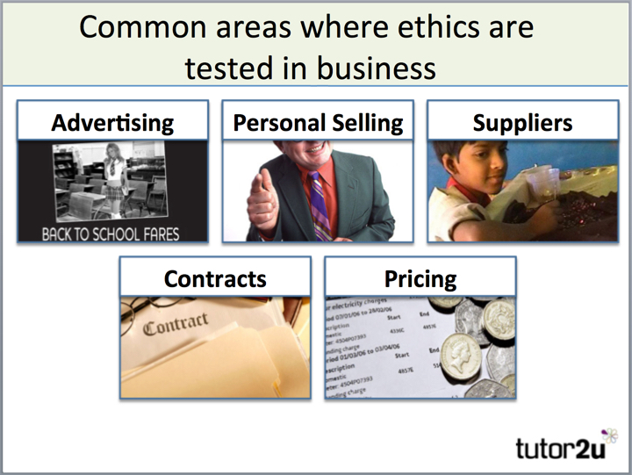

Ethics are tested in business almost every day and in a wide range of business activities.

For example - let's take one of the above – suppliers.

A business cannot claim to be ethical firm if it ignores unethical practices by its suppliers

e.g.

* Use of child labour and forced labour
* Production in sweatshops
* Violation of the basic rights of workers
* Ignoring health, safety and environmental standards

An ethical business has to be concerned with the behaviour of all businesses that operate in the supply chain such as:

* Suppliers
* Contractors
* Distributors
* Sales agents

# Pressure for businesses to act ethically

Businesses and industries increasingly find themselves facing **external pressure** to improve their ethical track record.

An interesting feature of the rise of consumer activism online has been increased scrutiny of business activities.

Pressure groups are a good example of this. Pressure groups are external stakeholders they

* Mostly focus on activities & ethical practice of multinationals or industries with ethical issues
* Combine direct and indirect action can damage the target business or industry

Direct consumer action is another way in which business ethics can be challenged. Consumers may take action against:

* Businesses they consider to be unethical in some ways (e.g. animal furs)
* Business acting irresponsibly
* Businesses that use business practices they find unacceptable

Consumer action can also be positive – supporting businesses with a strong ethical stance & record. A good example of this is Fairtrade.

# Is ethical behaviour good or bad for business?

You might think the above question is an easy one for businesses to answer? Surely acting ethically makes good business sense? As with all issues in business studies, there are two sides to every argument:

## The advantages of ethical behaviour include:

* Higher revenues – demand from positive consumer support
* Improved brand and business awareness and recognition
* Better employee motivation and recruitment
* New sources of finance – e.g. from ethical investors

## The disadvantages claimed for ethical business include:

* Higher costs – e.g. sourcing from Fairtrade suppliers rather than lowest price
* Higher overheads – e.g. training & communication of ethical policy
* A danger of building up false expectations

Examples for the other areas are shown below:

|  |  |
| --- | --- |
| Advertising | Who are you advertising to and how?  What type of advertising are you using? Persuasive or informative – does it matter? |
| Personal selling | How aggressive are your sales people? Will they take No for an answer? |
| Contracts | Are you paying your suppliers on time? Do you give customers a reasonable time to pay? Are you employing people fairly and paying them a fair wage? |
| Pricing | Are you charging a fair price – especially where you are the market leader or have little competition or are you charging as much as you can to maximise profits – are you offering value for money or a rip-off? |