3.2.1 **Understanding management, leadership and decision making**

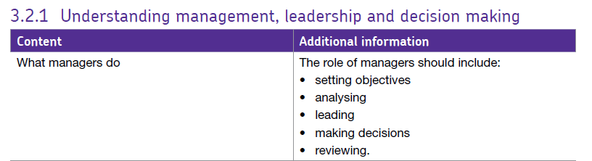

## Leadership and management are not the same thing.

Leaders direct the business, they set the long term vision and goals, so what do managers do?

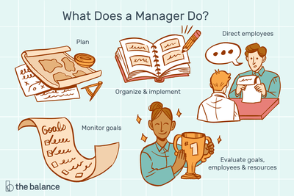Businesses of any size need people to manage them. So what is a "manager" and what does a manager do?

So, managers are responsible for:

* Setting objectives and planning
* Organising a group
* Motivating and communicating
* Measuring performance
* Developing people

## The Key Levels of Management in a Business

The management structure of a business will vary depending on several factors, in particular the scale and complexity of the firm as well as its culture. However, usually management takes place at three core levels in a business:

**1. Senior Management**

* E.g. Board of Directors
* Set corporate objectives & strategic direction
* Board is responsible to shareholders; led by the CEO

**2. Middle Management**

* Accountable to senior management
* Run business functions and departments

**3. Junior Management**

* Supervisory role, accountable to middle management
* Monitor & control day-to-day tasks, and manage teams of workers

# Leadership and management styles

Leaders and managers exercise their authority in different ways. In doing so, they are said to exhibit a leadership (or management) style.

Leadership styles are essentially about:

* The way the responsibilities are carried out
* The way that a leader or manager behaves

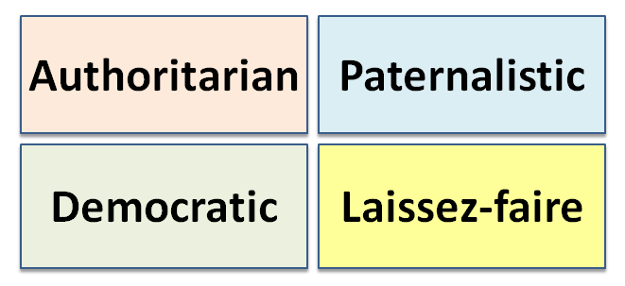There has been a lot of research into the types and effectiveness of various leadership styles, with the four most common generally accepted to be:

Authoritarian

* Autocratic leaders hold onto as much power and decision-making as possible
* Focus of power is with the manager, communication is top-down & one-way
* Formal systems of command & control
* Minimal consultation, very little delegation
* Use of rewards & penalties
* Most likely to be used when subordinates are unskilled, not trusted and their ideas are not valued

Paternalistic

* Leader decides what is best for employees
* Akin to a parent/child relationship – where the leader is seen as a “father-figure”
* Still little delegation
* A softer form of authoritarian leadership, which often results in better employee motivation and lower staff turnover
* Typical paternalistic leader explains the specific reason as to why he has taken certain actions

Democratic

* Focus of power is more with the group as a whole
* Leadership functions are shared within the group
* Employees have greater involvement in decision-making – but potentially this slows-down decision-making
* Emphasis on delegation and consultation – but the leader still has the final say
* Perhaps the most popular leadership style because of the positive emotional connotations of acting democratically
* A potential trade-off between speed of decision-making and better motivation and morale?
* Likely to be most effective when used with skilled, free-thinking and experienced subordinates

Laissez-faire

* Laissez-faire means to “leave alone”. Leader has little input into day-to-day decision-making
* Conscious decision to delegate power and employees have freedom to do what they think is best
* Often criticised for resulting in poor role definition.
* Effective when staff are ready and willing to take on responsibility, they are motivated, and can be trusted to do their jobs

As a generalisation, in most business sectors there has been a gradual shift away from autocratic leadership. This may be due to:

* Changes in society’s values
* Better educated workforce
* Focus on need for soft HR skills
* Changing workplace organisation
* Greater workplace legislation
* Pressure for greater employee involvement