

**Higher IGCSE (9 – 1) Revision Pack**

**Transformation of Graphs**

**Name --------------------------------**

**Transformation of graphs**

**Question 1**

Here is the graph of for

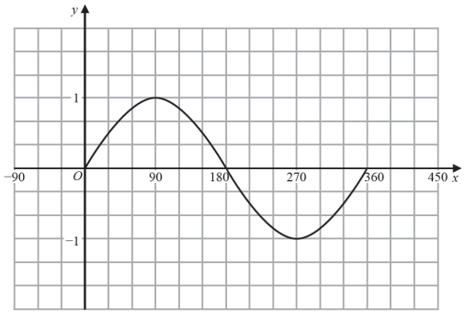

In , the graph of has a maximum at the point .

Write down the coordinates of .

..........................

**(2 marks)**

**Question 2**

Here is the graph of

On the grid, draw the graph of

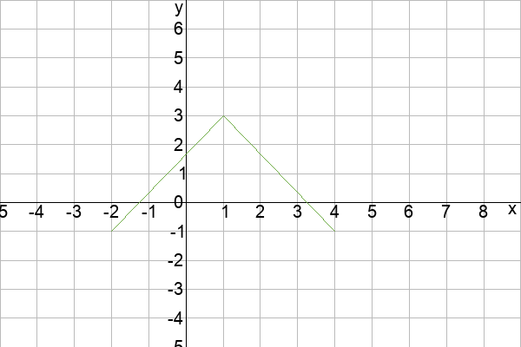

**(2 marks)**

**Question 3**

Here is the graph of

On the grid, draw the graph of



**(2 marks)**

**Question 4**

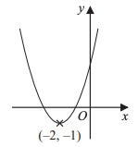

The diagram shows the curve with equation

The coordinates of the minimum point of the curve are

Write down the coordinates of the minimum point of the curve with equation

**..........................**

**(1 mark)**

**Question 5**



The diagram shows the curve with equation

The coordinates of the minimum point of the curve are

Write down the coordinates of the minimum point of the curve with equation

**..........................**

**(1 mark)**

**Question 6**

The graph of for is drawn on the grid below.

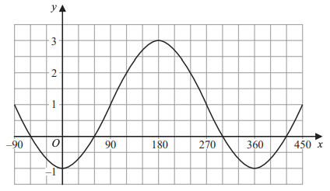

Find the value of , the value of and the value of .

*Input note: find*  and when

**..........................**

**(3 marks)**

**Question 7**

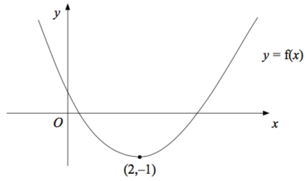

The diagram shows part of the curve with equation

The minimum point of the curve is at (2,-1)

Write down the coordinates of the minimum point of the curve with equation

**..........................**

**(1 mark)**

**Question 8**

Write in the form .

**..........................**

**(3 marks)**

**Question 9**

It can be shown that is identical to .

Write down the coordinates of the turning point of the graph of .

**..........................**

**(2 marks)**

**Question 10**

The coordinates of the turning point of the graph of is .

Hence describe the single transformation which maps the graph of onto the graph of .

**..........................**

**(2 marks)**

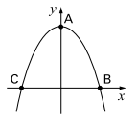

**Question 11**

The diagram shows a sketch of the curve

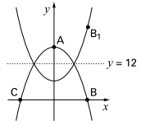

The curve is reflected in the line

is the reflection of . What are the coordinates of ?

**..........................**

**Question 12**

Here is the graph of for

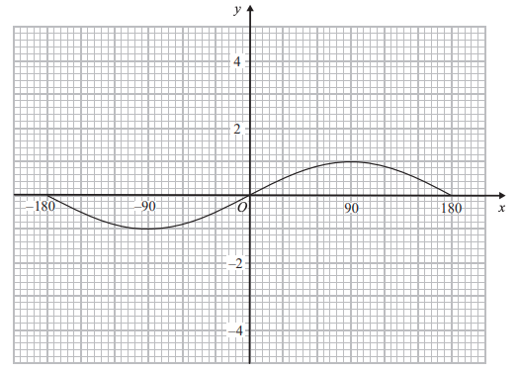

To sketch the graph of , what would you do to each point on the graph?

You would  **..........................**

to the  **..........................** coordinates

**(2 marks)**

**Question 13**

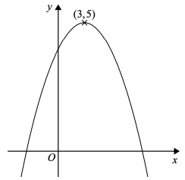

The diagram shows part of the curve with equation The coordinates of the maximum point of the curve are

Write down the coordinates of the maximum point of the curve with equation

**..........................**

**(1 mark)**

**Question 14**



The diagram shows part of the curve with equation The coordinates of the maximum point of the curve are

Write down the coordinates of the maximum point of the curve with equation

**..........................**

**(1 mark)**

**Question 15**



The diagram shows part of the curve with equation The coordinates of the maximum point of the curve are

Write down the coordinates of the maximum point of the curve with equation

**..........................**

**(1 mark)**

**Question 16**



The diagram shows part of the curve with equation The coordinates of the maximum point of the curve are

The curve with equation is transformed to give the curve with equation

Describe the transformation.

**..........................**

**(1 mark)**

**Question 17**

The diagram shows part of the curve with equation .  
The coordinates of the minimum point of this curve are .

Write down the coordinates of the minimum point of the curve with equation

**..........................**

**(3 marks)**

**Question 18**

The diagram shows part of the curve with equation .  
The coordinates of the minimum point of this curve are .

Write down the coordinates of the minimum point of the curve with equation

**..........................**

**(1 mark)**

**Question 19**

The diagram shows part of the curve with equation .  
The coordinates of the minimum point of this curve are .

Write down the coordinates of the minimum point of the curve with equation

**..........................**

**(1 mark)**

**Question 20**

This is a sketch of the curve with the equation .  
The only minimum point of the curve is at .

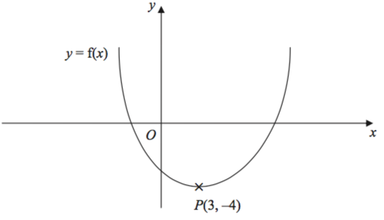

Write down the coordinates of the minimum point of the curve with the equation .

**..........................**

**(2 marks)**

**Question 21**

This is a sketch of the curve with the equation .  
The only minimum point of the curve is at .



Write down the coordinates of the minimum point of the curve with the equation

**..........................**

**(2 marks)**

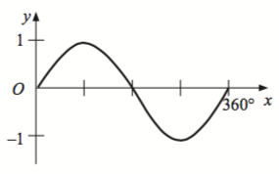**Question 22**

Here is the graph of , where

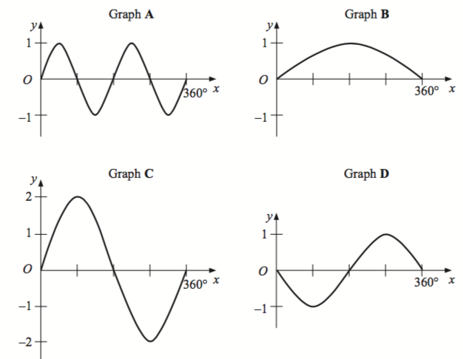

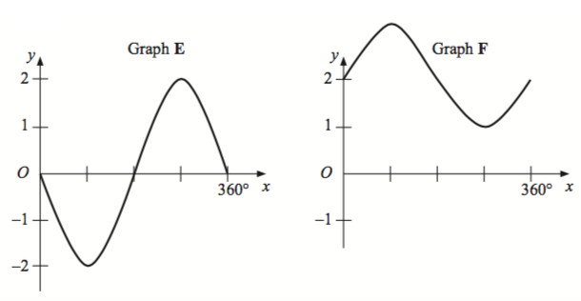

|  |  |
| --- | --- |
| Equation | Graph |
|  | .................. |
|  | .................. |
|  | .................. |
|  | .................. |
|  | .................. |
|  | .................. |

**(4 marks)**

**Question 23**

The diagram shows part of the curve with equation .  
The coordinates of the maximum point of the curve are .

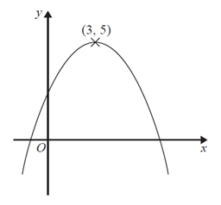

Write down the coordinates of the maximum point of the curve with equation

**..........................**

**(3 marks)**

**Question 24**

The diagram shows part of the curve with equation .  
The coordinates of the maximum point of the curve are .



Write down the coordinates of the maximum point of the curve with equation

**..........................**

**(1 mark)**

**Question 25**

The diagram shows part of the curve with equation .  
The coordinates of the maximum point of the curve are .



Write down the coordinates of the maximum point of the curve with equation

**..........................**

**(1 mark)**

**Question 26**

The curve with equation is transformed to give the curve with equation

Describe the transformation.

**..........................**

**(1 mark)**

**Question 27**

The diagram shows part of a sketch of the curve .

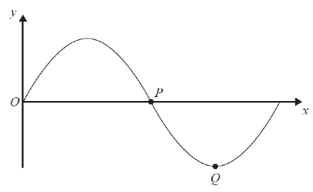

Write down the coordinates of the point .

**..........................**

**(1 mark)**

**Question 28**

The diagram shows part of a sketch of the curve *y* = sin *x*°.



Write down the coordinates of the point *Q*.

**..........................**

**(1 mark)**

**Question 29**

Here is a sketch of the curve *y* = *a* cos *bx*° + *c*, 0 < *x <* 360

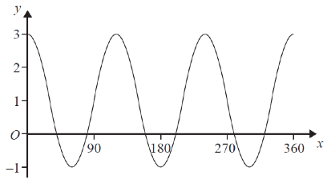

Find the values of *a*, *b* and *c*.

**..........................**

**(3 marks)**

**Question 30**

The graph of is shown on the grid.

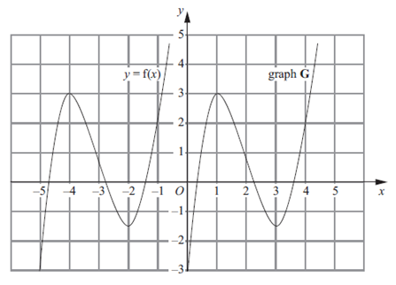

The graph **G** is a translation of the graph of .  
Write down, in terms of , the equation of graph **G**.

**..........................**

**(1 mark)**

**Question 31**

The graph of is shown on the grid.



The graph of has a maximum point at .

Write down the coordinates of the maximum point of the graph of .

**..........................**

**(2 marks)**

**Question 32**

The curve with equation is translated so that the point at (0, 0) is mapped onto the point (4, 0).

Find an equation of the translated curve.

**..........................**

**(2 marks)**

**Question 33**

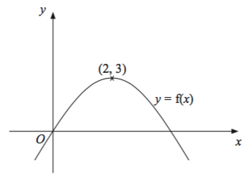

The diagram shows part of the curve with equation .

The coordinates of the maximum point of this curve are (2, 3).

(a) Write down the coordinates of the maximum point of the curve with equation

**..........................**

**(1 mark)**

**Question 34**



The diagram shows part of the curve with equation .

The coordinates of the maximum point of this curve are (2, 3).

(b) Write down the coordinates of the maximum point of the curve with equation

**..........................**

**(1 mark)**

**Question 35**



The diagram shows part of the curve with equation

The minimum point of the curve is at (2,-1)

The curve with equation has been transformed to give the curve with equation

Describe the transformation.

It is a  **..........................**

**(1 mark)**

**Question 36**



The diagram shows part of the curve with equation

The minimum point of the curve is at (2,-1)

The curve is reflected in the axis.

Find the equation of the curve following this transformation.

**..........................**

**(1 mark)**

**Question 37**



The diagram shows part of the curve with equation

The minimum point of the curve is at (2,-1)

Write down the coordinates of the minimum point of the curve with equation

**..........................**

**(1 mark)**

**Question 38**



The diagram shows part of the curve with equation

The minimum point of the curve is at (2,-1)

Write down the coordinates of the minimum point of the curve with equation

**..........................**

**(1 mark)**

**Question 39**

This is a sketch of the curve with equation .   
It passes through the origin .

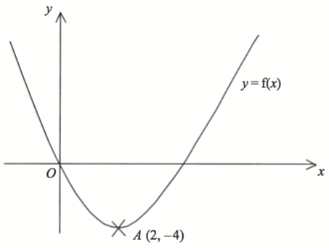

The only vertex of the curve is at .

The curve with equation has been translated to give the curve .

Find in terms of .

**..........................**

**(4 marks)**

**Question 40**

This is a sketch of the curve with equation .   
It passes through the origin .



The only vertex of the curve is at .

Write down the coordinates of the vertex of the curve with equation .

**..........................**

**(1 mark)**

**Question 41**

This is a sketch of the curve with equation .   
It passes through the origin .



The only vertex of the curve is at .

Write down the coordinates of the vertex of the curve with equation .

**..........................**

**(1 mark)**

**Question 42**

This is a sketch of the curve with equation .   
It passes through the origin .



The only vertex of the curve is at .

Write down the coordinates of the vertex of the curve with equation .

**..........................**

**(1 mark)**

**Question 43**

This is a sketch of the curve with equation .   
It passes through the origin .



The only vertex of the curve is at .

Write down the coordinates of the vertex of the curve with equation .

**..........................**

**(1 mark)**

**Question 44**

The axes below show the graph of and a translation of this graph, G.

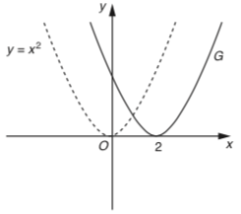

Write down the equation of graph G.

**..........................**

**(1 mark)**

**Question 45**

Write down the coordinates of the maximum point of for .

**..........................**

**(1 mark)**

**Question 46**

Write down the coordinates of the maximum point of for .

**..........................**

**(1 mark)**

**Question 47**

One solution to the equation is .

Find the value of .

**..........................**

**(2 marks)**

**Question 48**

One solution to the equation is .

Find another solution for in the range

**..........................**

**(1 mark)**

**Question 49**

The graph of is shown on the grid.

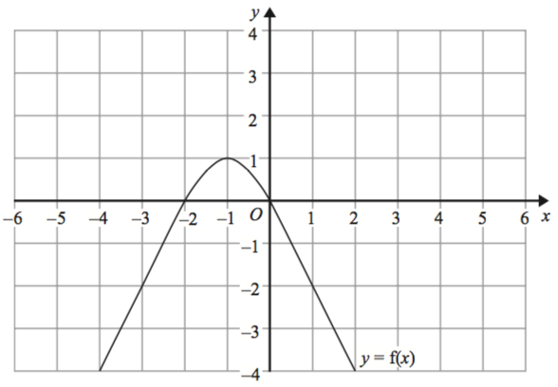

The graph of has a turning point at the point

Write down the coordinates of the turning point of the graph of

**..........................**

**(1 mark)**

**Question 50**

The graph of is shown on the grid.

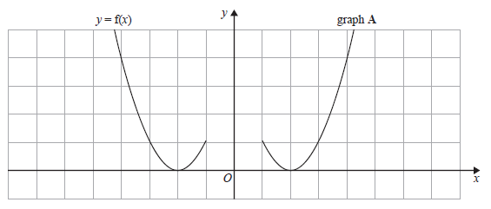

Graph is a reflection of the graph of .

(a) Write down the equation of graph .

**..........................**

**(1 mark)**

**Question 51**

The graph of is shown on the grid.

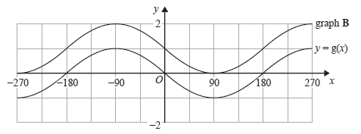

Graph is a translation of the graph of .

(a) Write down the equation of graph .

**..........................**

**(1 mark)**

**Question 52**

The graph of is shown.

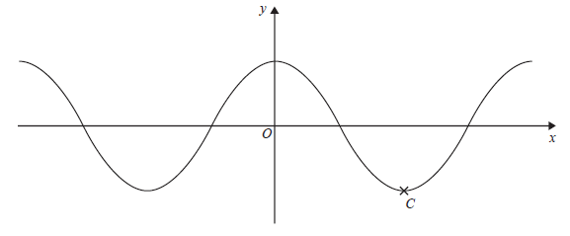

(c) Write down the coordinates of the point marked .

**..........................**

**(1 mark)**

**Question 53**

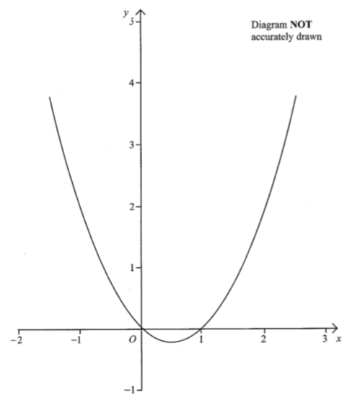

The diagram shows a sketch of the graph of .

Write down where the graph of crosses the -axis and where it crosses the -axis.

It crosses the -axis first at  **..........................**

and at  **..........................**

It crosses the -axis at  **..........................**

**Answers**

**Question 1**

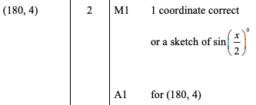

**Question 2**

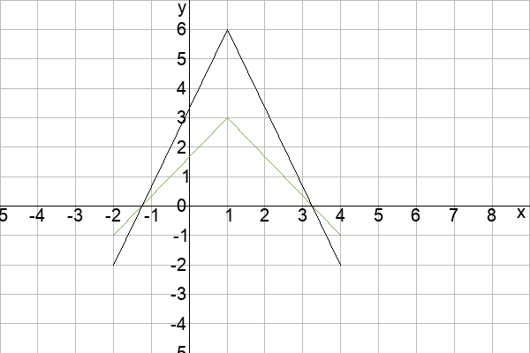

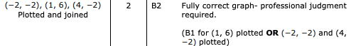

**Question 3**

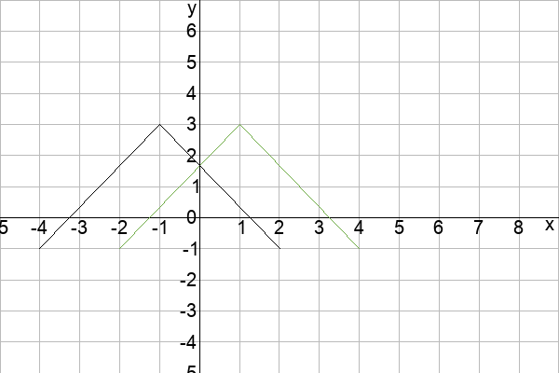

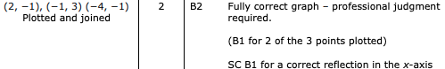

**Question 4**

../uploads/users/6190/images/img-6190-1562491269-413.png

**Question 5**

../uploads/users/6190/images/img-6190-1562491317-995.png

**Question 6**

,

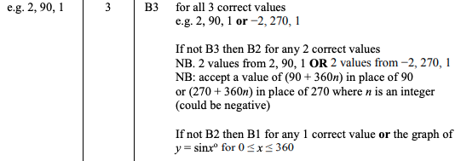

**Question 7**

../uploads/users/1379/images/img-1379-1550703766-251.png

**Question 8**

../uploads/users/84981/images/img-84981-1557063739-33.png

**Question 9**

../uploads/users/84981/images/img-84981-1557063801-183.png

**Question 10**



**Question 11**

../uploads/users/1379/images/img-1379-1556985358-370.png

**Question 12**

"-2 OR - 2 OR minus 2 OR take 2 OR take away 2 OR subtract 2" and "y"

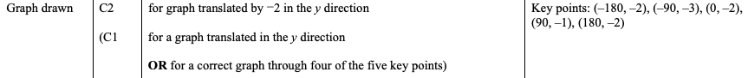

**Question 13**

../uploads/users/6190/images/img-6190-1551615079-83.png

**Question 14**

../uploads/users/6190/images/img-6190-1551615134-64.png

**Question 15**

../uploads/users/6190/images/img-6190-1551615168-754.png

**Question 16**

../uploads/users/6190/images/img-6190-1551615223-943.png

**Question 17**

../uploads/users/1379/images/img-1379-1551353222-700.png

**Question 18**

../uploads/users/1379/images/img-1379-1551353231-523.png

**Question 19**

../uploads/users/1379/images/img-1379-1551353242-864.png

**Question 20**

../uploads/users/1379/images/img-1379-1551016594-806.png

**Question 21**

../uploads/users/1379/images/img-1379-1551016602-214.png

**Question 22**

|  |  |
| --- | --- |
| Equation | Graph |
|  | **C** |
|  | **D** |
|  | **A** |
|  | **F** |
|  | **B** |
|  | **E** |

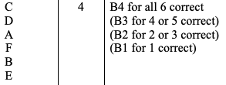

**Question 23**

../uploads/users/1379/images/img-1379-1550785284-928.png

**Question 24**

../uploads/users/1379/images/img-1379-1550785293-486.png

**Question 25**

../uploads/users/1379/images/img-1379-1550785302-483.png

**Question 26**

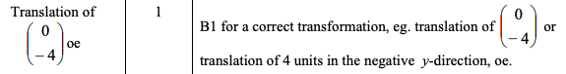

**Question 27**

../uploads/users/1379/images/img-1379-1550782990-568.png

**Question 28**

../uploads/users/1379/images/img-1379-1550783007-144.png

**Question 29**

, ,

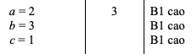

**Question 30**

../uploads/users/1379/images/img-1379-1550758962-469.png

**Question 31**

../uploads/users/1379/images/img-1379-1550758972-352.png

**Question 32**

../uploads/users/1379/images/img-1379-1550756424-158.png

**Question 33**

../uploads/users/1379/images/img-1379-1550747770-721.png

**Question 34**

../uploads/users/1379/images/img-1379-1550747780-757.png

**Question 35**

"translation"

../uploads/users/1379/images/img-1379-1550703809-2.png

**Question 36**

../uploads/users/1379/images/img-1379-1550703798-579.png

**Question 37**

../uploads/users/1379/images/img-1379-1550703786-729.png

**Question 38**

../uploads/users/1379/images/img-1379-1550703778-174.png

**Question 39**

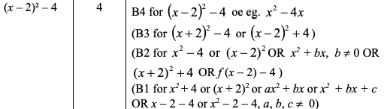

**Question 40**

../uploads/users/1379/images/img-1379-1550695670-472.png

**Question 41**

../uploads/users/1379/images/img-1379-1550695661-797.png

**Question 42**

../uploads/users/1379/images/img-1379-1550695652-421.png

**Question 43**

../uploads/users/1379/images/img-1379-1550695642-81.png

**Question 44**

../uploads/users/1379/images/img-1379-1550599964-903.png

**Question 45**

../uploads/users/1379/images/img-1379-1550339669-370.png

**Question 46**

../uploads/users/1379/images/img-1379-1550339680-865.png

**Question 47**

../uploads/users/1379/images/img-1379-1550339690-324.png

**Question 48**

120

../uploads/users/1379/images/img-1379-1550339704-13.png

**Question 49**

../uploads/users/1379/images/img-1379-1549719665-993.png

**Question 50**

../uploads/users/1379/images/img-1379-1549712397-777.png

**Question 51**

../uploads/users/1379/images/img-1379-1549712407-455.png

**Question 52**

../uploads/users/1379/images/img-1379-1549712418-207.png

**Question 53**

It crosses the -axis first at 1 and and at 2 and It crosses the -axis at 2