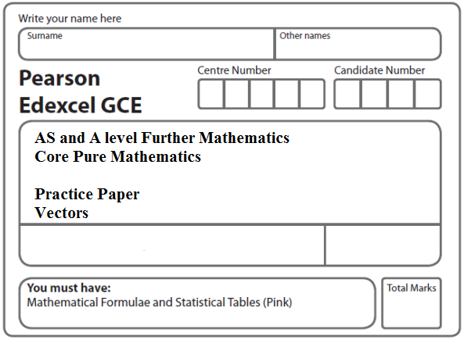

**Instructions**

* Use black ink or ball-point pen.
* If pencil is used for diagrams/sketches/graphs it must be dark (HB or B).
* Fill in the boxes at the top of this page with your name, centre number and candidate number.
* Answer all the questions and ensure that your answers to parts of questions are clearly labelled.
* Answer the questions in the spaces provided – there may be more space than you need.
* You should show sufficient working to make your methods clear. Answers without working may not gain full credit.
* Inexact answers should be given to three significant figures unless otherwise stated.

**Information**

* A booklet ‘Mathematical Formulae and Statistical Tables’ is provided.
* There are 8 questions in this question paper. The total mark for this paper is 101.
* The marks for each question are shown in brackets – use this as a guide as to how much time to spend on each question.
* Calculators must not be used for questions marked with a * sign.

**Advice**

• Read each question carefully before you start to answer it.

• Try to answer every question.

• Check your answers if you have time at the end.

• If you change your mind about an answer, cross it out and put your new answer and any working underneath.

**1.** With respect to a fixed origin *O*, the lines *l*1 and *l*2 are given by the equations

*l*1: **r** =  + *λ*,  *l*2: **r** = + *μ* ,

where *λ* and *μ* are scalar parameters and *p* is a constant.

The lines *l*1 and *l*2 intersect at the point *A*.

(*a*) Find the coordinates of *A*.

**(2)**

(*b*) Find the value of the constant *p*.

**(3)**

(*c*) Find the acute angle between *l*1 and *l*2, giving your answer in degrees to 2 decimal places.

**(3)**

The point *B* lies on *l*2 where *μ* = 1.

(*d*) Find the shortest distance from the point *B* to the line *l*1, giving your answer to 3 significant figures.

**(3)**

**(Total 11 marks)**

**___________________________________________________________________________**

**2.** Relative to a fixed origin *O*, the point *A* has position vector **i** − 3**j** + 2**k** and the point *B* has position vector −2**i** + 2**j** − **k**. The points *A* and *B* lie on a straight line *l*.

(*a*) Find .

**(2)**

(*b*) Find a vector equation of *l*.

**(2)**

The point *C* has position vector 2**i** + *p***j** − 4**k** with respect to *O*, where *p* is a constant.

Given that *AC* is perpendicular to *l*, find

(*c*) the value of *p*,

**(4)**

(*d*) the distance *AC*.

**(2)**

**(Total 10 marks)**

**___________________________________________________________________________**

**3.** With respect to a fixed origin *O*, the lines *l*1 and *l*2 are given by the equations

*l*1 : **r** = + 𝜆, *l*2 : **r** = + *μ*

where 𝜆and *μ* are scalar parameters.

The lines *l*1 and *l*2 intersect at the point *X*.

(*a*)Find the coordinates of the point *X*.

**(3)**

(*b*)Find the size of the acute angle between *l*1 and *l*2, giving your answer in degrees to

2 decimal places.

**(3)**

The point *A* lies on *l*1 and has position vector 

(*c*)Find the distance *AX*, giving your answer as a surd in its simplest form.

**(2)**

The point *Y* lies on *l*2. Given that the vector ** is perpendicular to the line *l*1

(*d*)find the distance *YA*, giving your answer to one decimal place.

**(2)**

The point *B* lies on *l*1 where |**| = 2||.

(*e*)Find the two possible position vectors of *B*.

**(3)**

**(Total 13 marks)**

**___________________________________________________________________________**

**4.** With respect to a fixed origin *O*, the lines *l*1and *l*2 are given by the equations

*l*1: **r** =  + *λ* , *l*2: **r** =  + *μ* ,

where *μ* and *λ* are scalar parameters.

(*a*) Show that *l*1and *l*2 meet and find the position vector of their point of intersection *A*.

**(6)**

(*b*) Find, to the nearest 0.1°, the acute angle between *l*1and *l*2.

**(3)**

The point *B* has position vector .

(*c*) Show that *B* lies on *l*1.

**(1)**

(*d*) Find the shortest distance from *B* to the line *l*2, giving your answer to 3 significant figures.

**(4)**

**(Total 14 marks)**

**___________________________________________________________________________**

**5.** With respect to a fixed origin *O*, the lines *l*1 and *l*2 are given by the equations

*l*1 : **r** = (9**i** + 13**j** – 3**k**) + *λ* (**i** + 4**j** – 2**k**)

*l*2 : **r** = (2**i** – **j** + **k**) + *μ* (2**i** + **j** + **k**)

where *λ* and *μ* are scalar parameters.

(*a*) Given that *l*1 and *l*2 meet, find the position vector of their point of intersection.

**(5)**

(*b*) Find the acute angle between *l*1 and *l*2, giving your answer in degrees to 1 decimal place.

**(3)**

Given that the point *A* has position vector 4**i** + 16**j** – 3**k** and that the point *P* lies on *l*1 such that *AP* is perpendicular to *l*1,

(*c*) find the exact coordinates of *P*.

**(6)**

**(Total 14 marks)**

**___________________________________________________________________________**

**6.** Relative to a fixed origin *O*, the point *A* has position vector (2**i** – **j** + 5**k**),

the point *B* has position vector (5**i** + 2**j** + 10**k**),

and the point *D* has position vector (–**i** + **j** + 4**k**).

The line *l* passes through the points *A* and *B*.

(*a*) Find the vector .

**(2)**

(*b*) Find a vector equation for the line *l*.

**(2)**

(*c*) Show that the size of the angle *BAD* is 109°, to the nearest degree.

**(4)**

The points *A*, *B* and *D*, together with a point *C*, are the vertices of the parallelogram *ABCD*, where = .

(*d*) Find the position vector of *C*.

**(2)**

(*e*) Find the area of the parallelogram *ABCD*, giving your answer to 3 significant figures.

**(3)**

(*f*) Find the shortest distance from the point *D* to the line *l*, giving your answer to 3 significant figures.

**(2)**

**(Total 15 marks)**

**___________________________________________________________________________**

**7.** Relative to a fixed origin *O*, the point *A* has position vector 

and the point *B* has position vector .

The line *l*1 passes through the points *A* and *B*.

(*a*) Find the vector .

**(2)**

(*b*) Hence find a vector equation for the line *l*1.

**(1)**

The point *P* has position vector .

Given that angle *PBA* is *θ*,

(*c*) show that .

**(3)**

The line *l*2 passes through the point *P* and is parallel to the line *l*1.

(*d*) Find a vector equation for the line *l*2.

**(2)**

The points *C* and *D* both lie on the line *l*2.

Given that *AB* = *PC* = *DP* and the *x* coordinate of *C* is positive,

(*e*) find the coordinates of *C* and the coordinates of *D*.

**(3)**

(*f*) find the exact area of the trapezium *ABCD*, giving your answer as a simplified surd.

**(4)**

**(Total 15 marks)**

**___________________________________________________________________________**

**8.** With respect to a fixed origin *O*, the line *l* has equation

, where *λ* is a scalar parameter.

The point *A* lies on *l* and has coordinates (3, – 2, 6).

The point *P* has position vector (–*p***i** + 2*p***k**) relative to *O*, where *p* is a constant.

Given that vector is perpendicular to *l*,

(*a*) find the value of *p.*

**(4)**

Given also that *B* is a point on *l* such that <*BPA* = 45°,

(*b*) find the coordinates of the two possible positions of *B*.

**(5)**

**(Total 9 marks)**

**TOTAL FOR PAPER: 101 MARKS**