**The Fate of Dido**

**Key**

Juno

Mercury

Venus

Cupid

Jupiter

The Fates

Aeneas

Dido

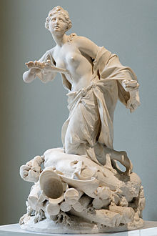*Divide up the pie chart between the different culprits in the key to show who is to blame for the fate of Dido:*