

**Higher IGCSE (9 – 1) Revision Pack**

**Sets**

**Name --------------------------------**

**Questions**

**Q1.**

Each student in a group of 32 students was asked the following question.

"Do you have a desktop computer (*D*), a laptop (*L*) or a tablet (*T* )?"

Their answers showed that

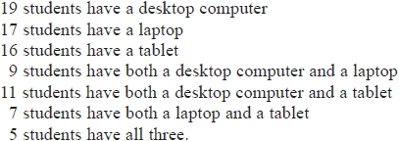

(a)  Using this information, complete the Venn diagram to show the number of students in each appropriate subset.

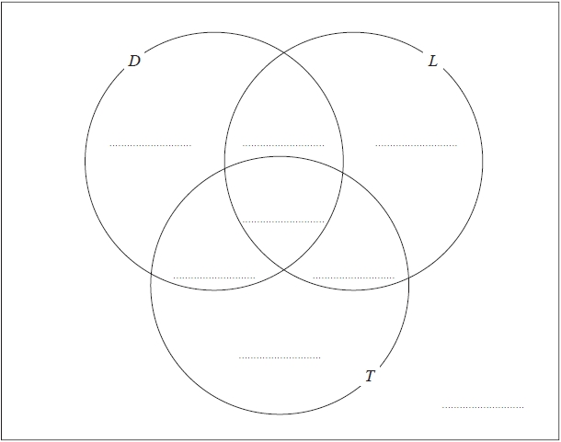

**(3)**

One of the students with both a desktop computer and a laptop is chosen at random.

(b)  Find the probability that this student also has a tablet.

...........................................................

**(1)**

**(Total for question = 4 marks)**

**Q2.**

The Venn diagram shows a universal set  and three sets *X*, *Y* and *Z*.

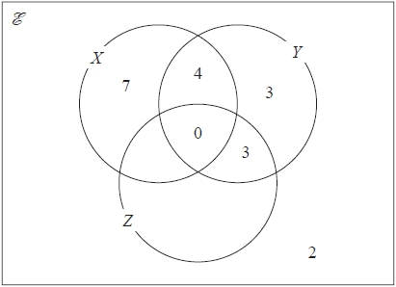

The numbers shown represent **numbers** of elements.

n(*X* ′ ) = 14

n(*Z*) = 14

(a)  Complete the Venn diagram.

**(2)**

(b)  Find the value of

(i)  n(*X* ∪ *Z*)

...........................................................

(ii)  n(*X* ∩ Y ′ )

...........................................................

**(2)**

**(Total for question = 4 marks)**

**Q3.**

*A* and *B* are two sets.

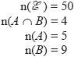

1. Complete the Venn diagram to show the numbers of elements.

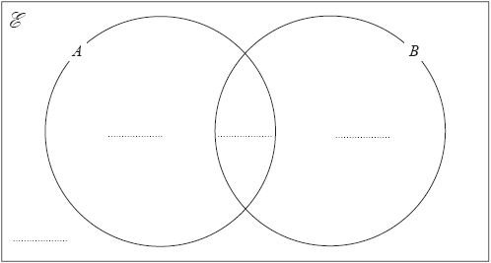

**(2)**

(b)  Find

(i)  n(A ∩ B′)

...........................................................

(ii)  n(A ∪ B′)

...........................................................

**(2)**

**(Total for question = 4 marks)**

**Q4.**

*A* and *B* are two sets.

        n() = 36   
        n(*B*) = 21   
   n(*A**B*) = 8   
        n(*A*') = 18

(a)  Complete the Venn diagram to show the **number of elements** in each region of the Venn diagram.

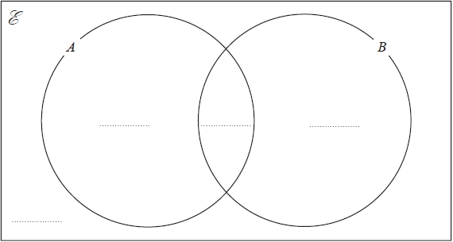

**(3)**

(b)  Find n(*A**B*)

...........................................................

**(1)**

(c)  Find n(*A**B*')

...........................................................

**(1)**

**(Total for question = 5 marks)**

**Q5.**

 = 1, 2, 3, 4, 5, 6, 7, 8, 9, 10, 11, 12, 13   
*A* = 3, 7, 11, 13   
*B* = 3, 6, 9, 12, 13   
*C* = 2, 3, 5, 6, 7, 8

(a)  Complete the Venn diagram.

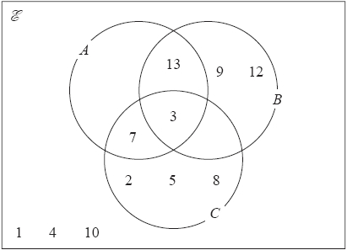

**(1)**

(b)  List the members of the set 

...........................................................

**(1)**

(c)  List the members of the set  

...........................................................

**(1)**

(d)  Find   

...........................................................

**(1)**

**(Total for question = 4 marks)**

**Q6.**

There are 100 students in Year 11

All 100 students study at least one of art, drama and music.

  7 of the students study art and drama and music.   
23 of the students study art and drama.   
35 of the students study art and music.   
12 of the students study music and drama.   
65 of the students study art.   
52 of the students study music.

(a)  Draw a Venn diagram to show this information.

**(3)**

One of the 100 students is selected at random.

(b)  Find the probability that this student studies Drama but not Music.

...........................................................

**(1)**

Given that the student studies Drama,

(c)  find the probability that this student also studies Art.

...........................................................

**(1)**

**(Total for question = 5 marks)**

**Q7.**



(a)  List the members of the set

(i)  

...........................................................

(ii)  

...........................................................

**(2)**

(b) Explain why 

.............................................................................................................................................

**(1)**

**(Total for question = 3 marks)**

**Q8.**

 = whole numbers   
*A* = factors of 100   
*B* = multiples of 5   
List the members of the set *A* ∩ *B*

...........................................................

**(Total for question = 2 marks)**

**Q9.**

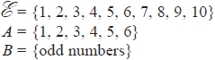

(a)  List the members of 

...........................................................

**(1)**

*C* is a set such that   
The set *C* has 4 members.

(b)  List the members of one possible set *C*

...........................................................

**(2)**

**(Total for question = 3 marks)**

**Q10.**

= { even numbers }  
*A* = { 2, 4, 6, 8, 10 }

(a) *B* is a set such that *A* ∩ *B* = { 4, 8 }  
The set *B* has 3 members.

List the members of one possible set *B*.

...........................................................

**(2)**

(b) *C* is a set such that *A* ∩ *C* = ∅   
The set *C* has 3 members.

List the members of one possible set *C*.

...........................................................

**(1)**

**(Total for question = 3 marks)**

**Q11.**



(a)  List the members of the set

(i)  A  B

...........................................................

(ii)  A  B

...........................................................

**(2)**

(b)  Find  n(*A*′ )

...........................................................

**(1)**

**(Total for question = 3 marks)**

**Q12.**

(a)  = {Students in Year 12}  
G = {Students who study German}  
F = {Students who study French}  
M = {Students who study Maths}

(i) G ∩ M = ∅

Use this information to write a statement about the students who study German in Year 12

      ..............................................................................................................................................

(ii) Preety is a student in Year 12   
Preety ∉ *F*.

Use this information to write a statement about Preety.

      ..............................................................................................................................................

**(2)**

(b) A = 2, 4, 6, 8, 10   
A ∩ B = 2, 4  
A ∪ B = 1, 2, 3, 4, 6, 8, 10

List all the members of set *B*.

...........................................................

**(2)**  
**(Total for question is 4 marks)**

**Q13.**

*A* and *B* are two sets.

n() = 37

n(*A*) = 22

n(*A* ∩ *B*) = 12

n(*A* ∪ *B*) = 30

(a) Complete the Venn Diagram to show the **numbers** of elements.

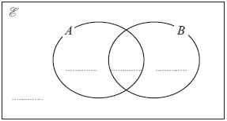

**(2)**

(b) Find     (i)    n(*A* ∪ *B*')

...........................................................

(i)    n(*A*' ∪ *B*')

...........................................................

**(2)**

**(Total for question is 4 marks)**

**Q14.**

 = positive whole numbers **less than** 13  
*A* = even numbers  
*B* = multiples of 3  
*C* = prime numbers

(a)  List the members of the set

(i)  A  B

...........................................................

(ii)  B  C

...........................................................

**(2)**

(b)  Is it true that 14   *A*?

Tick () the appropriate box.

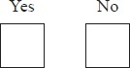

Explain your answer.

.............................................................................................................................................

**(1)**

**(Total for Question is 3 marks)**

**Q15.**

 = {1, 2, 3, 4, 5, 6, 7, 8, 9}

*A* = {1, 3, 5, 7}

*B* = {2, 4, 6, 8}

(a)   Explain why *A* ∩ *B* = ∅

.............................................................................................................................................

.............................................................................................................................................

**(1)**

*x*  and *x* ∉ *A* ∪ *B*

(b)   Write down the value of *x*.

*x* = ...........................................................

**(1)**

*A* ∩ *C* = {3, 7}, *B* ∩ *C* = {8} and *A* ∪ *B* ∪ *C* = 

(c)   List all the members of *C*.

...........................................................

**(2)**

**(Total for Question is 4 marks)**

**Q16.**

(a)   *A* = {p, r, a, g, u, e}

*B* = {p, a, r, i, s}

*C* = {b, u, d, a, p, e, s, t}

List the members of the set

(i)   *A* ∩ *B*

...........................................................

(ii)   *B* ∪ *C*

...........................................................

**(2)**

(b)   *D* = {r, o, m, e}

*E* = {l, i, s, b, o, n}

*F* = {b, e, r, l, i, n}

Put one of the letters *D*, *E* or *F* in the box below to make the statement correct.



Explain your answer.

.............................................................................................................................................

**(1)**

**(Total for Question is 3 marks)**

**Q17.**

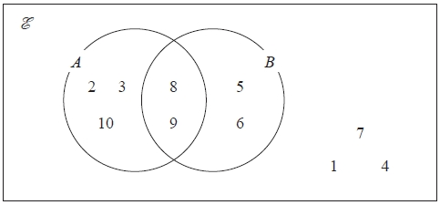

The Venn diagram shows all of the elements in sets *A*, *B* and.

(a)  Write down the elements in *A'*

...........................................................

**(1)**

(b) Find n(*A* ∩ *B*)*'*

...........................................................

**(1)**

(c) Find the elements in (*A* ∩ *B*)  (*A**B*)*'*

...........................................................

**(1)**

*A* ∩ *C* = Ø   
*B**C* = {5, 6, 7, 8, 9}  
n(*C*) = 3

(d)  Write down the elements in *C*.

...........................................................

**(1)**

  **(Total for question = 4 marks)**

**Q18.**

 = {1, 2, 3, 4, 5, 6, 7, 8, 9, 10}

*A* = {even numbers}

*B* = {multiples of 3}

(a)  List the members of set *B*.

...........................................................

**(1)**

(b)  Find *A**B*

...........................................................

**(1)**

(c)  Find *A* ∩ *B*

...........................................................

**(1)**

*x* is a member of 

*x**B*

*x**A*

(d)  What are the possible values of *x*?

...........................................................

**(2)**

  **(Total for question = 5 marks)**

**Q19.**

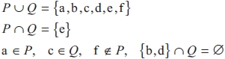

(a)  List the members of the set *P*.

...........................................................

**(2)**

(b)  List the members of the set *Q*.

...........................................................

**(1)**

**(Total for question = 3 marks)**

**Q20.**

The Venn diagram shows a universal set  and sets *A*, *B* and *C*, where 6, 3, 7, 5, 2, 9, 4 and 8 represent **numbers** of elements.

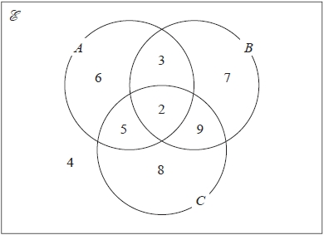

(a)  Find n(*A**B*)′

...........................................................

**(1)**

(b)  Find n((*A**C*)′ *B*)

...........................................................

**(1)**

(c)  On the Venn diagram, shade the region that represents the set (*A*  *B*)  *C*

**(1)**

**(Total for question = 3 marks)**

**Q21.**

*A*, *B* and *C* are three sets.

*A* ∩ *B* = ∅ and *C* ⊂ *A*

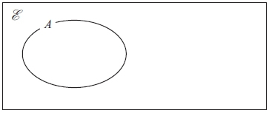

(a) Complete the Venn diagram to show the sets *B* and *C*

**(2)**

(b) On the Venn diagram, shade the region that represents *A* ∩ *C* ′

**(1)**

**(Total for question = 3 marks)**

**Q22.**

There are 31 students in a class.  
 The only languages available for the class to study are French and Spanish.  
 17 students study French.  
 15 students study Spanish.  
 6 students study neither French nor Spanish.

Using a Venn diagram, or otherwise, work out how many students study only one  
 language.

...........................................................

**(Total for question = 4 marks)**

**Q23.**

The Venn diagram shows a universal set  and three sets *A*, *B* and *C*.

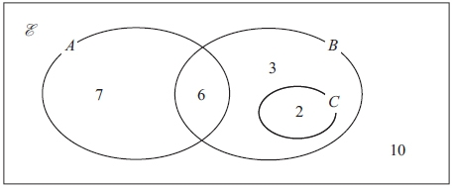

7, 6, 3, 2 and 10 represent the **numbers** of elements.

Find

(i)     n(*A* ∪ *B*)

...........................................................

(ii)     n(*A*′)

...........................................................

(iii)     n(*B* ∩ *C*′)

...........................................................

(iv)     n(*A*′ ∪ *B*′)

...........................................................

**(Total for question = 4 marks)**

**Q24.**

The Venn diagram shows a universal set  and 3 sets *A*, *B* and *C*.

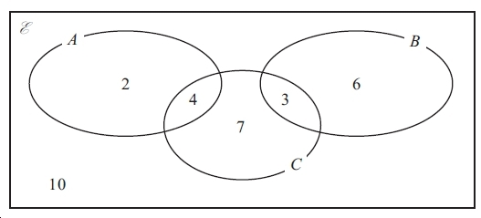

2, 4, 7, 3, 6 and 10 represent **numbers** of elements.

Find

(i) n (*A* ∪ *B*)

...............................

(ii) n (*B*′)

...............................

(iii) n (*A* ∩ *C*′)

...............................

(iv) n (*B*′ ∩ *C*′)

...............................

**(Total for question = 4 marks)**

**Q25.**

A garage tests cars for faults.  
There are three types of fault - braking, steering and lighting.  
A car fails the test if it has one or more of these three types of fault.

Last week, 11 cars had braking faults   
9 cars had steering faults  
7 cars had lighting faults  
no car had both steering faults and lighting faults  
2 cars had both braking faults and steering faults  
3 cars had both braking faults and lighting faults.

By drawing a Venn Diagram, or otherwise, find the number of cars which failed the test  
 last week.

...........................................................

**(Total for question = 3 marks)**

**End of questions**