

**Higher IGCSE (9 – 1) Revision Pack**

**Similarity and congruence**

**Name --------------------------------**

**Questions**

**Q1.**

Here are two supermarket price tickets.

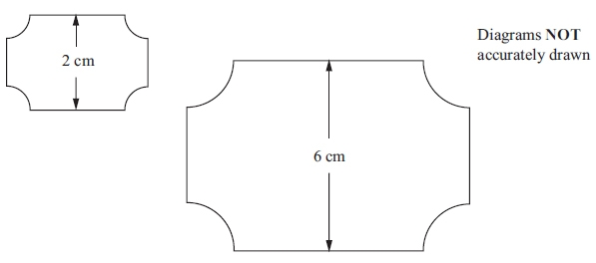

The two supermarket price tickets are mathematically similar.

The area of the smaller ticket is 7 cm2.  
 Calculate the area of the larger ticket.

........................................................... cm2

**(Total for question = 2 marks)**

**Q2.**

The diagram shows two regular hexagons, *OABCDE* and *OFGHIJ*.

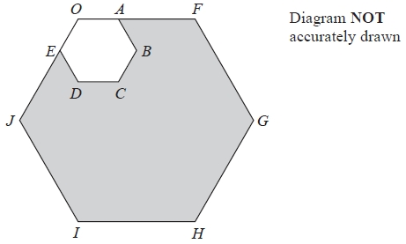

*OAF* and *OEJ* are straight lines.   
*OF* = 3 *OA*.   
The area of *OABCDE* is 4 cm2.

Calculate the area of the shaded region.

........................................................... cm2

**(Total for Question is 3 marks)**

**Q3.**

The diagram shows two mathematically similar pots, **A** and **B**.

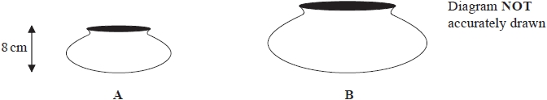

**A** has a volume of 264 cm3  
**B** has a volume of 891 cm3

**A** has a height of 8 cm

(a)  Work out the height of pot **B**.

........................................................... cm

**(2)**

**B** has a surface area of 459 cm2

(b)  Work out the surface area of pot **A**.

........................................................... cm2

**(2)**

**(Total for question = 4 marks)**

**Q4.**

**L** and **M** are two mathematically similar prisms.

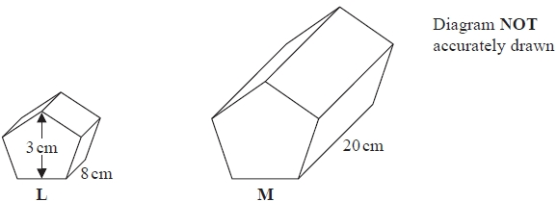

Prism **L** has length 8 cm.   
Prism **M** has length 20 cm.

Prism **L** has height 3 cm.

(a)  Work out the height of prism **M**.

........................................................... cm

**(2)**

Prism **M** has a volume of 1875 cm3

(b)  Work out the volume of prism **L**.

........................................................... cm3

**(2)**

**(Total for question = 4 marks)**

**Q5.**

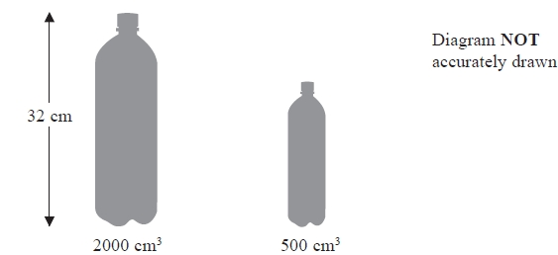

Zane buys mineral water in large bottles and in small bottles.   
The large bottles are mathematically similar to the small bottles.   
Large bottles have a height of 32 cm and a volume of 2000 cm3  
Small bottles have a volume of 500 cm3

Work out the height of a small bottle.   
Give your answer correct to 3 significant figures.

........................................................... cm

**(Total for question = 3 marks)**

**Q6.**

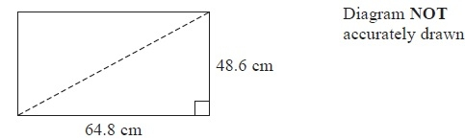

A TV screen is rectangular.   
The width of the rectangle is 64.8 cm and the height is 48.6 cm.   
The length of a diagonal of the rectangle gives the 'size' of the TV screen.

(a)  Calculate the 'size' of the TV screen.

........................................................... cm

**(3)**

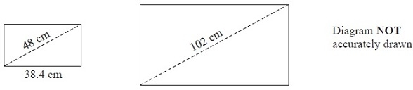

The diagram shows two rectangular TV screens.   
The rectangles are similar.   
The 'size' of the smaller screen is 48 cm.   
The width of the smaller screen is 38.4 cm.   
The 'size' of the larger screen is 102 cm.

(b)  Calculate the width of the larger TV screen.

........................................................... cm

**(2)**

**(Total for Question is 5 marks)**

**Q7.**

Here are two mathematically similar cups, **A** and **B**.

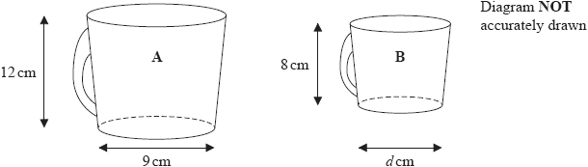

**A** has height 12 cm and base diameter 9 cm.   
**B** has height 8 cm and base diameter *d* cm.

(a)  Work out the value of *d*.

...........................................................

**(2)**

The volume of **B** is 160 millilitres.

(b)  Work out the volume of **A**.

........................................................... millilitres

**(2)**

Two solid plates, **P** and **Q**, are mathematically similar and made of the same material.

The surface area of **P** is *p* cm2  
The surface area of **Q** is *q* cm2  
The weight of **P** is *w* grams.

(c)  Find an expression for the weight of **Q**.

Give your answer in terms of *p*, *q* and *w*.

........................................................... grams

**(2)**

**(Total for question = 6 marks)**

**Q8.**

*PQRS* and *PLMN* are similar quadrilaterals.

*PN* = 12 cm, *NS* = 8 cm, *PL* = 9 cm and *RS* = 13.5 cm.

*LM* is parallel to *QR* and *MN* is parallel to *RS*.

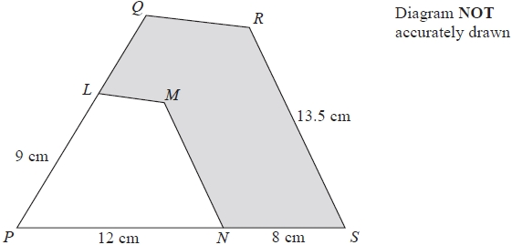

(a)  Work out the length of *MN*.

........................................................... cm

**(2)**

(b)  Work out the length of *LQ*.

........................................................... cm

**(2)**

The area of *PLMN* is *A* cm2  
The area of *PQRS* is *kA* cm2

(c)  Find the value of *k*.

*k* = ...........................................................

**(1)**

The area of the shaded region is 105.6 cm2

(d)  Work out the value of *A*.

*A* = ...........................................................

**(3)**

**(Total for question = 8 marks)**

**Q9.**

*ABCD* and *APQR* are two similar quadrilaterals.

*PQ* = 9 cm.  
*BC* = 6 cm.  
*AD* = 5 cm.  
*QR* = 12 cm.

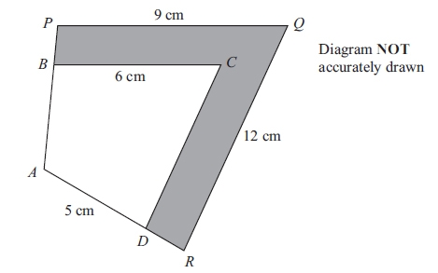

(a) Find the length of *DC*.

........................................................... cm

**(2)**

(b) Find the length of *AR*.

........................................................... cm

**(2)**

The area of the quadrilateral *ABCD* is 32 cm2.

(c) Calculate the area of the shaded region.

........................................................... cm2

**(3)**

**(Total for question is 7 marks)**

**Q10.**

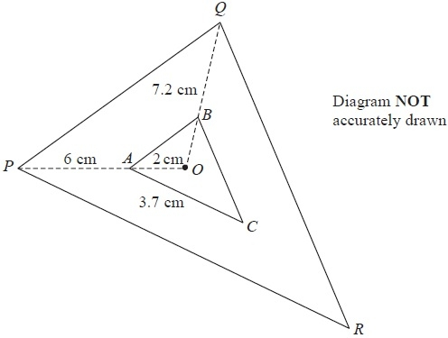

Triangle *PQR* is an enlargement, centre *O*, of triangle *ABC*.   
*OAP* and *OBQ* are straight lines.   
*OA* = 2 cm.   
*AP* = 6 cm.   
*BQ* = 7.2 cm.   
*AC* = 3.7 cm.

(a)  Work out the length of *OB*.

........................................................... cm

**(2)**

(b)  Work out the length of *PR*.

........................................................... cm

**(3)**

The area of triangle *PQR* is 72 cm2

(c)  Work out the area of triangle *ABC*.

........................................................... cm2

**(2)**

**(Total for Question is 7 marks)**

**Q11.**

The table shows information about the weights of 80 parcels.

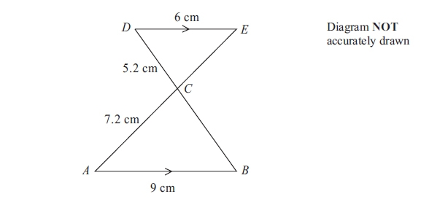

*AB* is parallel to *DE*.  
*ACE* and *BCD* are straight lines.  
*AB* = 9 cm.  
*AC* = 7.2 cm.  
*CD* = 5.2 cm.  
*DE* = 6 cm.

(a) Calculate the length of *BC*.

........................................................... cm

**(2)**

(b) Calculate the length of *CE*.

........................................................... cm

**(2)**

**(Total for question = 4 marks)**

**Q12.**

In the diagram, *DAPS* and *CBQR* are straight lines.   
*AB* is parallel to *QP* and *DC* is parallel to *RS*.   
*AD* = 11 cm, *BC* = 5 cm, *PS* = 27.5 cm and *RS* = 42.5 cm.

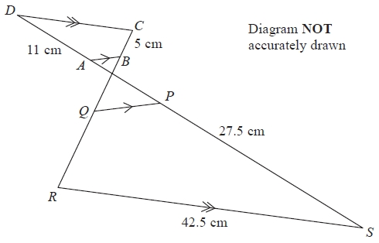

Quadrilateral *ABCD* is similar to quadrilateral *PQRS*.

(a)   Find the ratio of the length of *AB* to the length of *PQ*.   
Give your answer in the form 1 : *n*

1 : ...........................................................

**(2)**

(b)   Work out the length of *RQ*.

........................................................... cm

**(2)**

(c)   Work out the length of *CD*.

........................................................... cm

**(2)**

The area of quadrilateral *ABCD* is 54 cm2

(d)   Work out the area of quadrilateral *PQRS*.

........................................................... cm2

**(2)**  
**(Total for Question is 8 marks)**

**Q13.**

Solid **A** and solid **B** are mathematically similar.

Solid **A** has surface area 384 cm2  
Solid **B** has surface area 864 cm2

Solid **B** has a volume of 2457 cm3

Calculate the volume of solid **A**.

........................................................... cm3

**(Total for question = 3 marks)**

**Q14.**

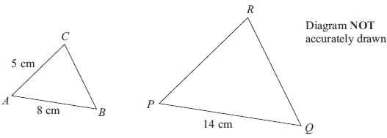

Triangle *ABC* is similar to triangle *PQR*.  
*AB* corresponds to *PQ*.  
*AC* corresponds to *PR*.  
*AB* = 8 cm.  
*AC* = 5 cm.  
*PQ* = 14 cm.

(a) Calculate the length of *PR*.

...........................................................cm

**(2)**

The area of triangle *ABC* is 16 cm2

(b) Calculate the area of triangle *PQR*.

...........................................................cm2

**(3)**

**(Total for question = 5 marks)**

**Q15.**

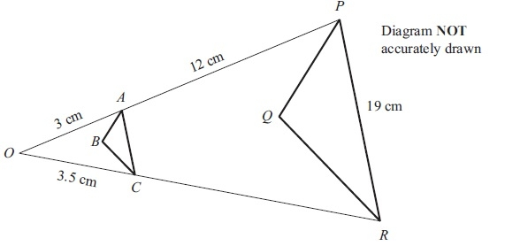

Triangle *PQR* is an enlargement, centre *O*, of triangle *ABC*.  
*OAP* and *OCR* are straight lines.  
*OA* = 3 cm.  
*AP* = 12 cm.  
*OC* = 3.5 cm.  
*PR* = 19 cm.

(a) Work out the length of *CR*.

........................................................... cm

**(2)**

(b) Work out the length of *AC*.

........................................................... cm

**(3)**

The area of triangle *ABC* is 2 cm2

(c) Work out the area of triangle *PQR*.

........................................................... cm2

**(2)**

**(Total for question = 7 marks)**

**Q16.**

The diagram shows two mathematically similar vases, **A** and **B**.

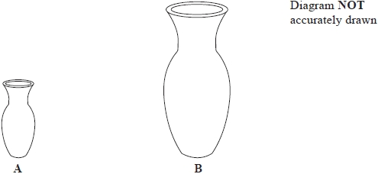

Vase **A** has a surface area of 120 cm2  
Vase **B** has a surface area of 750 cm2 and a volume of 1600 cm3

Work out the volume of vase **A**.

........................................................... cm3

**(Total for question = 3 marks)**

**Q17.**

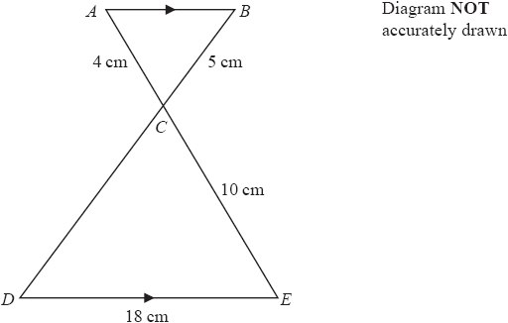

*ACE* and *BCD* are straight lines.   
*AB* is parallel to *DE*.

(a)  Calculate the length of *CD*.

........................................................... cm

**(2)**

(b)  Calculate the length of *AB*.

........................................................... cm

**(2)**

The area of triangle *ABC* = *T* cm2  
(c)  Find the area of triangle *CDE* in terms of *T*.

........................................................... cm2

**(1)**

**(Total for question = 5 marks)**

**Q18.**

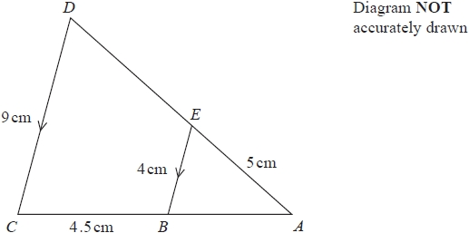

Triangle *ABE* is similar to triangle *ACD*.   
*AED* and *ABC* are straight lines.   
*EB* and *DC* are parallel.   
*AE* = 5cm, *BC* = 4.5cm, *BE* = 4cm, *CD* = 9cm

(a)  Calculate the length of *AD*.

........................................................... cm

**(2)**

(b)  Calculate the length of *AB*.

........................................................... cm

**(2)**

The area of quadrilateral *BCDE* is *x* cm2  
The area of triangle *ABE* is *y* cm2

(c)  Find an expression for *y* in terms of *x*.

Give your answer as simply as possible.

*y* = ...........................................................

**(3)**

**(Total for question = 7 marks)**

**Q19.**

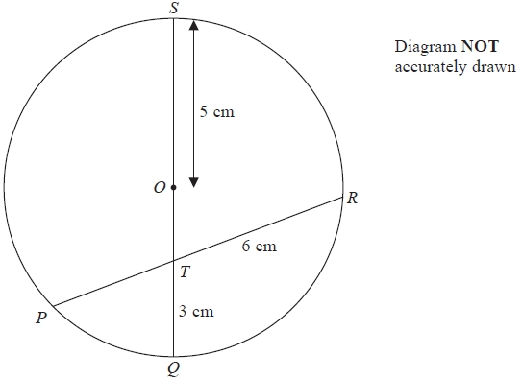

*P*, *Q*, *R* and *S* are points on a circle, centre *O*.   
*QS* is a diameter of the circle.   
*QS* and *PR* intersect at the point *T*.   
*OS* = 5 cm, *QT* = 3 cm and *TR* = 6 cm.

Work out the length of *PT*.

........................................................... cm

**(Total for question = 3 marks)**

**Q20.**

Triangles *ABC* and *ACD* are similar.

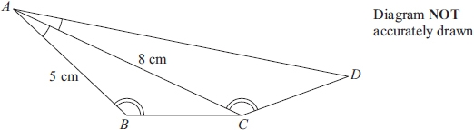

Angle *BAC* = angle *CAD*.  
 Angle *ABC* = angle *ACD*.  
*AB* = 5 cm and *AC* = 8 cm.

(a) Calculate the length of *AD*.

...........................................................cm

**(2)**

The area of triangle *ABC* is 12 cm2

(b) Calculate the area of triangle *ACD*.

...........................................................cm2

**(2)**

**(Total for question = 4 marks)**

**End of questions**