

**Higher IGCSE (9 – 1) Revision Pack**

**Areas and Perimeters**

**Name --------------------------------**

**Questions**

**Q1.**

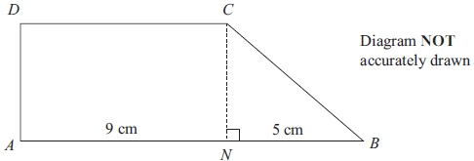

The shape *ABCD* is made from a rectangle *ANCD*  
 and the right-angled triangle *NBC*.  
*ANB* is a straight line.  
*AN* = 9 cm.  
*NB* = 5 cm.

The area of rectangle *ANCD* is 36 cm2.

Work out the area of shape *ABCD*.

........................................................... cm2

**(Total for question = 4 marks)**

**Q2.**

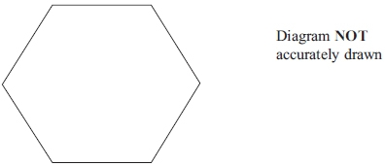

The diagram shows a regular hexagon.  
 The perimeter of the hexagon is 42 cm.

Calculate the area of the hexagon.  
 Give your answer correct to 3 significant figures.

...........................................................cm2

**(Total for question = 5 marks)**

**Q3.**

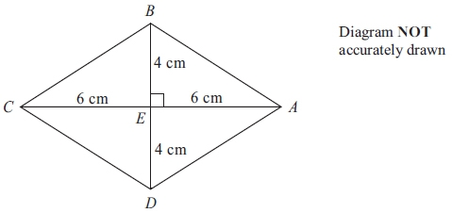

*ABCD* is a rhombus.   
The diagonals *AC* and *BD* cross at the point *E*.   
*AE* = *CE* = 6cm.   
*BE* = *DE* = 4cm   
Angle *AEB* = 90°

(a) Work out the area of the rhombus.

...........................................................cm2

**(3)**

(b) Work out the length of *AB*.   
Give your answer correct to 3 significant figures.

........................................................... cm

**(3)**

**(Total for question is 6 marks)**

**Q4.**

The diagram shows a trapezium *PQRS*.

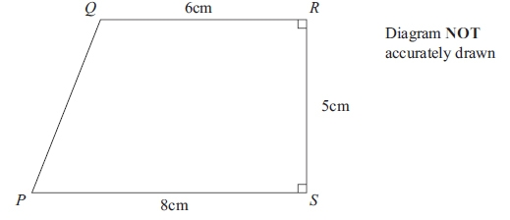

(a) Calculate the area of the trapezium *PQRS*.

...........................................................cm2

**(2)**

(b) Calculate the length *PQ*.   
Give your answer correct to 3 significant figures.

........................................................... cm

**(4)**

**(Total for question = 6 marks)**

**Q5.**

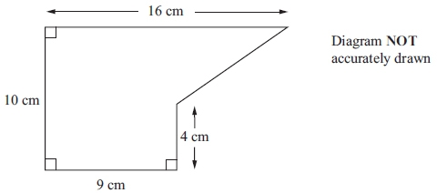

The diagram shows a shape.

Work out the area of the shape.

...........................................................cm2

**(Total for question = 4 marks)**

**Q6.**

The diagram shows a rectangle *PQRS*.   
*PQ* = 14 cm and *QR* = 9 cm.   
The point *A* lies on *PS* so that *PA* = 5 cm.   
The point *B* lies on *SR* so that *BR* = 8 cm.

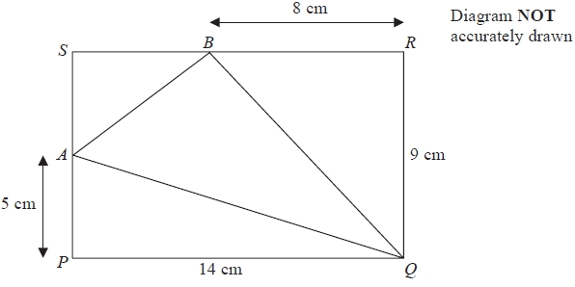

(a)   Work out the area of triangle *AQB*.

........................................................... cm2

**(4)**

(b)   Work out the length of *AQ*.   
Give your answer correct to 3 significant figures.

........................................................... cm

**(3)**

**(Total for Question is 7 marks)**

**Q7.**

Here is an isosceles triangle.

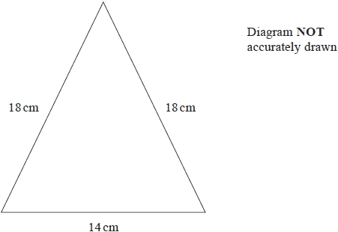

Work out the area of the triangle.   
Give your answer correct to 3 significant figures.

........................................................... cm2

**(Total for question = 4 marks)**

**Q8.**

The diagram shows a shape.

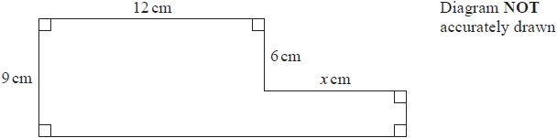

The shape has area 129 cm2

Work out the value of *x*.

*x* = ...........................................................

**(Total for question = 4 marks)**

**Q9.**

The area of the floor of a room is 12 m2

Change 12 m2 into cm2

........................................................... cm2

**(Total for question = 2 marks)**

**Q10.**

The diagram shows a right-angled triangle and a rectangle.

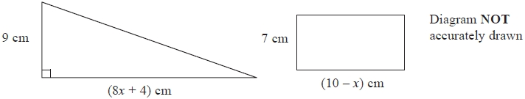

The area of the triangle is twice the area of the rectangle.

(i)  Write down an equation for *x*.

...........................................................

(ii)  Find the area of the rectangle.   
Show clear algebraic working.

........................................................... cm2

**(Total for question = 7 marks)**

**Q11.**

Here is a trapezium.

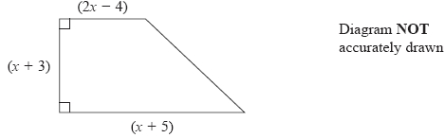

All measurements are in centimetres.

The area of the trapezium is 60 cm2

Show that   3*x*2 + 10*x* − 117 = 0

**(3)**

(b)  Work out the value of *x*

Show your working clearly.   
Give your answer correct to 3 significant figures.

...........................................................

**(3)**

**(Total for question = 6 marks)**

**Q12.**

Here is a hexagon.

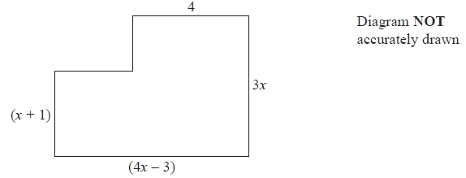

In the diagram, all the measurements are in centimetres.   
All the corners are right angles.

The area of the hexagon is 40 cm2

(a)   Show that 4*x*2 + 9*x* − 47 = 0

**(3)**

(b)   Solve 4*x*2 + 9*x* − 47 = 0

Show your working clearly.   
Give your solutions correct to 3 significant figures.

...........................................................

**(3)**

(c)   Find the length of the longest side of the hexagon.   
Give your answer correct to 3 significant figures.

........................................................... cm

**(2)**

**(Total for Question is 8 marks)**

**Q13.**

The diagram shows a shape with one line of symmetry.

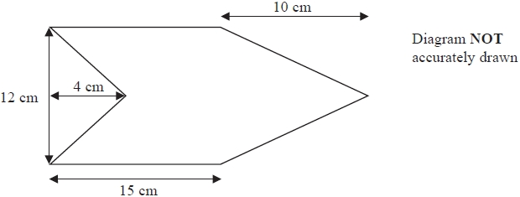

Work out the area of the shape.

........................................................... cm2

**(Total for question = 4 marks)**

**Q14.**

The diagram shows an isosceles triangle.

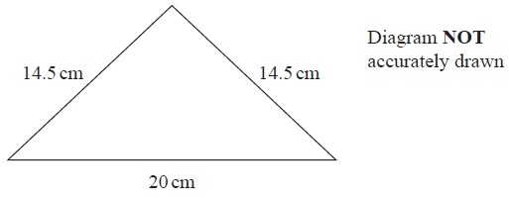

Work out the area of the triangle.

........................................................... cm2

**(Total for question = 4 marks)**

**Q15.**

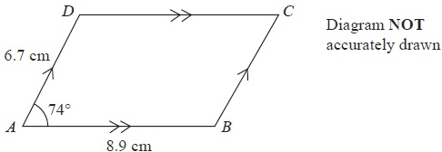

*ABCD* is a parallelogram.   
*AB* = 8.9 cm.   
*AD* = 6.7 cm.   
Angle *BAD* = 74°

Calculate the area of parallelogram *ABCD*.   
Give your answer correct to 3 significant figures.

........................................................... cm2

**(Total for Question is 3 marks)**

**Q16.**

Here is a trapezium *ABCD*.

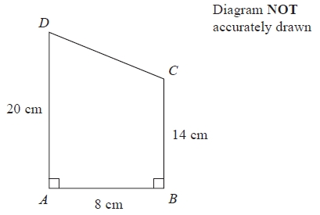

Angle *DAB* = angle *ABC* = 90°

*AD* = 20 cm   
*AB* = 8 cm   
*BC* = 14 cm

(a)  Calculate the area of the trapezium *ABCD*.

........................................................... cm2

**(2)**

(b)  Calculate the length of *CD*.

........................................................... cm

**(4)**

**(Total for question = 6 marks)**

**Q17.**

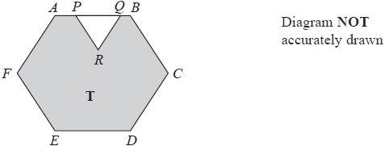

The diagram shows a shaded region **T** formed by removing an equilateral triangle *PQR* from a regular hexagon *ABCDEF*.

The points *P* and *Q* lie on *AB* such that *AB* = 1.5 × *PQ*

Given that the area of region **T** is 72  cm2

work out the length of *PQ*.

........................................................... cm

**(Total for question = 4 marks)**

**Q18.**

The diagram shows parallelogram *EFGH*.

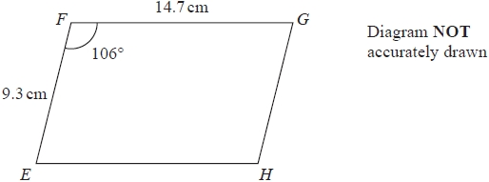

*EF* = 9.3 cm   
*FG* = 14.7 cm   
Angle *EFG* = 106°

(a)  Work out the area of the parallelogram.   
Give your answer correct to 3 significant figures.

........................................................... cm2

**(2)**

(b)  Work out the length of the diagonal *EG* of the parallelogram.   
Give your answer correct to 3 significant figures.

........................................................... cm

**(3)**

**(Total for question = 5 marks)**

**Q19.**

The diagram shows an isosceles triangle.

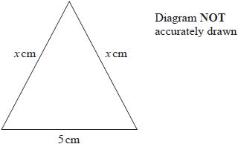

The area of the triangle is 12 cm2

Work out the perimeter of the triangle.   
Give your answer correct to 3 significant figures.

cm

**(Total for question = 4 marks)**

**Q20.**

The area of a rectangle is 18 cm2

The length of the rectangle is  cm.

Without using a calculator and showing each stage of your working,

find the width of the rectangle.   
Give your answer in the form  where *a*, *b* and *c* are integers.

........................................................... cm

**(Total for question = 3 marks)**

**Q21.**

The diagram shows a trapezium.

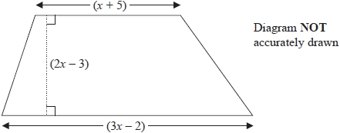

All measurements shown on the diagram are in centimetres.

The area of the trapezium is 133 cm2

(a)  Show that 8*x*2 – 6*x* – 275 = 0

**(3)**

(b)  Find the value of *x*.

Show your working clearly.

*x* =

**(3)**

**(Total for question = 6 marks)**

**Q22.**

Here are a rectangle and a square.

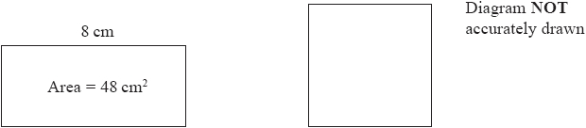

The rectangle has length 8 cm and area 48 cm2  
The perimeter of the square is the same as the perimeter of the rectangle.

Calculate the area of the square.

........................................................... cm2

**(Total for question = 4 marks)**

**Q23.**

Calvin has 12 identical rectangular tiles.   
He arranges the tiles to fit exactly round the edge of a shaded rectangle, as shown in the diagram below.

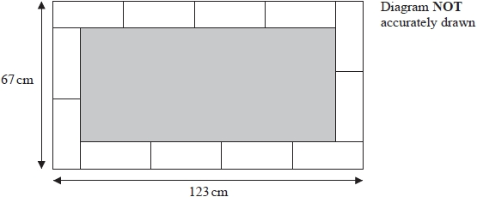

Work out the area of the shaded rectangle.

cm2

**(Total for question = 5 marks)**

**Q24.**

The diagram shows a trapezium.

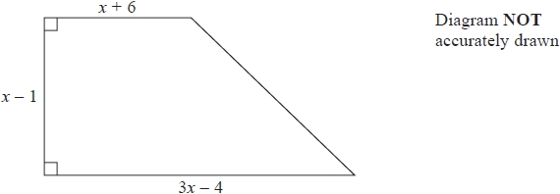

All measurements on the diagram are in centimetres.

The area of the trapezium is 119 cm2

(i)  Show that     2*x*2 − *x* − 120 = 0

(ii)  Find the value of *x*.   
Show your working clearly.

*x* = ...........................................................

**(Total for question = 6 marks)**

**Q25.**

Here is a shape *ABCDE*.

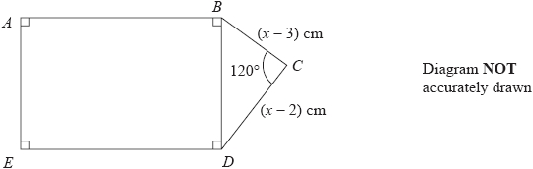

*ABDE* is a rectangle in which *AB* = 2*BD*  
*BCD* is a triangle in which angle *BCD* = 120°

*BC* = (*x* − 3) cm      *CD* = (*x* − 2) cm

The area of the rectangle *ABDE* is *S* cm2

Show that *S* can be expressed in the form *S* = *ax*2 + *bx* + *c*  
where *a*, *b* and *c* are integers to be found.

*S* = ...........................................................

**(Total for question = 5 marks)**

**End of questions**