**The Odyssey – Book 5**

**Read lines 1-43**

Athena creates sympathy for Odysseus by appealing to the following:

|  |  |  |
| --- | --- | --- |
| **Appeal** | **Quote** | **Creates Sympathy because…** |
| Attitude of the Ithacans |  |  |
| Odysseus’ location |  |  |
| His equipment |  |  |
| His family |  |  |

What different names does Zeus receive in this passage?



What does Zeus advise Athena to do?

What message does Hermes need to bring to Calypso?

**Read lines 43-148**

Annotate the picture of Hermes with details from this passage:

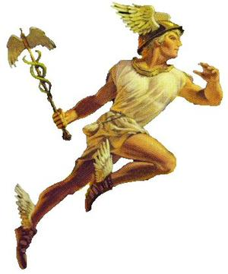

How does Hermes appear to have divine power?

|  |  |
| --- | --- |
| Quote | Explanation |
|  |  |
|  |  |
|  |  |

Draw the scene you imagine when you read the description of Calypso’s home. Use colour and label it with details from the passage:

What impression do you get of Calypso and her home?

How do we know that *xenia* is a priority for Calypso?

Complete the following diagram of Calypso’s two short stories:

Killed by…

**goddess**

**male lover**

**S**

Killed by…

**S**

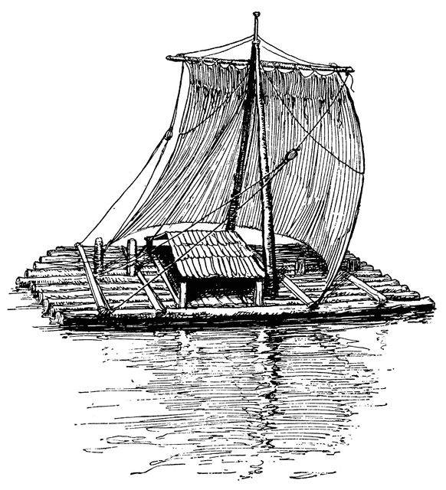**Read lines 149-192**

What is Odysseus instructed to do?

What will Calypso provide?

List quotes to support the attitudes of Calypso and Odysseus in this passage:

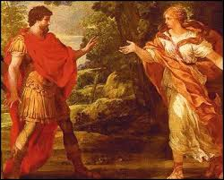

**Helpful**

**Wary**

**Read lines 193-227**

Why do you think Odysseus does not accept the offer of immortality?

How does Odysseus show that he is both flexible and stubborn in his response to Calypso?

**Read lines 228-261**

Complete the following:

|  |  |  |
| --- | --- | --- |
| **Tools Provided by Calypso** | **Description** | **Use** |
| Axe |  |  |
| Adze |  |  |
| Boring tools |  |  |
| Cloth |  |  |

What additions to this vessel sound more like a ship than a raft?

How might this reflect an oral tradition?

How is Odysseus portrayed throughout this passage?

**Read lines 262-333**

Annotate Homer’s description of Poseidon’s storm with any techniques for creating excitement:

With that he marshalled the clouds and, seizing his trident in his hands, stirred up the sea. He roused the stormy blasts of every wind that blows, and covered land and water alike with a canopy of clouds. Darkness swooped down from the sky. The East Wind and the South Wind and the tempestuous West Wind clashed together, and the North Wind came from the upper sky, rolling a great wave in front of it. Odysseus’ knees shook and his spirit failed. In anguish he communed with his great heart:

‘Poor wretch that I am, what will become of me after all? I fear the goddess prophesied all too well when she told me I should have my full measure of misery on the sea before I reached my native land. Every word she said is coming true. At Zeus’ command the whole sky is heavy with clouds, the sea is seething, squalls from every quarter hurtle together. There is nothing for me now but sudden death. Three and four times blessed are those countrymen of mine who fell long ago on the broad plains of Troy in loyal service to the sons of Atreus. If only I too could have met my fate and died the day the Trojan hordes let fly at me with their bronze spears over Achilles’ corpse! I should at least have had my burial rites and the Achaeans would have spread my fame abroad. But now it seems I was predestined to an ignoble death.’

As he spoke, a mountainous wave, advancing with awesome speed, crashed down upon him from above and whirled his raft around. The rudder was torn from his hands, and he himself was tossed off the raft; at the same moment the warring winds joined forces in one tremendous gust, which snapped the mast in two and flung the sail and half-deck far out into the sea. For a long time the water kept him under. Weighed down by the clothes which the goddess Calypso had given him, he could not quickly fight his way up against the downrush of the mighty wave. But at last he reached the air and spat out the bitter brine that poured down his face. Exhausted though he was, he did not forget his raft, but struck out after it through the surf, scrambled up, and sitting in the middle of it avoided the finality of death. The heavy seas thrust him with the current this way and that. Like the North Wind at harvest-time tossing about the fields a ball of thistles that have stuck together, the gusts drove his craft hither and thither over the sea. Now the South Wind would toss it to the North to play with, and now the East would leave it for the West to chase.

What does the passage reveal about Greek ideas of heroics and death?

**Read lines 334-380**

|  |  |
| --- | --- |
| **Dilemma 1** | |
| **Option A:** | **Option B:** |
| Odysseus’ conclusion: | |

How does Homer make Poseidon’s second assault visually exciting?

|  |  |
| --- | --- |
| Quote | Effect |
|  |  |
|  |  |
|  |  |
|  |  |

**Read lines 381-445**

|  |  |
| --- | --- |
| **Dilemma 2** | |
| **Option A:** | **Option B:** |
| Odysseus’ conclusion: | |

Why do you think Homer’s comparison between Odysseus and an Octopus is apt? How does it reflect Odysseus’ attitude since leaving Ogygia?

**Read lines 446-493**

How is Odysseus shown as an exhausted victim?

|  |
| --- |
| Quote |
|  |
|  |
|  |
|  |
|  |
|  |

|  |  |
| --- | --- |
| **Dilemma 3** | |
| **Option A:** | **Option B:** |
| Odysseus’ conclusion: | |