Basic business calculations.

People who are in business are usually wanting to make a profit. To do this they need to know how much money they are bringing into the business (their **revenue**) and how much money they are spending (their **costs**). **The difference between these 2 figures is their profit**.

Costs and revenue.

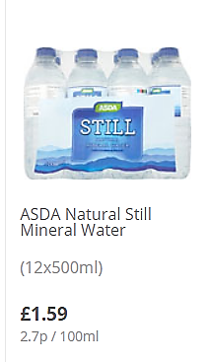Revenue can be worked out if you know how much the business is charging for 1 unit of product and how much it costs them to make or buy in that unit.

**For example;**

On a hot day, Kate decided to buy in some bottles of water to sell to her friends at school. In Asda, she can buy 12 bottles of water for £1.59.

**To make sure she makes a profit, Kate needs to know the cost of each bottle.**

**Cost per unit = total cost ÷ number of units**

**= £1.59 ÷ 12**

**= 13.3p per bottle**

Kate decides to charge 50p per bottle – this is her **selling price**

To find out how much profit Kate makes we need to work out the total revenue.

**Total revenue = Selling price x number of units sold**

**= 50p x 12 bottles = £6**

To work out Kate’s profit, we take one from the other

**Profit = Total revenue – total cost**

**So Kate’s profit = £6 - £1.59 = £4.41**

This doesn’t sound very much but on a big scale it adds up. If Kate sold 10 packs (120 bottles) of water her profit would be:

Total cost = £1.59 x 10 packs of bottles = £15.90 Revenue would be 50p x 120 bottles = £60

profit = £60 - £15.90 = £44.10