

**IGCSE (9 – 1) Revision Pack**

**Unit Conversion and some compound measures**

**Name --------------------------------**

**Questions**

**Q1.**

Here are nine road signs.

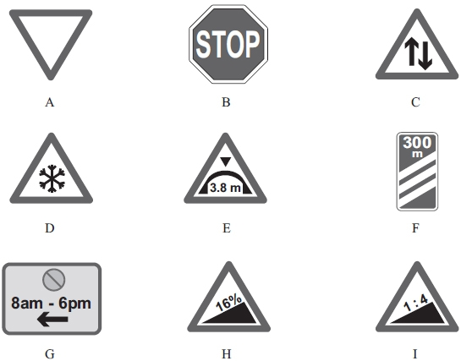

(a) The triangle in sign A has 3 equal sides.

Write down the mathematical name of this type of triangle.

...........................................................

**(1)**

(b) Sign B is an 8-sided polygon.

Write down the mathematical name of an 8-sided polygon.

...........................................................

**(1)**

(c) How many lines of symmetry has sign C?

...........................................................

**(1)**

(d) Write down the order of rotational symmetry of sign D.

...........................................................

**(1)**

(e) Change 3.8 m to centimetres.

...........................................................cm

**(1)**

(f) Change 300 m to kilometres.

...........................................................km

**(1)**

(g) Work out the length of time between 8 am and 6 pm.

...........................................................hours

**(1)**

(h) Write 6 pm as a time using the 24-hour clock.

...........................................................

**(1)**

(i) Write 16% as a decimal.

...........................................................

**(1)**

(j) Write 16% as a fraction.   
Give your fraction in its simplest form.

...........................................................

**(2)**

(k) On the dotted line, write a number so that the two ratios are equivalent.

1 : 4 = 3 : .........................

**(1)**

**(Total for question = 12 marks)**

**Q2.**

Wendy travelled on the Eurostar train from St Pancras station to the Gare du Nord station.  
The Eurostar train travelled a distance of 495 km.  
The journey time was 2 hours 15 minutes.

Work out the average speed of the Eurostar train in kilometres per hour.

...........................................................km/h

**(Total for question = 3 marks)**

**Q3.**

Yoko flew on a plane from Tokyo to Sydney.  
The plane flew a distance of 7800 km.  
The flight time was 9 hours 45 minutes.

Work out the average speed of the plane in kilometres per hour.

............................................................km/h

**(Total for question = 3 marks)**

**Q4.**

The average speed for an aeroplane flight from Dubai to London is 750 km/h.   
The flight time from Dubai to London is 7 hours 18 minutes.

(a)  Work out the flight distance from Dubai to London.

........................................................... km

**(3)**

(b)  Change 750 kilometres per hour to a speed in metres per second.   
       Give your answer correct to the nearest whole number.

........................................................... m/s

**(3)**

**(Total for question = 6 marks)**

**Q5.**

Jenna travelled from London to Edinburgh by coach.   
The coach left London at 21 10 on Monday.   
The coach arrived in Edinburgh at 06 45 on Tuesday.

(a)  How long did the coach take to travel from London to Edinburgh?   
Give your answer in hours and minutes.

.............................. hours .............................. minutes

**(2)**

A bus travelled a distance of 493 km from Paris to Zurich.



The bus took hours to travel from Paris to Zurich.

(b)  Work out the average speed of the bus.   
Give your answer, in km/h, correct to the nearest whole number.

........................................................... km/h

**(2)**

**(Total for question = 4 marks)**

**Q6.**

Jean gets home at 7 o'clock in the evening.

(a)  Write 7 o'clock in the evening using the 24–hour clock.

..........................................................

**(1)**

Jean is going to watch her favourite TV programme.

The programme starts at 8 40 pm.   
The programme lasts for 1 hour 45 minutes.

(b)  Work out the time at which the programme ends.

.......................................................... pm

**(2)**

The next programme lasts for 40 minutes.

(c)  Write 40 minutes as a fraction of 1 hour.   
       Give your answer in its simplest form.

..........................................................

**(2)**

**(Total for question = 5 marks)**

**Q7.**

Toy cars are made in a factory.

300 cars per hour are made in the factory.

Cars are made in the factory for hours each day.



8% of the cars made in the factory are faulty.   
The rest of the cars made in the factory are **not** faulty.

Work out how many of the cars made each day are **not** faulty.

**(Total for question = 4 marks)**

**Q8.**

Complete the following sentences by writing a sensible metric unit on each of the dotted lines.

(i)  The length of a room is 4 ...........................................................

(ii)  A full bottle contains 1.5 ........................................................... of juice.

(iii)  A notebook weighs 140 ...........................................................

**(Total for question = 3 marks)**

**Q9.**

Complete the following sentences by writing a sensible metric unit on each of the dotted lines.

(i)  The distance from Paris to Madrid is 1053

...........................................................

(ii)  The area of a basketball court is 420

...........................................................

(iii)  The volume of a can of cola is 330

...........................................................

**(Total for Question is 3 marks)**

**Q10.**

Complete the following estimates by writing a suitable metric unit on each of the dotted   
lines.

(a) The length of a small car is about 400 ...........................................................

**(1)**

(b) The weight of a new pencil is about 4 ...........................................................

**(1)**

(c) The volume of a coffee cup is about 200 ...........................................................

**(1)**

**(Total for question = 3 marks)**

**Q11.**

A block of wood has a mass of 3.5 kg.   
The wood has density 0.65 kg/m3

(a)  Work out the volume of the block of wood.

Give your answer correct to 3 significant figures.

m3

**(3)**

(b)  Change a speed of 630 kilometres per hour to a speed in metres per second.

m/s

**(3)**

**(Total for question = 6 marks)**

**Q12.**

Amandine worked in a restaurant from 6 30 pm to 10 15 pm one evening.

(a)  Write 630 pm as a time using the 24-hour clock.

...........................................................

**(1)**

(b)  Work out the length of time between 6 30 pm and 10 15 pm.

.................... hours .................... minutes

**(2)**

Rachel and Alan arrived at the restaurant at 7 50 pm.   
They stayed at the restaurant for 1 hour 35 minutes.

(c)  At what time did Rachel and Alan leave the restaurant?

...........................................................

**(1)**

**(Total for question = 4 marks)**

**Q13.**

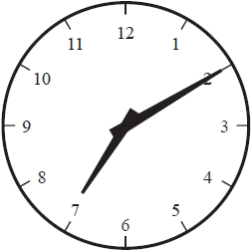

The clock face shows the time in the **evening** that James got home from work.

(a)  Write this time using the 24-hour clock.

...........................................................

**(1)**

Later that evening James watched a film on TV.   
The film started at 19 50   
The film lasted 1 hour 25 minutes.

(b)  At what time did the film end?   
Give your answer using the 12-hour clock.

...........................................................

**(2)**

**(Total for question = 3 marks)**

**Q14.**

The currency in Bangladesh is the taka.   
1 pound (£) = 119 taka

(a)  Change 3500 taka to pounds.

Give your answer correct to 2 decimal places.

£ ...........................................................

**(2)**

The currency in Thailand is the baht.   
1 pound (£) = 52 baht

(b)  Change 8500 baht to taka.

Give your answer correct to the nearest whole number.

........................................................... taka

**(3)**

An aeroplane takes 2 hours and 24 minutes to fly from Bangkok to Dhaka.   
The aeroplane flies a distance of 1534 km.

(c)  Work out the average speed of the aeroplane.

Give your answer in kilometres per hour correct to 3 significant figures.

........................................................... kilometres per hour

**(3)**

**(Total for question = 8 marks)**

**Q15.**

(a)  Change 4.5 metres into centimetres.

........................................................... centimetres

**(1)**

(b)  Change 8900 grams into kilograms.

........................................................... kilograms

**(1)**

**(Total for question = 2 marks)**

**Q16.**

(a)  Change 8 metres into centimetres.

........................................................... centimetres

**(1)**

(b)  Change 9600 grams into kilograms.

........................................................... kilograms

**(1)**

Jamil has 5 litres of water in a container.   
He pours 750 millilitres of water into each of 6 bottles.

(c)  How much water is left in the container?   
 Give your answer in millilitres.

........................................................... millilitres

**(3)**

**(Total for question = 5 marks)**

**Q17.**

Change a speed of *x* kilometres per hour into a speed in metres per second.   
Simplify your answer.

........................................................... m/s

**(Total for question = 3 marks)**

**Q18.**

(a)  Work out the number which is exactly halfway between 1.2 and 1.4

...........................................................

**(1)**

(b)  Here is a scale which shows a weight in kilograms.   
What is the reading on the scale?

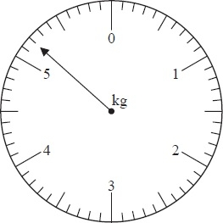

........................................................... kg

**(1)**

(c)  On the scale below, mark with an arrow a reading of 0.4 kilograms.

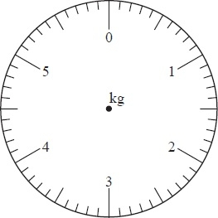

**(1)**

(d)  Change 0.4 kilograms to grams.

........................................................... grams

**(1)**

**(Total for Question is 4 marks)**

**Q19.**

(a) Work out the number which is exactly halfway between 0.3 and 0.6

...........................................................

**(1)**

(b)

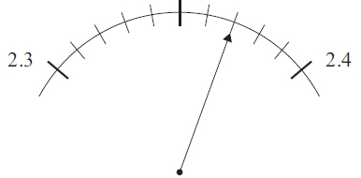

What is the reading on the scale?

...........................................................

**(1)**

(c) Write down the value of the 3 in the number 0.243

...........................................................

**(1)**

(d) Write these numbers in order of size.   
Start with the smallest.



...........................................................

**(2)**

**(Total for question = 5 marks)**

**Q20.**

The diagram shows a solid cuboid made from wood.

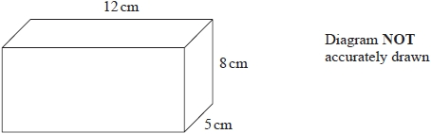

The wood has density 0.7 g/cm3

Work out the mass of the cuboid.

........................................................... grams

**(Total for question = 3 marks)**

**Q21.**

Tenzin walks in the mountains.   
She has a rule to estimate the temperature at different heights on a mountain.



The temperature at a height of 800 metres on a mountain is 6 °C.

(a)  Use Tenzin's rule to work out an estimate of the temperature at a height of 2000 metres on the mountain.

........................................................... °C

**(3)**

Tenzin also has a rule to estimate the time it will take her to complete a walk in the mountains.

She uses

an average speed of 5 km / h for the distance she will walk

and then

adds on 1 minute for every increase of 10 metres in height.

Tenzin plans to walk 12 km in the mountains with an increase of 800 metres in height.

(b)  Use Tenzin's rule to work out an estimate for the time it will take her to complete this walk.

Give your answer in hours and minutes.

........................................................... hours ........................................................... minutes

**(3)**

**(Total for question = 6 marks)**

**Q22.**

The diagram shows a picture of a ship and four containers.   
The ship and the containers are drawn to the same scale.

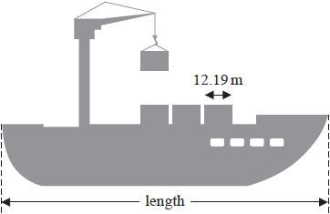

The length of each container is 12.19 m.

(a)  Work out an estimate for the length of the ship.   
       Show your working clearly.

........................................................... m

**(2)**

A different container is a cuboid with length 6.2 m, width 2.4 m and height 2.5 m.

(b)  Work out the volume of this container.

........................................................... m3

**(2)**

**(Total for question = 4 marks)**

**Q23.**

Nicole went on holiday from Paris to South Africa.  
 The exchange rate was 1 euro = 9.54 Rand.

(a) Nicole changed 600 euros into Rand.   
How many Rand did she get?

........................................................... Rand

**(2)**

(b) Her flight took off at 20 30 Paris time and landed at 08 15 Paris time the next day.   
How long was the flight in hours and minutes?

.............................. hours .............................. minutes

**(3)**

Nicole returned to Paris after her holiday.  
 The exchange rate had changed to 1 euro = 9.80 Rand.

(c) Nicole changed 1470 Rand into euros.   
How many euros did she get?

........................................................... euros

**(2)**

**(Total for question = 7 marks)**

**Q24.**

A plane flew from Bogotá to Quito.

The distance the plane flew was 725 km.   
The time taken by the plane was 1 hour 24 minutes.

Work out the average speed of the plane.   
Give your answer correct to 3 significant figures.

........................................................... km/h

**(Total for question = 3 marks)**

**Q25.**

The wheel of the Singapore Flyer is a circle with a diameter of   
150 metres.

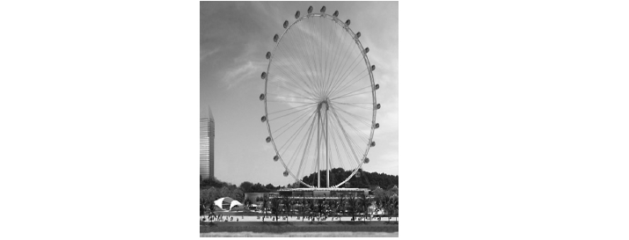

(a)  Calculate the circumference of the wheel.   
       Give your answer correct to the nearest metre.

.......................................................... metres

**(2)**

The wheel takes 30 minutes to rotate once.

(b)  Work out the average speed of a point on the circumference of the wheel as it   
       rotates once.   
       Give your answer in metres per second correct to 3 significant figures.

.......................................................... metres per second

**(3)**

The diagram shows a giant wheel above horizontal ground.

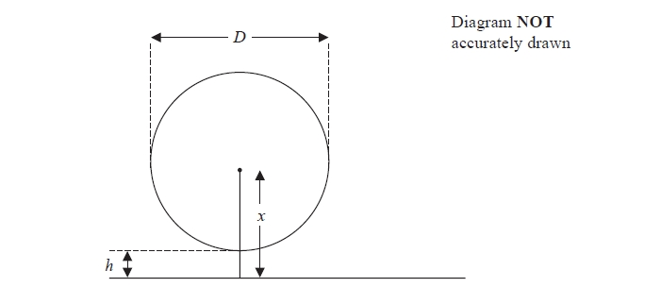

The wheel is a circle of diameter *D* metres.   
The lowest point of the wheel is *h* metres above the ground.   
The centre of the wheel is *x* metres above the ground.

(c)  Express *h* in terms of *D* and *x*

..........................................................

**(2)**

**(Total for question = 7 marks)**

**Q26.**

The diagram shows three points *P*, *Q* and *R* on a centimetre grid.

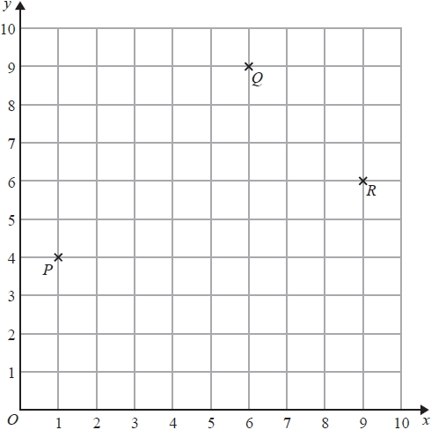

(a)  Write down the coordinates of *R*.

(........................... , ...........................)

**(1)**

(b)  Measure the distance between *P* and *R*.   
Give your answer in millimetres.

........................................................... mm

**(1)**

(c)  On the diagram, mark with a cross (×) the position of the point *S* so that *PQRS* is a rectangle.   
Label your point *S*.

**(1)**

(d)  Find the coordinates of the midpoint of *PQ*.

(........................... , ...........................)

**(2)**

**(Total for question = 5 marks)**

**Q27.**

The diagram shows a 5-sided polygon *ABCDE* drawn on a centimetre grid.

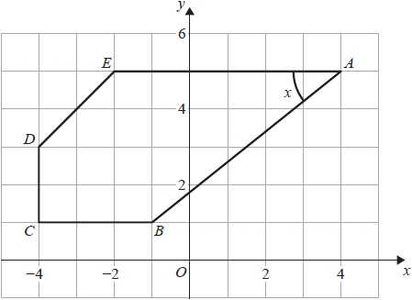

(a)  Write down the coordinates of the point *A*.

( ................ , ................ )

**(1)**

(b)  Write down the coordinates of the point *C*.

( ................ , ................ )

**(1)**

(c)  Write down the mathematical name for a 5-sided polygon.

...........................................................

**(1)**

(d)  Measure the length of the line *AB*.   
       Give your answer in centimetres to 1 decimal place.

........................................................... cm

**(1)**

(e)  Measure the size of the angle marked *x*.

........................................................... °

**(1)**

**(Total for question = 5 marks)**

**Q28.**

Joseph travels to work each day by train.  
 The weekly cost of his train journey is £45  
 Joseph's weekly pay is £625

(a) Work out 45 as a percentage of 625

...........................................................%

**(2)**

(b) The weekly cost of his train journey increases by 8%.   
Increase £45 by 8%.

£...........................................................

**(3)**

(c) Joseph's weekly pay increases to £640   
Calculate the percentage increase from 625 to 640

...........................................................%

**(3)**

(d) Joseph decides to cycle to work.   
He cycles 18 km to work.  
His journey to work takes 1 hour 20 minutes.

Calculate his average speed in kilometres per hour.

...........................................................km/h

**(3)**

**(Total for question = 11 marks)**

**Q29.**



Find the pressure exerted by a force of 810 newtons on an area of 120 cm2  
Give your answer in newtons/m2

........................................................... newtons/m2

**(Total for question = 3 marks)**

**Q30.**

The water in a fish tank is treated by using 5 millilitres of AquaGuard for every 10 litres of water in the tank.

(a)   Write down the ratio of the volume of AquaGuard used to the volume of water in the tank. Give your answer in the form 1 : *n*

1 : ...........................................................

**(2)**

A tank contains 96 litres of water.

(b)   Work out the volume of AquaGuard that should be used.   
Give your answer in millilitres.

........................................................... millilitres

**(2)**

**(Total for Question is 4 marks)**

**Q31.**

Louis makes a model of a plane.

The wingspan of the model is 50 centimetres.   
The wingspan of the real plane is 80 metres.

(a)  Work out the scale of the model.   
Give your answer in the form 1: *n*

1: ...........................................................

**(2)**

The length of the real plane is 72 metres.

(b)  Work out the length of the model.   
Give your answer in centimetres.

........................................................... centimetres

**(2)**

**(Total for question = 4 marks)**

**Q32.**

An aeroplane flew from Qatar to Bahrain.   
The distance flown was 135 km.   
The average speed was 180 km/h.

Work out the time taken.   
Give your answer in minutes.

........................................................... minutes

**(Total for question is 3 marks)**

**Q33.**

Complete the following statements by writing a number on each dotted line.

(a)  A pentagon has ....................................................... sides.

**(1)**

(b)  The size of each angle in an equilateral triangle is ....................................................... °

**(1)**

(c)  1 kilometre = ....................................................... metres.

**(1)**

**(Total for question = 3 marks)**

**Q34.**

Here is a quadrilateral.

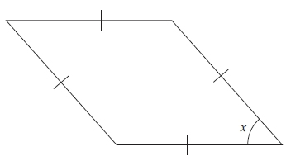

(a) What is the mathematical name for this type of quadrilateral?

...........................................................

**(1)**

(b) (i) Measure the size of angle *x*.

...........................................................°

(ii) What type of angle is angle *x*?

...........................................................

**(2)**

(c) Find, by measuring, the perimeter of the quadrilateral.

...........................................................cm

**(2)**

**(Total for question = 5 marks)**

**Q35.**

The diagram shows a quadrilateral *PQRS* drawn on a centimetre grid.

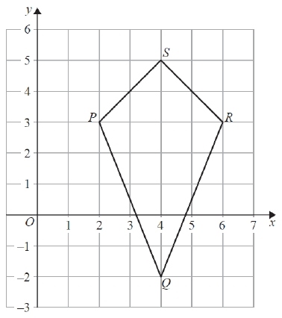

(a)  Write down the mathematical name of the quadrilateral *PQRS*.

...........................................................

**(1)**

(b)  Measure the length of *PQ*.

Give your answer in millimetres.

........................................................... mm

**(1)**

(c)  Write down the coordinates of

(i)  the point *P*,

(........................... , ...........................)

(ii)  the point *Q*.

(........................... , ...........................)

**(2)**

(d)  On the quadrilateral *PQRS*, draw the line of symmetry.

**(1)**

(e)  Work out the area of the quadrilateral *PQRS*.

........................................................... cm2

**(2)**

**(Total for question = 7 marks)**

**Q36.**

The diagram shows triangle *ABC* drawn on a centimetre grid.

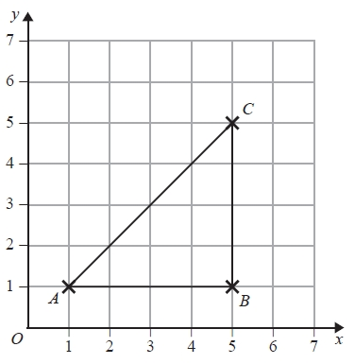

(a)  Write down the coordinates of the point *B*.

(.......................... , ..........................)

**(1)**

(b)  Measure the length of the line *AC*.

Give your answer in millimetres.

........................................................... mm

**(1)**

(c)  Find the area of triangle *ABC*.

........................................................... cm2

**(2)**

*D* is the point such that *ABCD* is a trapezium with *AD* = 3 cm.

(d)  On the grid, mark with a cross (×) the position of the point *D*  
Label your point with the letter *D*.

**(1)**

**(Total for question = 5 marks)**

**Q37.**

You can use this graph to change between pounds (£) and Hong Kong dollars (HKD).

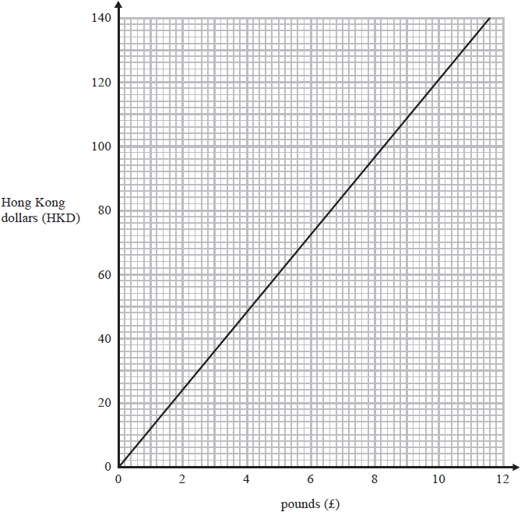

(a)  Change 120 Hong Kong dollars into pounds.

£ ...........................................................

**(1)**

(b)  Change £6 into Hong Kong dollars.

........................................................... HKD

**(1)**

(c)  Change 1000 Hong Kong dollars into pounds.

£ ...........................................................

**(2)**

**(Total for question = 4 marks)**

**Q38.**

Kevin left his home at 1000 to cycle to a lake.   
On the way, he stopped at a friend's house and then continued his journey to the lake.   
Here is the distance-time graph for his journey to the lake.

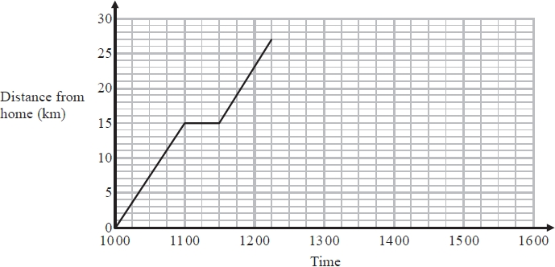

(a)  For how many minutes did Kevin stop at his friend's house?

........................................................... minutes

**(1)**

(b)  How far is the lake from Kevin's home?

........................................................... km

**(1)**

Kevin stayed at the lake until 1315.   
He then cycled, without stopping, at a constant speed from the lake back to his home.



It took Kevin hours to cycle home.

(c)  (i)  Show all this information on the graph.

(ii) Work out Kevin's speed as he cycled from the lake back to his home.

........................................................... km/h

**(4)**

**(Total for question = 6 marks)**

**Q39.**

(a)

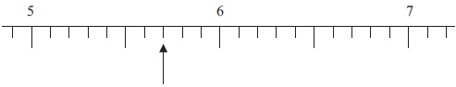

Write down the number marked with an arrow.

...........................................................

**(1)**

(b)



(i) Find the number 3.76 on the number line.   
Mark it with an arrow ()



(ii) Round 3.76 to the nearest whole number.

...........................................................

(iii) Write down the value of the 7 in the number 3.76

...........................................................

**(3)**

(c) Write down the number which is exactly halfway between 3.76 and 3.77

...........................................................

**(1)**

**(Total for question = 5 marks)**

**Q40.**

Here is part of a timetable for the Paris to Montpellier express train service.

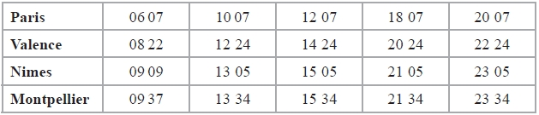

(a)   At what time should the 12 07 from Paris get to Nimes?

...........................................................

**(1)**

One day, the 06 07 from Paris arrived at Montpellier 3⁄4 of an hour late.

(b)   At what time did this train arrive at Montpellier?

...........................................................

**(2)**

(c)   Work out how long it should take the 20 07 train from Paris to get to Montpellier.

...........................................................

**(1)**

The average speed of the 20 07 train from Paris is 224 km/h.

(d)   Work out the distance this train travels from Paris to Montpellier.

........................................................... km

**(3)**

**(Total for Question is 7 marks)**

**Q41.**

Change 32.4 m3 into cm3

........................................................... cm3

**(Total for question = 2 marks)**

**Q42.**

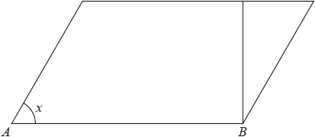

(a)  On the diagram, mark a right angle with the letter R.

**(1)**

(b)  Measure the size of the angle marked *x*.

...........................................................°

**(1)**

(c)  Measure the length of the line *AB*.   
State the units of your answer.

...........................................................   .............

**(2)**

**(Total for question = 4 marks)**

**Q43.**

The density of gold is 19.3 g/cm3  
A gold bar has volume 150 cm3

Work out the mass of the gold bar.

........................................................... g

**(Total for question = 2 marks)**

**Q44.**

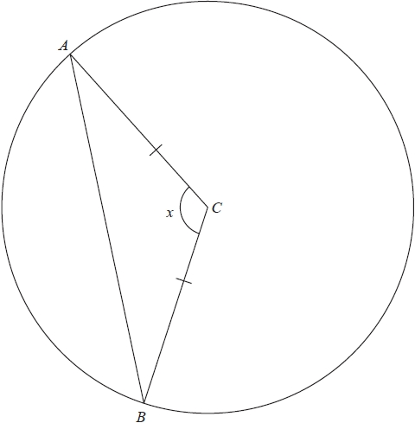

*A* and *B* are points on a circle, centre *C*.   
*AC* = *BC*.

(a)  (i)  Measure the size of angle *x*.

...........................................................°

(ii)  Write down the mathematical name for angle *x*.

...........................................................

**(2)**

(b)  Write down the mathematical name for triangle *ABC*.

...........................................................

**(1)**

**(Total for question = 3 marks)**

**Q45.**

The diagram shows a trapezium *PQRS* and a line *AB* on a centimetre grid.

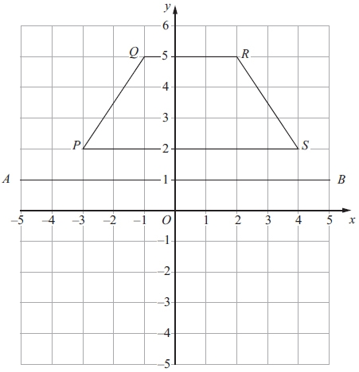

(a) Measure the length of *RS*.   
Give your answer in millimetres.

........................................................... mm

**(1)**

(b) Write down the coordinates of *Q*.

(.............................. , ..............................)

**(1)**

(c) Write down the equation of the line *AB*.

...........................................................

**(1)**

(d) Reflect the trapezium *PQRS* in the line *AB*.

**(2)**

**(Total for question is 7 marks)**

**Q46.**

Here is a scale drawing of a car.  
 The line *AB* represents the length of the car.

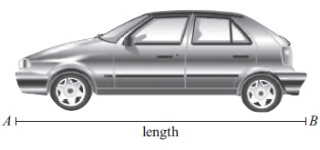

(a) Measure the length, in centimetres, of the line *AB*.

...........................................................cm

**(1)**

(b) On the drawing, 2 centimetres represents a real length of 1 metre.   
Work out the real length of the car.

...........................................................m

**(2)**

**(Total for question = 3 marks)**

**Q47.**

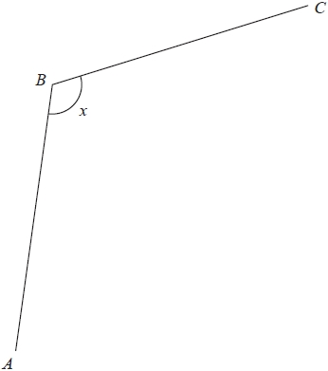

(a)  Measure the length of the line *BC*.   
Give your answer in millimetres.

........................................................... mm

**(1)**

(b)  Measure the size of angle *x*.

........................................................... °

**(1)**



(c)  Choose the word from the box that best describes angle *x* in the diagram.

...........................................................

**(1)**

**(Total for question = 3 marks)**

**Q48.**

The diagram shows two quadrilaterals and a triangle on a square grid.

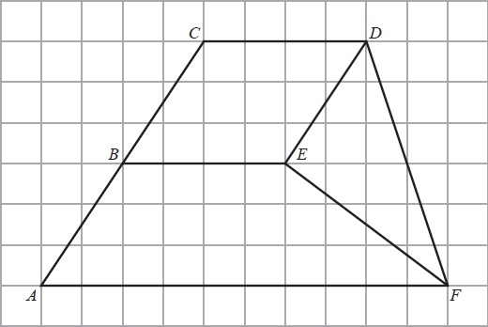

(a)  Measure the length of *DF*.   
State the units of your answer.

...........................................................

**(2)**

(b) On the diagram, mark with arrows (>>) a pair of parallel lines.

**(1)**

(c)  Write down the mathematical name of quadrilateral *ABEF*.

...........................................................

**(1)**

(d)  On the diagram, mark an obtuse angle with the letter *O*.

**(1)**

**(Total for question = 5 marks)**

**Q49.**

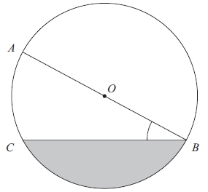

*A*, *B* and *C* are points on a circle, centre *O*.

(a) Measure the length of *CB*.

...........................................................cm

**(1)**

(b) Measure the size of angle *ABC*.

...........................................................°

**(1)**

(c) Write down the mathematical name for

(i) the line *OA*,

...........................................................

(ii) the shaded region.

...........................................................

**(2)**

**(Total for question = 4 marks)**

**Q50.**

Matthias buys a bag of Power Pup food for his dog, Rex.

The food in the bag weighs 16 kilograms.

Matthias feeds Rex 250 grams of Power Pup each day.

(a)  Find the number of days for which Matthias can feed Rex from one bag of Power Pup.

...........................................................

**(3)**

There are 24 grams of protein in 100 grams of Power Pup.

(b)  How many grams of protein are there in 250 grams of Power Pup?

........................................................... grams

**(3)**

There are 12 grams of fibre and 40 grams of fat in a daily portion of Power Pup.

(c)  Write down the ratio of the weight of fibre to the weight of fat.   
Give your ratio in its simplest form.

...........................................................

**(2)**

**(Total for Question is 8 marks)**

**Q51.**

(a)  Change 650 centimetres into metres.

........................................................... metres

**(1)**

(b)  Change 8 litres into millilitres.

........................................................... millilitres

**(1)**

Memona has a 6 kg sack of rice and some empty bags.   
She fills each bag with 475 grams of rice from the sack.

(c)  How many bags can Memona completely fill with rice?

...........................................................

**(3)**

**(Total for question = 5 marks)**

**Q52.**

(a)  Complete the following sentences by writing a sensible metric unit on each of the dotted lines.

(i)  The distance from Cairo to Nairobi is 5211 .......................................................

(ii)  The weight of an egg is 20 .......................................................

(iii)  The area of the floor of a classroom is 260 .......................................................

**(3)**

Cara has a bottle of juice.   
There is 1 litre of juice in the bottle.

Cara makes some drinks.   
She uses exactly 30 millilitres of this juice to make each drink.

Cara makes as many drinks as possible.

(b)  How many drinks does Cara make?

...........................................................

**(3)**

**(Total for question = 6 marks)**

**Q53.**

*A*, *B* and *C* are points on a circle, centre *O*.

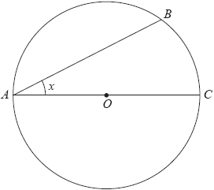

(a)  (i)  Write down the mathematical name for the line *OC*.

...........................................................

(ii)  Measure the size of the angle marked *x*.

........................................................... °

**(2)**

In the diagram, *ABCD* is a quadrilateral.

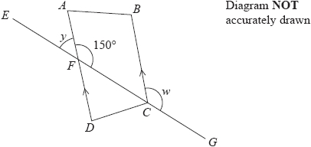

*DA* and *CB* are parallel lines.   
*AFD* and *EFCG* are straight lines.

(b)  (i)  Find the size of angle *y*.

*y* = ........................................................... °

(ii)  Give a reason for your answer.

.............................................................................................................................................

**(2)**

(c)  (i)  Find the size of angle *w*.

*w* = ........................................................... °

(ii)  Give a reason for your answer.

.............................................................................................................................................

**(2)**

**(Total for question = 6 marks)**

**Q54.**

The temperature of food in a freezer is −18°C   
The temperature of food in a fridge is −3°C

(a) What is the difference between the temperature of food in the freezer and the temperature of food in the fridge?

........................................................... °C

**(2)**

(b) Alison took a pie from the freezer.   
The temperature of the pie was −18°C.  
One hour later, the temperature of the pie was 11°C higher.

Work out the temperature of the pie after one hour.

........................................................... °C

**(2)**

(c) At 14 25 Zak takes a chicken from the fridge.   
10 minutes later he places the chicken in an oven to cook.  
The cooking time is 1 hour 45 minutes.

(i) Write 14 25 using pm.

........................................................... pm

(ii) At what time will the chicken be cooked?

...........................................................

**(3)**

**(Total for question is 7 marks)**

**Q55.**

Here is some information from a weather forecast website for Chicago for one day in  
 January.

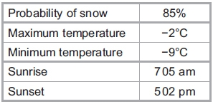

(a) Write 85% as a decimal.

...........................................................

**(1)**

(b) Write 85% as a fraction.   
Give your fraction in its simplest form.

...........................................................

**(2)**

(c) How many degrees higher is the maximum temperature than the   
minimum temperature?

........................................................... °C

**(2)**

(d) Write 5 02 pm as a time using the 24-hour clock.

...........................................................

**(1)**

(e) Work out the length of time between 7 05 am and 5 02 pm.   
Give your answer in hours and minutes.

.................... hours .......................................minutes

**(3)**

(f) The probability that it will snow is 85%.   
Work out the probability that it will **not** snow.

...........................................................%

**(1)**

**(Total for question = 10 marks)**

**Q56.**

(a) The diagram shows a solid.

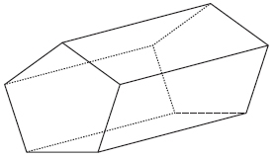

(i) What is the mathematical name for this solid?

...........................................................

(ii) How many faces does this solid have?

...........................................................

(iii) How many edges does this solid have?

...........................................................

**(3)**

(b) The solid has a volume of 2000 cm3

Convert 2000 cm3 to litres.

........................................................... litres

**(1)**

**(Total for question = 4 marks)**

**Q57.**

The table shows information about five different tablet computers.

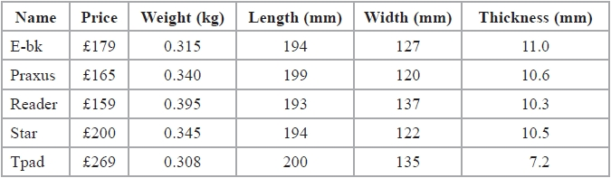

(a)  Write down the name of the tablet computer with the least weight.

...........................................................

**(1)**

The E-bk tablet computer has a weight of 0.315 kg.

(b)  Change 0.315 kg into grams.

........................................................... grams

**(1)**

The Reader tablet computer has a width of 137 mm.

(c)  Change 137 mm into centimetres.

........................................................... cm

**(1)**

Martin is the manager of a company.   
He buys each person in his sales team a Praxus tablet computer.

Martin has a budget of £1000   
There are 6 people in the sales team.

(d)  How much money is left in Martin's budget after buying 6 Praxus tablet computers?

£...........................................................

**(3)**

**(Total for question = 6 marks)**

**Q58.**

A machine makes paper clips from a 2 metre length of wire.

Each paper clip is made from 72 mm of wire.

(i) Work out the number of paper clips the machine makes.



...........................................................

(ii) Work out the length of wire which is left over.   
Give your answer in millimetres.

........................................................... mm

**(Total for question is 5 marks)**

**Q59.**

(a) Rachael uses her car for work.   
Her company pays her 32 cents for every kilometre she travels by car.  
Yesterday, her company paid her $48 for the distance she travelled by car.

Work out the distance she travelled by car yesterday.

........................................................... km

(b) The length of the journey from her home to work is 72 km.   
The journey takes 1 hour 20 minutes.

Work out her average speed in km/h.

........................................................... km/h

**(3)**

**(Total for question = 6 marks)**

**Mark Scheme**

Q1.

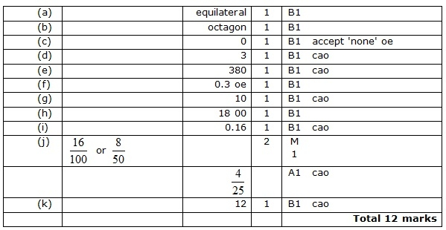

**Q2.**

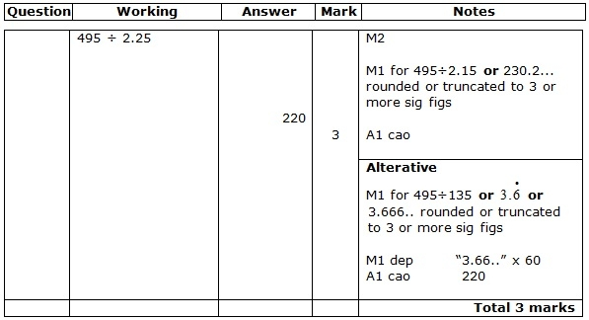

**Q3.**

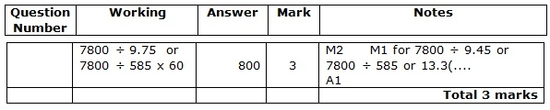

**Q4.**

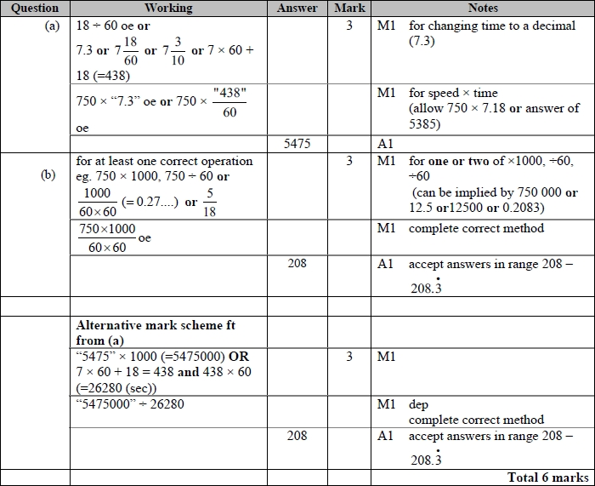

**Q5.**

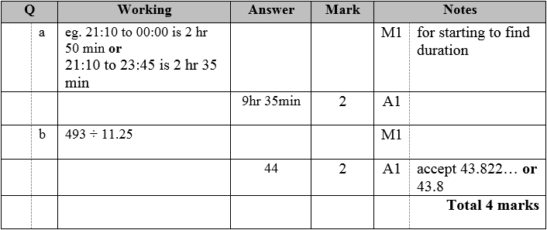

**Q6.**

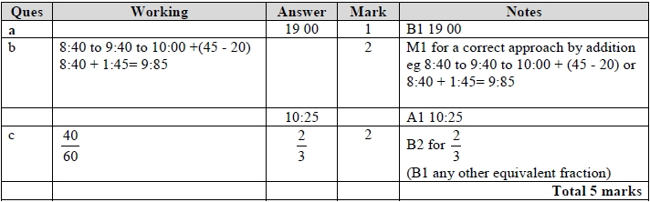

**Q7.**

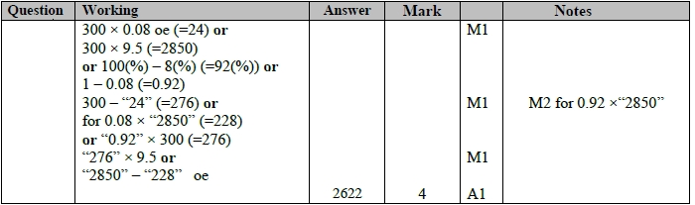

**Q8.**

Apart from question 18c where the mark scheme states otherwise, the correct answer, unless clearly obtained by an incorrect method, should be taken to imply a correct method.

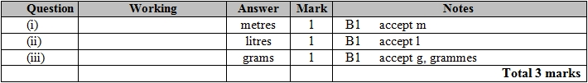

**Q9.**

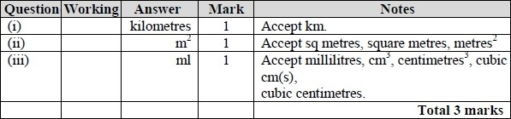

**Q10.**

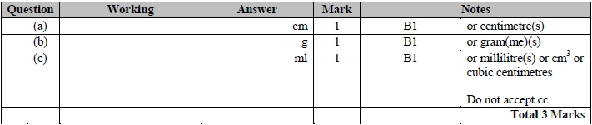

**Q11.**

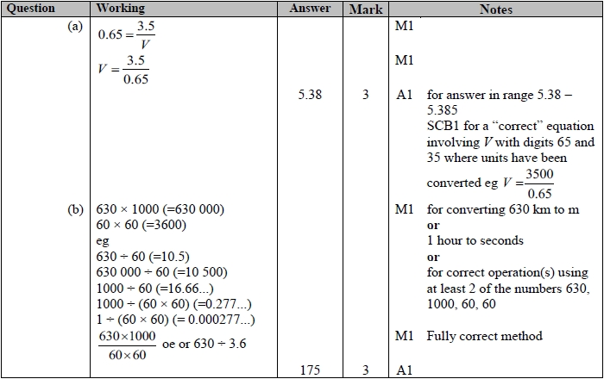

**Q12.**

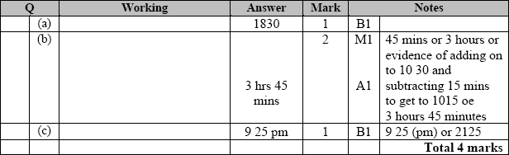

**Q13.**

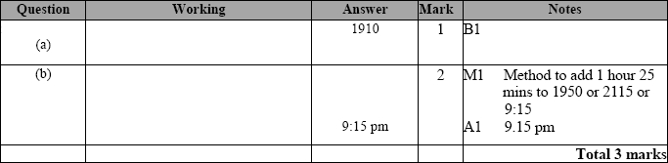

**Q14.**

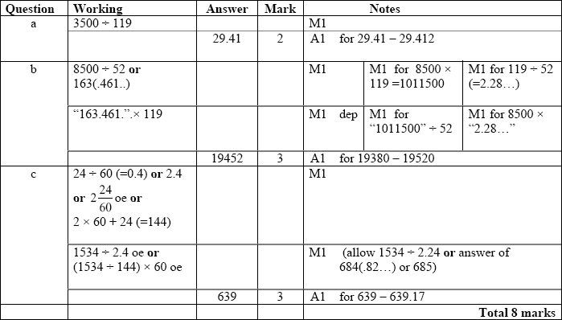

**Q15.**

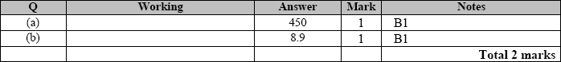

**Q16.**

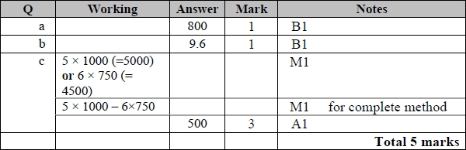

**Q17.**

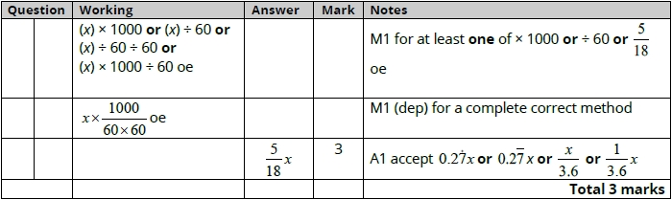

**Q18.**

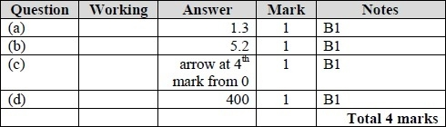

**Q19.**

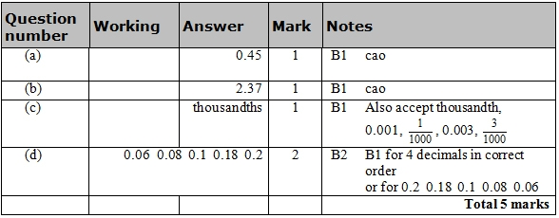

**Q20.**

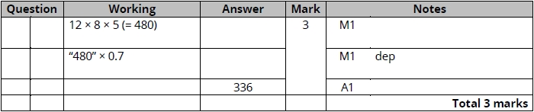

**Q21.**

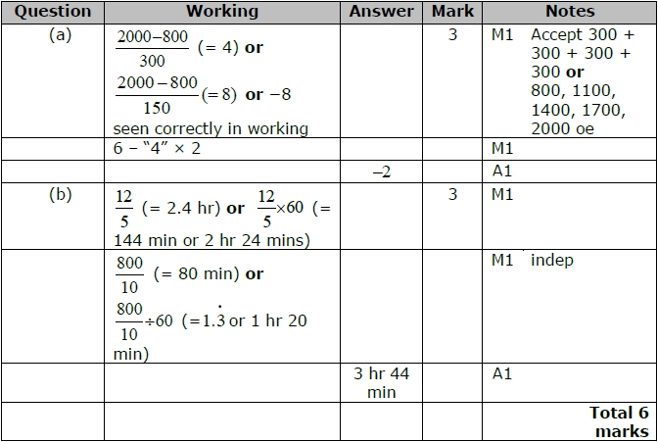

**Q22.**

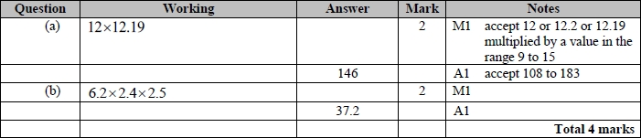

**Q23.**

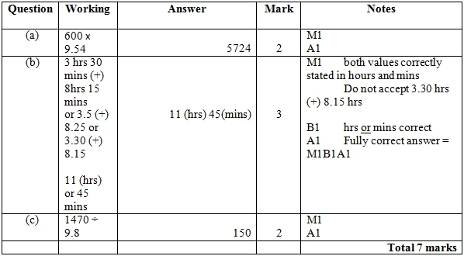

**Q24.**

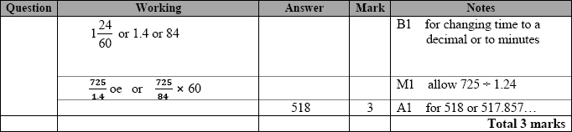

**Q25.**

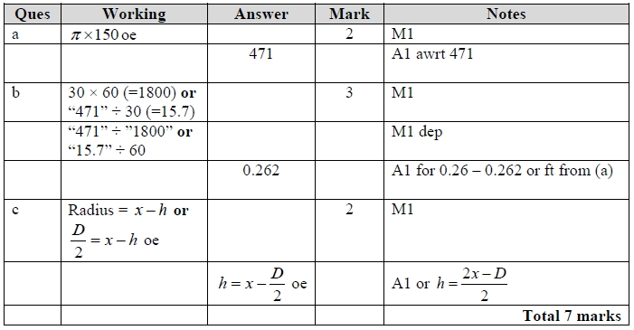

**Q26.**

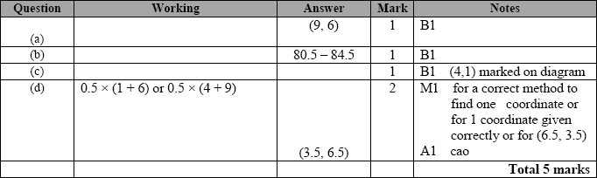

**Q27.**

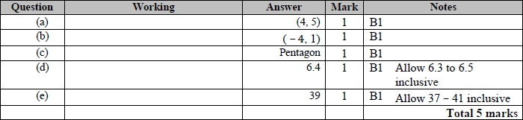

**Q28.**

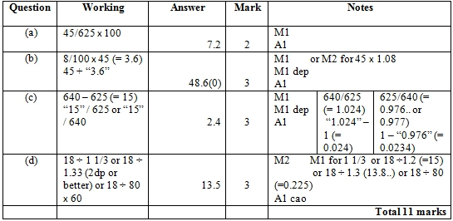

**Q29.**

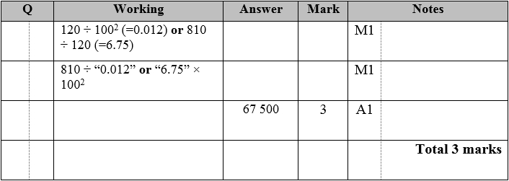

**Q30.**

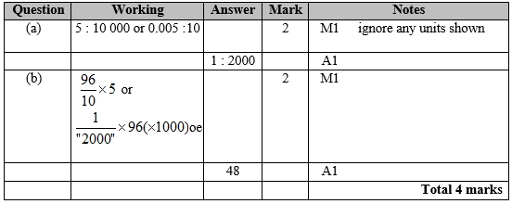

**Q31.**

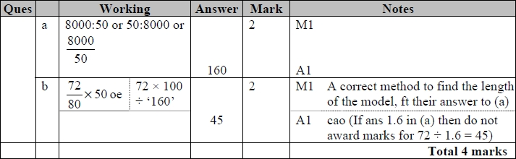

**Q32.**

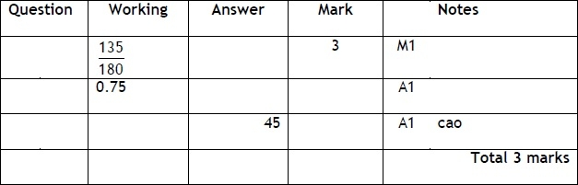

**Q33.**

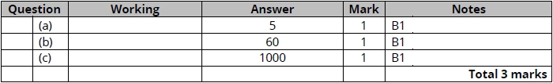

**Q34.**

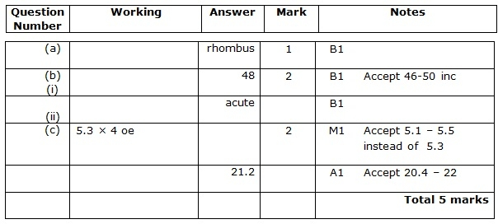

**Q35.**

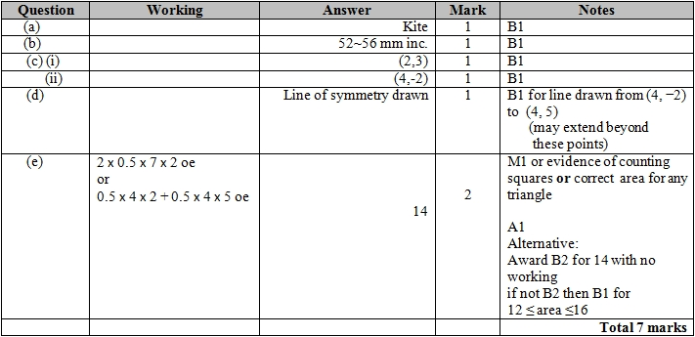

**Q36.** For all questions, the correct answer, unless clearly obtained by an incorrect method, should be taken to imply a correct method.

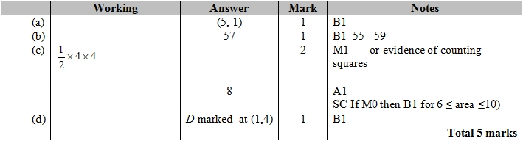

**Q37.**

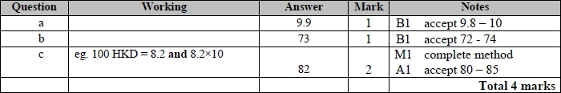

**Q38.**

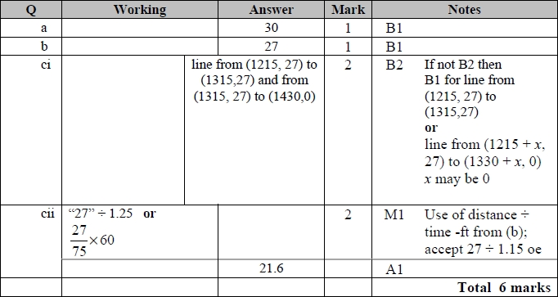

**Q39.**

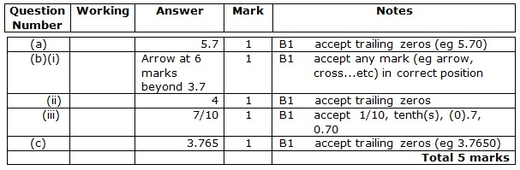

**Q40.**

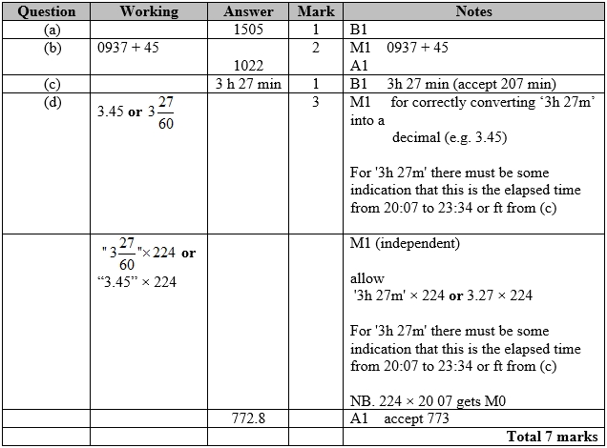

**Q41.**

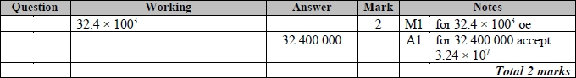

**Q42.**

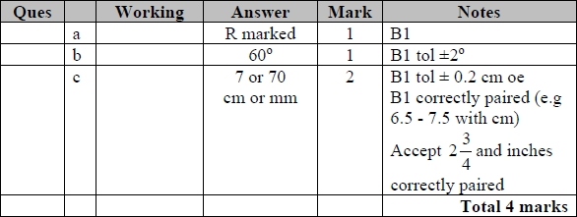

**Q43.**

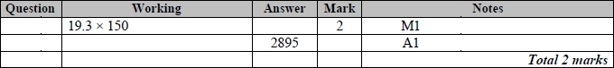

**Q44.**

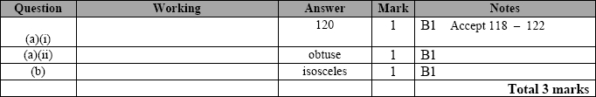

**Q45.**

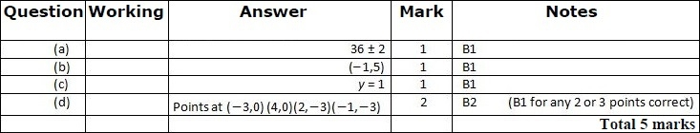

**Q46.**

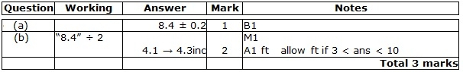

**Q47.**

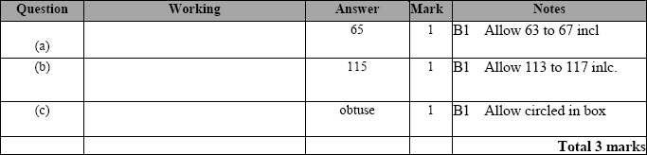

**Q48.**

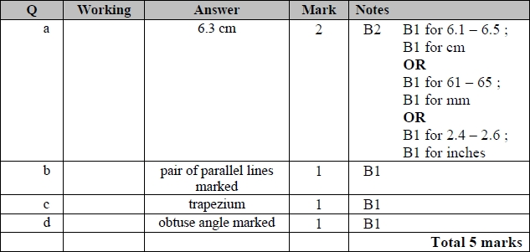

**Q49.**

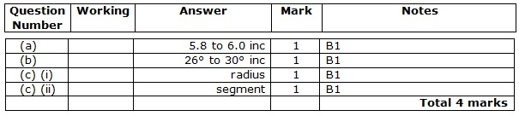

**Q50.**

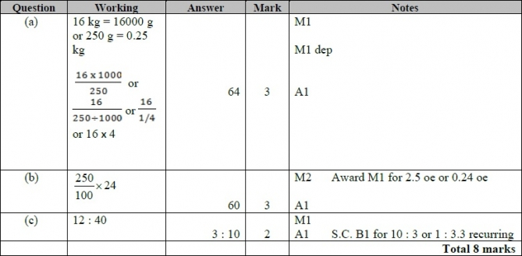

**Q51.**

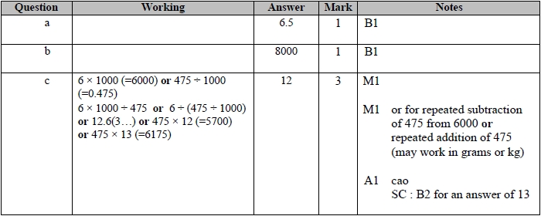

**Q52.**

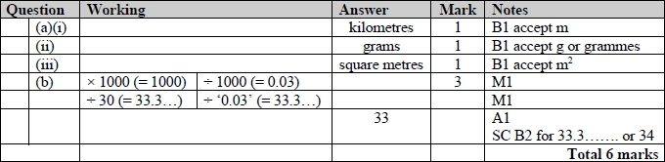

**Q53.**

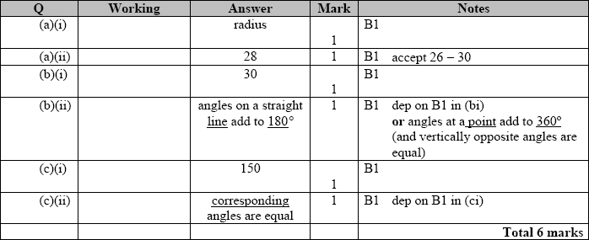

**Q54.**

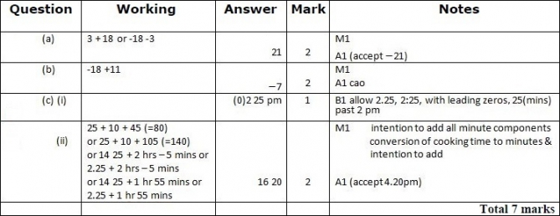

**Q55.**

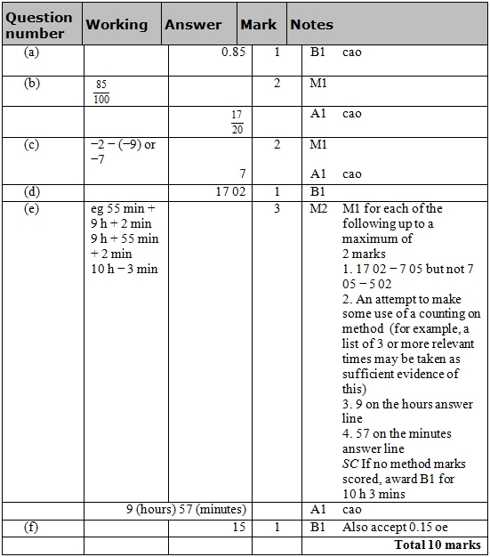

**Q56.**

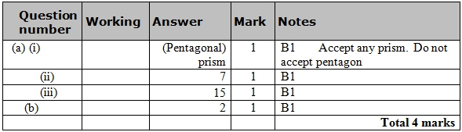

**Q57.**

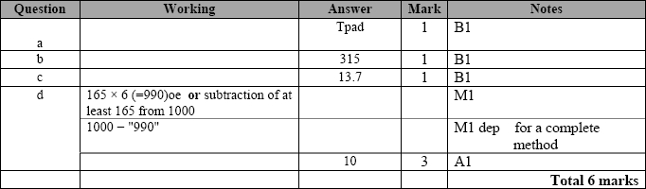

**Q58.**

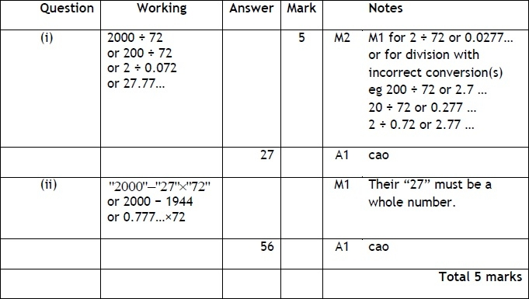

**Q59.**

