**FOSSIL FUELS**

**Q1. Fill in the gaps in the following paragraph. Use the words that are given.**

FOSSIL, BURIED, LIGHT, CHEMICAL, SEDIMENT, COAL, PLANTS, NATURAL GAS, PHOTOSYNTHESIS, CREATURES, MILLIONS, OIL, SEA



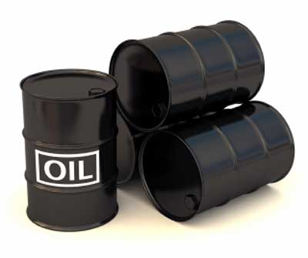The Sun produces a great deal of ________ energy and heat energy. Some of this reaches the Earth. _____________ can trap this energy and change it by a process called ___________________. Some of the energy becomes locked in them, in the form of _____________ energy. Over many years, loads and loads of plants grew. Some were ______________ underground. Their energy became trapped as they were turned into _______________. _____________ that fed on the plants fell to the bottom of the ________. They were buried under ____________ and chemical changes occurred to make ____________ and ______________. We call fuels formed from living things in this way ______________ fuels.

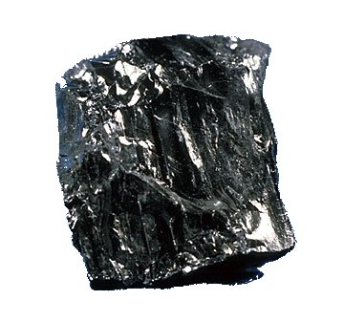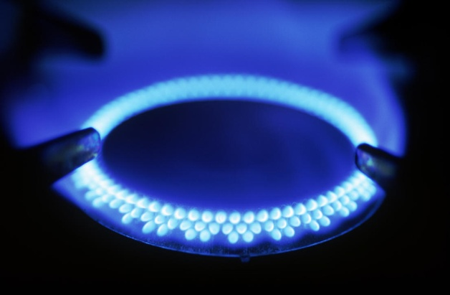

**Q2. The problem with fossil fuels:**

* Burning too many fossil fuels leads to environmental problems;
* Acid rain is caused by _________ in fossil fuels reacting with oxygen in the air to form sulphur dioxide
* Global warming is caused by carbon in fossil fuels reacting with oxygen in the air to form ______________.

**Can you think of any other problems?**

**___________________________________________________________________________________________________________________________________________________________________________________________________**