

**Higher IGCSE (9 – 1) Revision Pack**

**Transformation of Shapes**

**Name --------------------------------**

**Questions**

**Q1.**

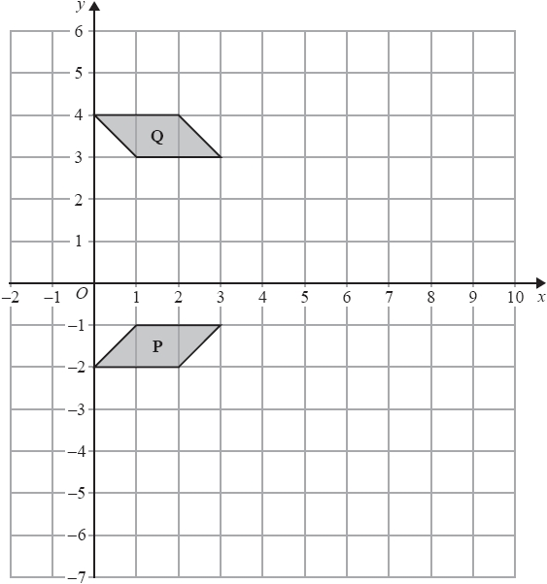

(a)  Describe fully the single transformation that maps shape **P** onto shape **Q**.

.............................................................................................................................................

.............................................................................................................................................

**(2)**

(b)  On the grid above, enlarge shape **P** with scale factor 3 and centre *O*.

**(2)**

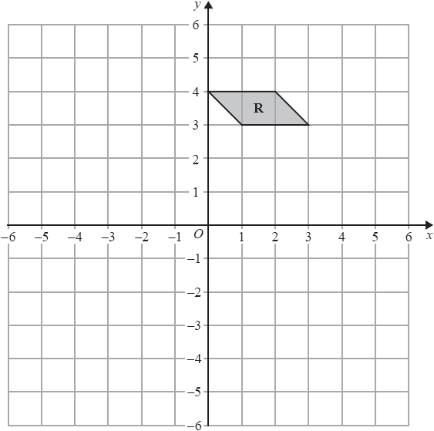

(c)  On the grid above, rotate shape **R** 90° anticlockwise with centre (0, 1)

**(2)**

**(Total for question = 6 marks)**

**Q2.**

The diagram shows a shape **P**, and a shape **Q**.

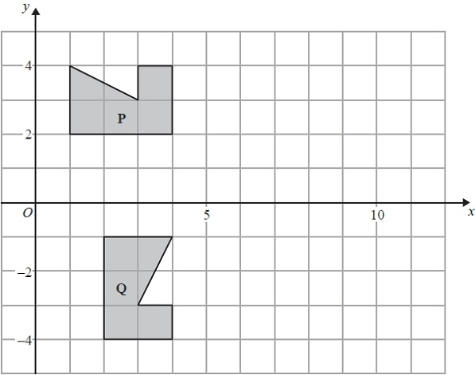

Describe fully the single transformation which maps shape **P** onto shape **Q**.

.............................................................................................................................................

.............................................................................................................................................

**(Total for Question is 3 marks)**

**Q3.**

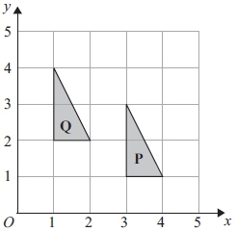

Describe fully the single transformation which maps triangle **P** onto triangle **Q**.

  ..............................................................................................................................................

      ..............................................................................................................................................

**(Total for question = 2 marks)**

**Q4.**

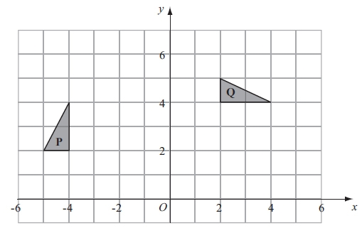

(a) Describe fully the single transformation which maps triangle **P** onto triangle **Q**.

  ..............................................................................................................................................

**(3)**

(b) Reflect triangle **Q** in the line *y* = *x*.

Label the new triangle **R**.

**(2)**

**(Total for question = 5 marks)**

**Q5.**

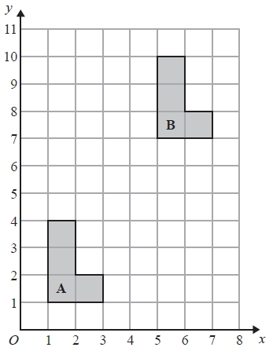

Describe fully the single transformation that maps shape **A** onto shape **B**.

.............................................................................................................................................

.............................................................................................................................................

  **(Total for question = 2 marks)**

**Q6.**

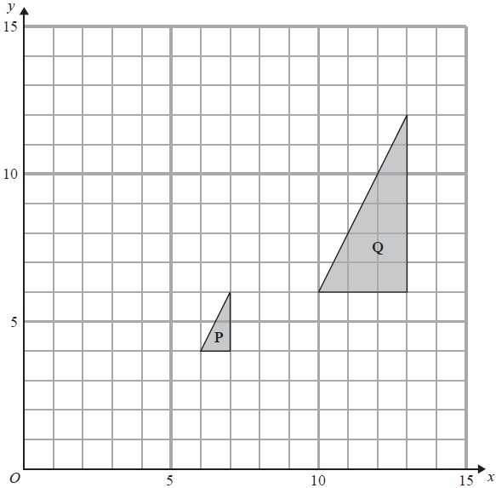

(a)  Describe fully the single transformation which maps triangle **P** onto triangle **Q**.

.............................................................................................................................................

.............................................................................................................................................

**(3)**

(b)  On the grid, translate triangle **Q** by the vector 

Label the new triangle **R**.

**(1)**

(c)  Describe fully the single transformation which maps triangle **R** onto triangle **P**.

.............................................................................................................................................

.............................................................................................................................................

**(2)**

**(Total for Question is 6 marks)**

**Q7.**

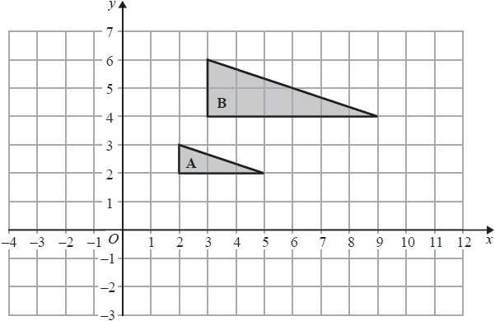

(a)  Describe fully the single transformation that maps triangle **A** onto triangle **B**.

.............................................................................................................................................

.............................................................................................................................................

**(3)**

(b)  On the grid, translate triangle **A** by the vector 

Label the new shape **C**.

**(1)**

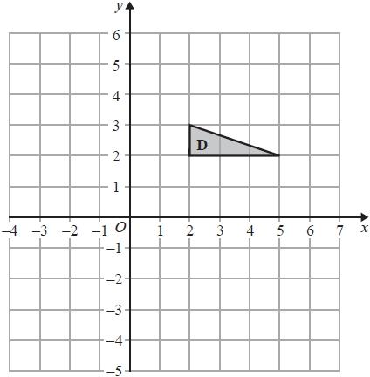

(c)  On the grid, rotate triangle **D** 90° anticlockwise with centre (3, 1)

**(2)**

**(Total for question = 6 marks)**

**Q8.**

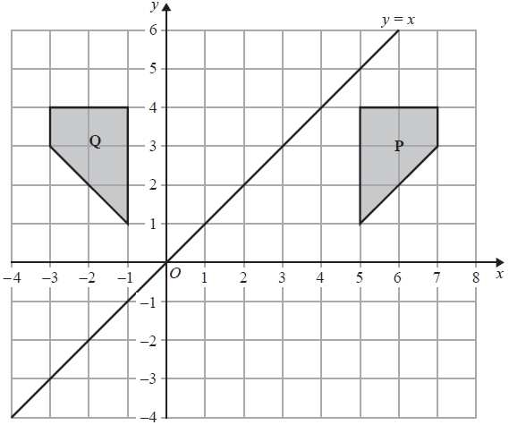

(a)  Describe fully the single transformation which maps shape **P** onto shape **Q**.

.............................................................................................................................................

.............................................................................................................................................

**(2)**

(b)  Reflect the shape **Q** in the line *y* = *x*.   
Label the new shape **R**.

**(2)**

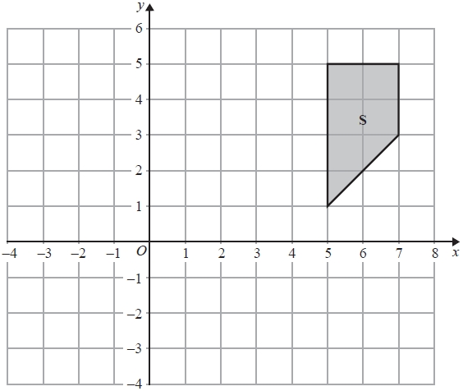

(c)  Enlarge shape **S** with scale factor  and centre (1, 3)

**(2)**

**(Total for question = 6 marks)**

**Q9.**

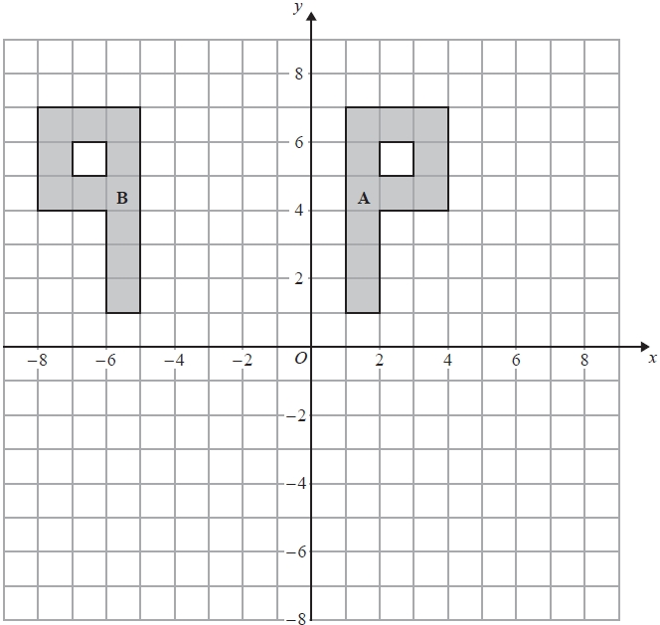

(a)   Describe fully the single transformation that maps shape **A** onto shape **B**.

.............................................................................................................................................

**(2)**

(b)   On the grid, rotate shape **A** 90° clockwise about the origin *O.*  
Label the new shape **C**.

**(2)**

**(Total for Question is 4 marks)**

**Q10.**

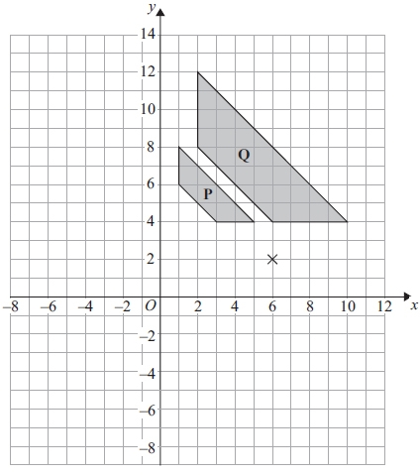

(a) Describe fully the single transformation that maps shape **P** onto shape **Q**.

      ..............................................................................................................................................

      ..............................................................................................................................................

**(3)**

(b) On the grid, rotate shape **Q** 180° about the point (6, 2).   
Label the new shape **R**.

**(2)**

**(Total for question = 5 marks)**

**Q11.**

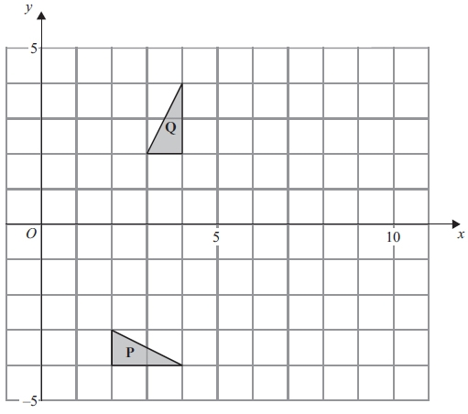

(a) Describe fully the single transformation which maps triangle **P** onto triangle **Q**.

.............................................................................................................................................

.............................................................................................................................................

**(3)**

(b) On the grid, translate triangle **Q** by the vector   
 Label the new triangle **R**.

**(1)**

(c) Describe fully the single transformation which maps triangle **P** onto triangle **R**.

.............................................................................................................................................

.............................................................................................................................................

**(2)**

**(Total for question is 6 marks)**

**Q12.**

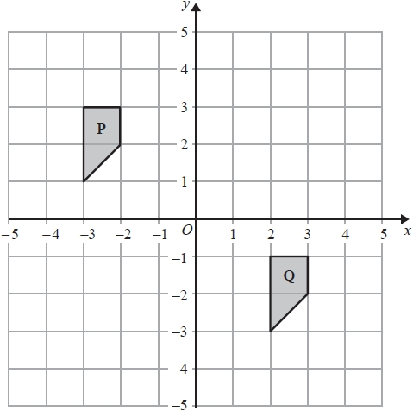

(a)  Describe fully the single transformation that maps shape **P** onto shape **Q**.

.............................................................................................................................................

.............................................................................................................................................

**(2)**

(b)  Rotate shape **Q** 90° clockwise about (1,0)

Label the new shape **R**.

**(2)**

**(Total for question = 4 marks)**

**Q13.**

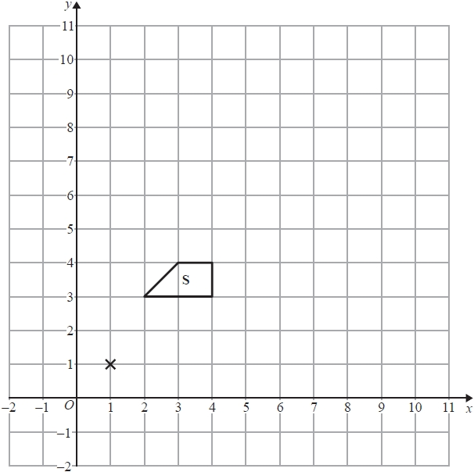

(a)  Enlarge shape **S**, by scale factor 2, centre (1,1).

Label the new shape **T**.

**(2)**

(b)  Describe fully the single transformation that maps shape **T** onto shape **S**.

.............................................................................................................................................

**(1)**

**(Total for question = 3 marks)**

**Q14.**

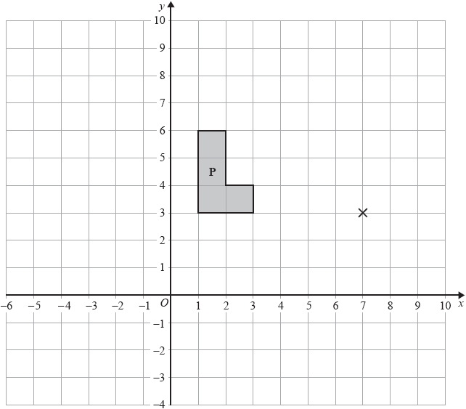

(a)  On the grid, enlarge shape **P** with scale factor 2 and centre (7, 3)

Label the new shape **Q**.

**(2)**

(b)  On the grid, rotate shape **P** through 90° anticlockwise about the point (7, 3)

Label the new shape **R**.

**(2)**

**(Total for question = 4 marks)**

**Q15.**

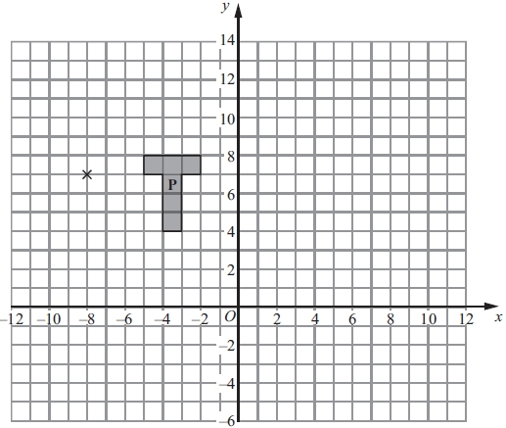

(a) On the grid, enlarge shape **P** with scale factor 3 and centre (−8, 7).   
Label the new shape **Q**.

**(3)**

(b) On the grid, rotate shape **P** through 90° clockwise about the point (−8, 7).   
Label the new shape **R**.

**(2)**

**(Total for question = 5 marks)**

**Q16.**

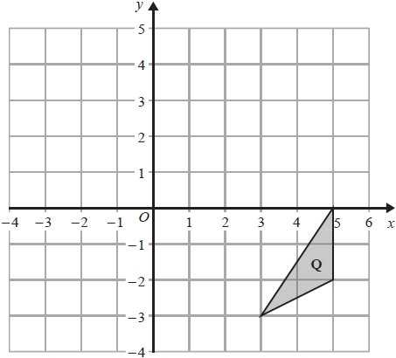

(a)  On the grid, reflect triangle **Q** in the line *x* = 1

Label the new triangle **R**.

**(2)**

Triangle **R** is mapped onto triangle **S** by a reflection in the line *y* = 0

(b)  Describe fully the single transformation that maps triangle **Q** onto triangle **S**.

.............................................................................................................................................

.............................................................................................................................................

**(3)**

**(Total for question = 5 marks)**

**Q17.**

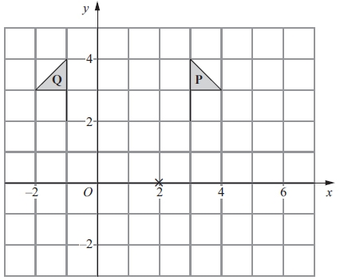

(a) Describe fully the single transformation that maps shape **P** onto shape **Q**.

      ..............................................................................................................................................

**(2)**

(b) On the grid, rotate shape **P** 90° clockwise about the point (2, 0).   
Label the new shape **R**.

**(2)**

**(Total for question = 4 marks)**

**Q18.**

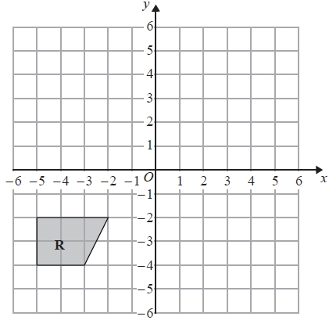

(a)  On the grid above, reflect shape **R** in the line *y* = −*x*

**(2)**

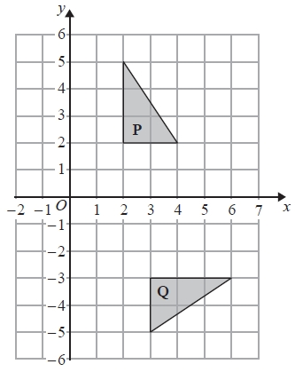

(b)  Describe fully the single transformation that maps triangle **P** onto triangle **Q**.

.............................................................................................................................................

.............................................................................................................................................

**(3)**

  **(Total for question = 5 marks)**

**Q19.**

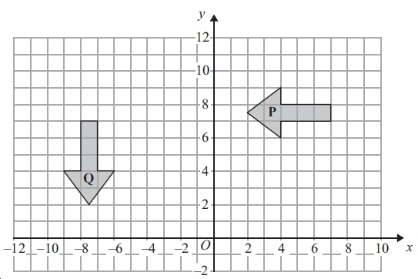

(a) Describe fully the single transformation that maps shape **P** onto shape **Q**.

      ..............................................................................................................................................

      ..............................................................................................................................................

**(3)**

(b) On the grid, translate shape **P** by the vector   
Label the new shape **R**.

**(2)**

**(Total for question = 5 marks)**

**Q20.**

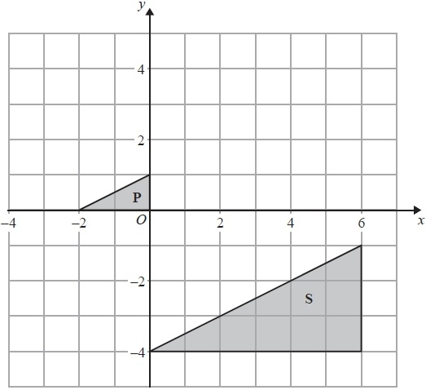

(a)  On the grid, translate triangle **P** by the vector 

Label the new triangle **Q**.

**(1)**

(b)  Describe fully the single transformation that maps triangle **P** onto triangle **S**.

.............................................................................................................................................

.............................................................................................................................................

**(3)**

**(Total for Question is 4 marks)**

**End of questions**