**Livy, *ab urbe condita* I.LV-LVI**

*Read through these two interim chapters from Livy and answer the questions on each.*

**55.**

Having got possession of Gabii, Tarquinius made peace with the Aequian nation and renewed the treaty with the Etruscans. He next turned his attention to affairs in the city. Here his first concern was to build a temple of Jupiter on the Tarpeian Mount to stand as a memorial of his reign and of his name, testifying that of the two Tarquinii, both kings, the father had made the vow and the son had fulfilled it. And that the site might be free from all other religious claims and belong wholly to Jupiter and his temple, which was building there, he determined to annul the consecration of several temples and shrines which had been first vowed by King Tatius at the crisis of the battle against Romulus, and had afterwards been consecrated and inaugurated. At the very time when he began this task the gods are said to have exerted their power to show the magnitude of this mighty empire. For whereas the birds permitted that the consecrations of all the other shrines should be rescinded, they refused their consent for the shrine of Terminus. This omen and augury was thus construed: the fact that the seat of Terminus was not moved, and that of all the gods he alone was not called away from the place consecrated to him, meant that the whole kingdom would be firm and steadfast. When this auspice of permanence had been received, there followed another prodigy foretelling the grandeur of their empire. A human head, its features intact, was found, so it is said, by the men who were digging for the foundations of the temple. This appearance plainly foreshowed that here was to be the citadel of the empire and the head of the world, and such was the interpretation of the soothsayers, both those who were in the City and those who were called in from Etruria to consider the matter. This made the king all the more ready to spend money on the work. Hence the Pometian spoils, which had been destined to carry the building up to the roof, barely sufficed for the foundations. This disposes me to believe the statement of Fabius (who is, besides, the earlier writer) that the spoils were only forty talents, rather than Piso’s, who writes that forty thousand pounds of silver were put aside for this work. So great a sum of money could not be expected from the booty of a single city of that time, and there is no building, even among those of our own day, for the foundations of which it would not be more than enough.

**Questions**

The first phrase is a mere two words in Latin: *Gabiis receptis*. How does Livy succinctly summarise the previous episode and signal a change in the narrative?

Who was King Tatius and why was he fighting Romulus?

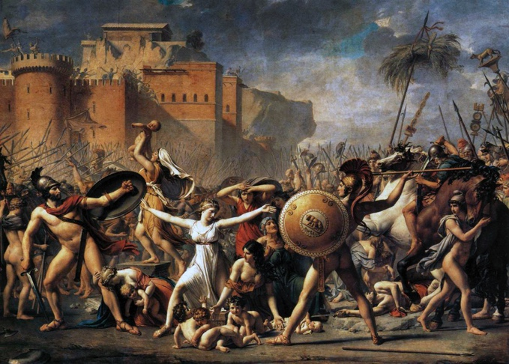

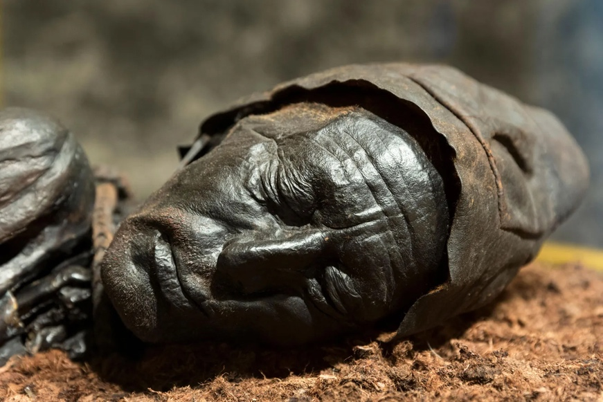What are the following omens and how are they interpreted to mean Rome is destined for greatness?

|  |  |
| --- | --- |
| **Omen:** | **Interpretation:** |
| The Colour of Crows |  |
|  |  |

What were the ‘*Pometian spoils’*?

How does Livy inject more of his own style of ‘history’ into his conclusion of this chapter?

**56.**

Being intent upon completing the temple, the king called in workmen from every quarter of Etruria, and used for this purpose not only the state funds but labourers drawn from the commons. This work was far from light in itself, and was added to their military service. Yet the plebeians felt less abused at having to build with their own hands the temples of the gods, than they did when they came to be transferred to other tasks also, which, while less in show, were yet rather more laborious. I mean the erection of seats in the circus, and the construction underground of the Great Sewer, as a receptacle for all the offscourings of the City,—two works for which the new splendour of these days has scarcely been able to produce a match. After making the plebeians toil at these hard tasks, the king felt that a populace which had now no work to do was only a burden to the City; he wished, moreover, by sending out settlers, to extend the frontiers of his dominions. He therefore sent colonists to Signia and Circei, to safeguard the City by land and sea.

**Questions**

Here Livy concedes that Tarquin left the city some of its **greatest architectural achievements** of all time, but still injects a tone of **tyranny** in the process. Highlight signs of each of these.

Look at the next line in Latin (the first in our next section to translate). Consider how the participle is used to help the narrative flow:

*Haec agenti portentum terribile visum*