***Aeneas vs Romulus***

*Surround the two heroes with virtues and vices and support them with quotes from the stories:*

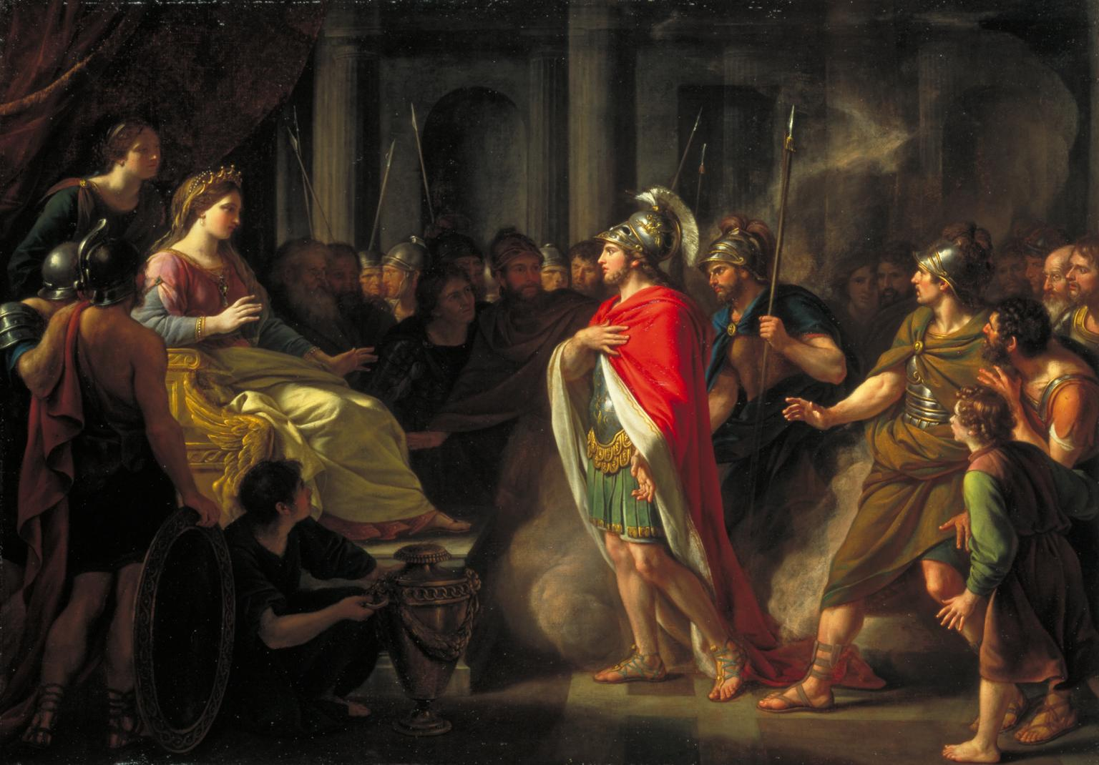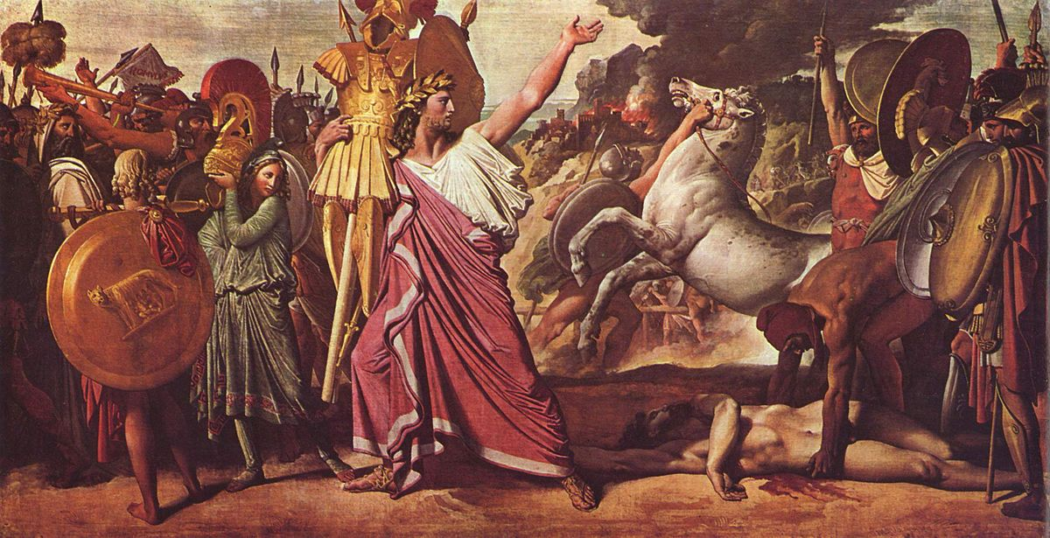

***Aeneas***

***Romulus***