

**Higher IGCSE (9 – 1) Revision Pack**

**Straight Line Graphs and Equations**

**Name --------------------------------**

**Questions**

**Q1.**

*A* is the point with coordinates (1, 3)   
*B* is the point with coordinates (−2, −1)

The line **L** has equation 3*y* = 4 − 2*x*

Is line **L** parallel to *AB*?   
Show your working clearly.

**(Total for question = 3 marks)**

**Q2.**

On the grid, draw the graph of *y* = 4*x* − 1 from *x* = −2 to *x* = 4  
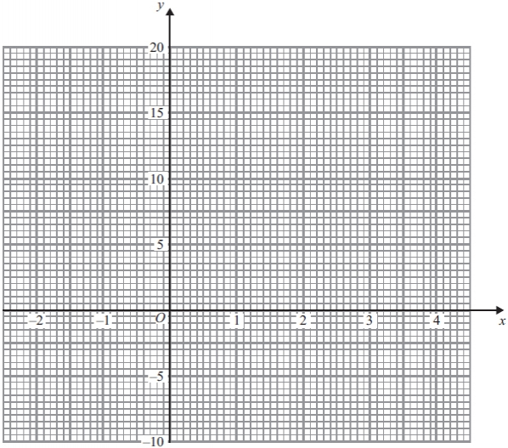

**(Total for question is 4 marks)**

**Q3.**

On the grid, draw the graph of *y* + 2*x* = 6 for values of *x* from –2 to 4

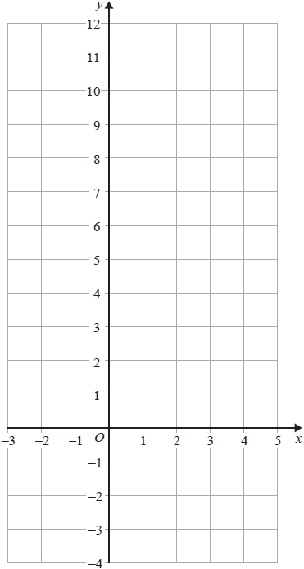

**(Total for question = 4 marks)**

**Q4.**

Here is the straight line **L** drawn on a grid.

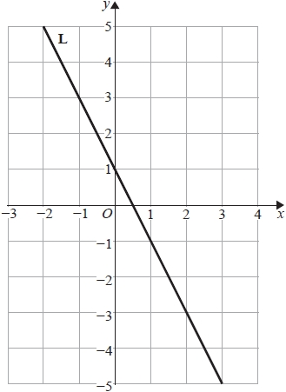

Find an equation for **L**.

...........................................................

**(Total for question = 2 marks)**

**Q5.**

(a)  The straight line **L** passes through the points (0, 12) and (10, 4).   
Find an equation for **L**.

...........................................................

**(3)**

(b)  Find an equation of the straight line which is parallel to **L** and passes through the point (5, −11).

...........................................................

**(2)**

**(Total for Question is 5 marks)**

**Q6.**

The straight line **L** is shown on the grid.

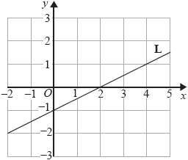

(a)  Find an equation of **L**.

...........................................................

**(2)**

(b)  Find an equation of the line that is parallel to **L** and passes through the point (5, 4)

...........................................................

**(2)**

**(Total for question = 4 marks)**

**Q7.**

(a)  Find an equation of the line that passes through the points (−3, 5) and (1, 2)

Give your answer in the form *ax* + *by* = *c* where *a*, *b* and *c* are integers.

...........................................................

**(4)**

Line **L1** has equation *y* = 3*x* + 5   
Line **L2** has equation 6*y* + 2*x* = 1

(b)  Show that **L1** is perpendicular to **L2**

**(2)**

**(Total for question = 6 marks)**

**Q8.**

Find an equation of the line that is parallel to the line *y* = 4 – 2*x* and passes through the point (3, 7)

...........................................................

**(Total for question = 3 marks)**

**Q9.**

The line **L** passes through the point (3,1) and is parallel to the line with equation *y* = – 2*x*.

Find an equation for the line **L**.

...........................................................

**(Total for question = 3 marks)**

**Q10.**

The straight line **L** (−2, 3) and (6, 9)

Find an equation of the line that is parallel to **L** and passes through the point (5, −1)   
Give your answer in the form *ax* + *by* = *c* where *a*, *b* and *c* are integers.

...........................................................

**(Total for question = 5 marks)**

**Q11.**

The straight line **L** is shown on the grid.

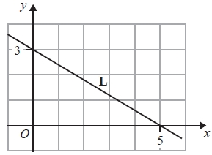

Find an equation of **L**.

...........................................................

**(Total for question = 3 marks)**

**Q12.**

(a) Find the gradient of the line with equation 3*x* + 4*y* = 10

...........................................................

**(3)**

(b) Find the coordinates of the point of intersection of the line with equation 3*x* + 4*y* = 10   
and the line with equation 5*x* − 6*y* = 23  
Show your working clearly.

(.............................. , ..............................)

**(5)**

**(Total for question is 8 marks)**

**Q13.**

The straight line **L** has equation  3*x* – 2*y* = 15

(a)  Find the gradient of **L**.

...........................................................

**(3)**

(b)  Find the coordinates of the point where **L** crosses the *y*-axis.

( ................ , ................ )

**(1)**

(c)  Find an equation of the line that is parallel to **L** and crosses the *x*–axis at (–2, 0)

...........................................................

**(2)**

**(Total for question = 6 marks)**

**Q14.**

The point *A* has coordinates (0, 2)   
The point *B* has coordinates (–4, –1)

(a)  Find the coordinates of the midpoint of *AB*.

...........................................................

**(2)**

(b)  Work out the gradient of the line *AB*.

...........................................................

**(2)**

(c)  Find an equation of the line *AB*.

...........................................................

**(2)**

**(Total for question = 6 marks)**

**Q15.**

Here are the equations of four straight lines.

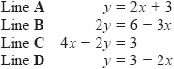

Two of these lines are parallel.

(a)  Which two lines?

...........................................................

**(2)**

Line **L** has a gradient of and passes through the point with coordinates (1, 3)

(b)  Find an equation of **L**.

Give your answer in the form *ax* + *by* = *c* where *a*, *b* and *c* are integers.

...........................................................

**(3)**

**(Total for question = 5 marks)**

**Q16.**

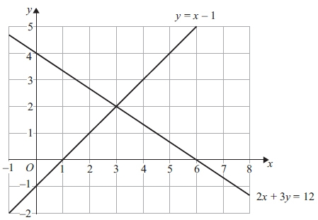

The diagram shows two straight lines.  
 The equations of the lines are *y* = *x* − 1 and 2*x* + 3*y* = 12

1. Write down the solution of the simultaneous equations



*x* = .............................., *y* = .............................

**(1)**

(b) Find an equation of the line which is parallel to the line with equation 2*x* + 3*y* = 12   
and passes through the point (0, 10)

...........................................................

**(4)**

(c) On the grid, mark with a cross (×) each point which satisfies both these inequalities   
*y* > *x* − 1 and 2*x* + 3*y* < 12 and whose coordinates are **positive integers**.

**(2)**

**(Total for question = 7 marks)**

**Q17.**

(a)  Solve

3*x* + 3*y* = 9

4*x* + 2*y* = 13

Show clear algebraic working.

*x* = ...........................................................

*y* = ...........................................................

**(4)**

**L** is a line parallel to the line with equation 4*x* + 2*y* = 13

**L** passes through the point with coordinates (3, −1)

(b)  Find an equation for the line **L**.

...........................................................

**(3)**

**(Total for question = 7 marks)**

**Q18.**

Line **A** has equation 3*x* – 4*y* = 5   
Line **B** goes through the points (4, 7) and (–1, 3)

Are lines **A** and **B** parallel?   
Show your working clearly.

**(Total for question = 4 marks)**

**End of questions**